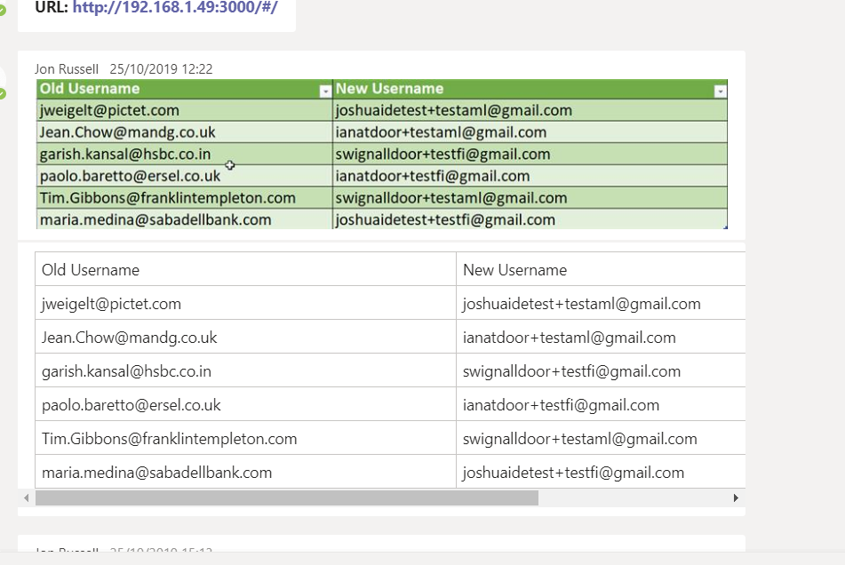

SELECT ID, ActionID, Roles, Location, Interaction, PageObjectForAction, ResultFromAction, Timestamp, UserID, FirmIDForUser, FirmIDForAction, FundIDForAction, UniqueCodeForAction

FROM door.activitytracking

JOIN door.activitymetadata ON door.activitytracking.ActionID = door.activitymetadata.ActivityMetaDataId

ORDER BY ID DESC;

UPDATE `door`.`fund` SET `Name` = 'WisdomTree Physical Gold' WHERE (`FundID` = '48610');

Door Release [[MRT-v1.0.007] [AMP-v0.0.003]]

Hello all, Sprint 38 has now been successfully deployed to Production and Demo environments.

Kind regards,

SQL

Now you will think let me install sql and start the course but no, it doesn’t work like that. To implement this you will need a database management system usually called a database or a platform.

So below is a database from a retail shop

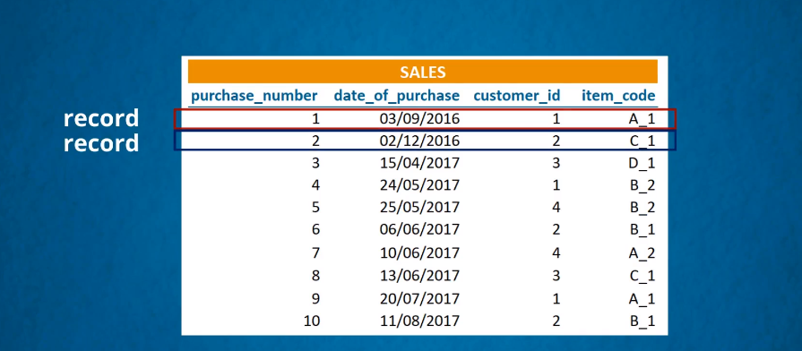

Each 4 data values form a record. Note row and record can be used interchangeably record=row

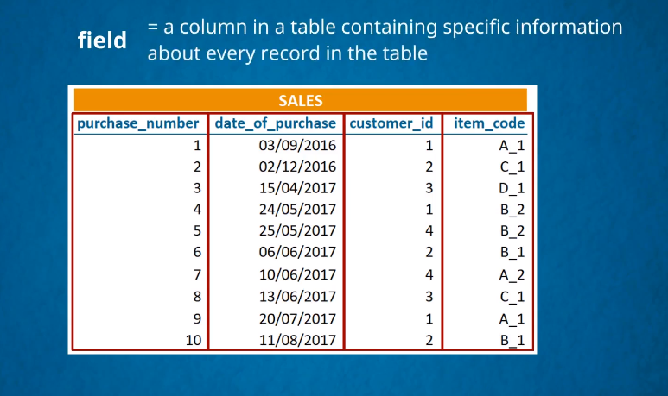

Field=column

Now the information about a customer is saved on another table

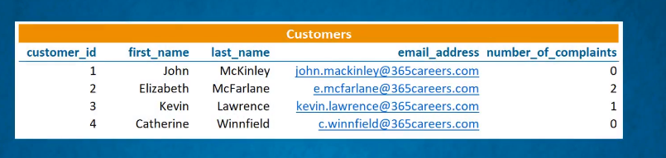

So when there is a sale we look at the sales table and look for the customer ID…. From the customers Id then we use the customers ID from sale to find the customer by checking the customers table with the same ID.

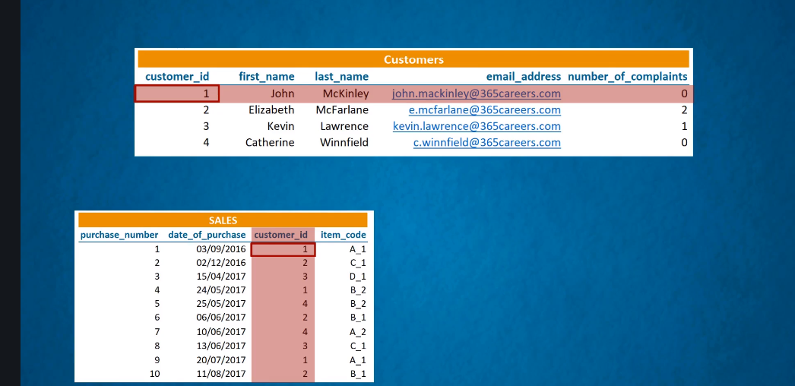

If you notice the tables are all related

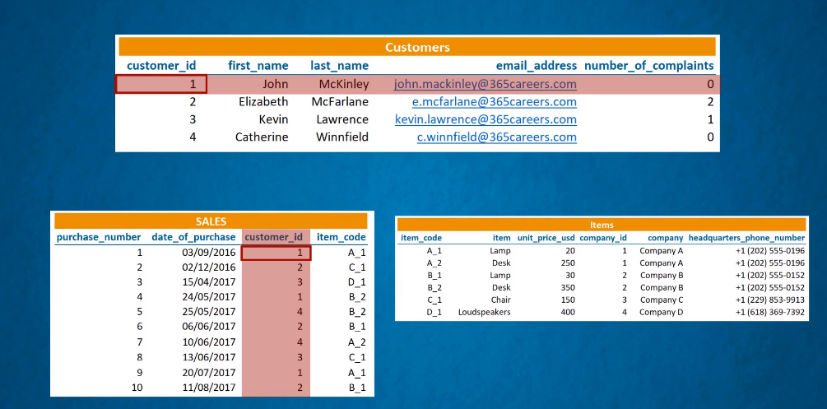

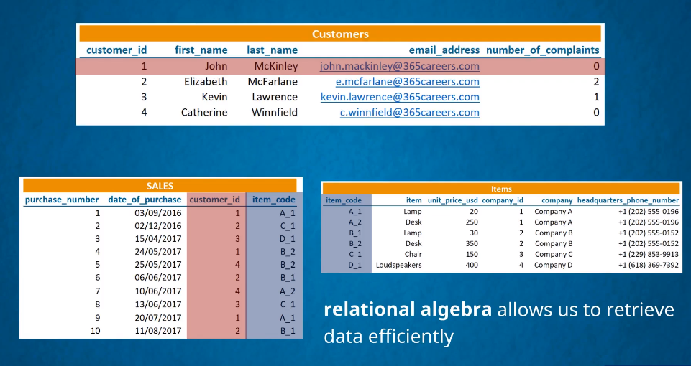

Relational database

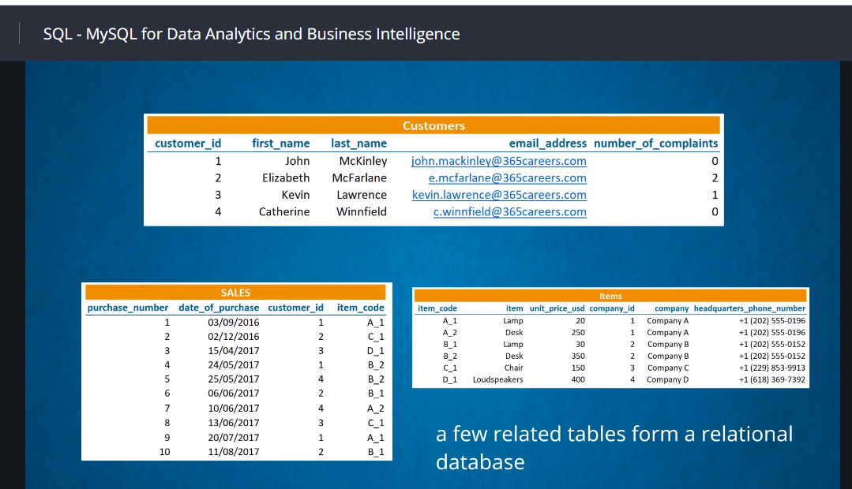

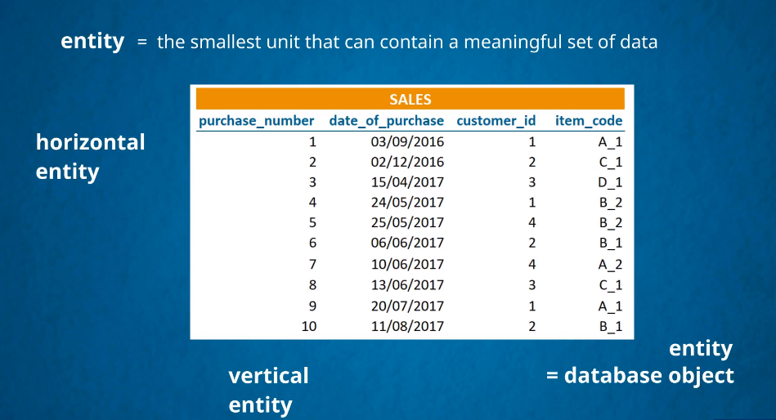

Horizontal=row

Vertical =column

Sql is the language used to operate relational tables

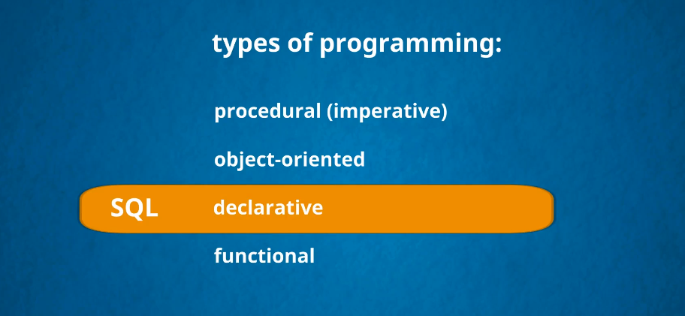

It’s a declarable type of programming

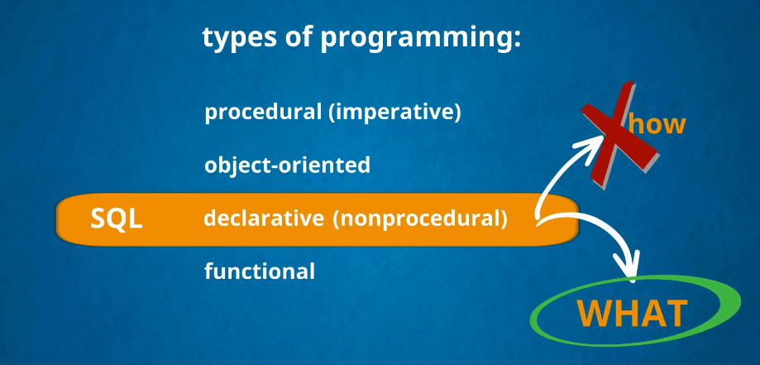

You are interested in what result you want to obtain and not on how to get the job done.

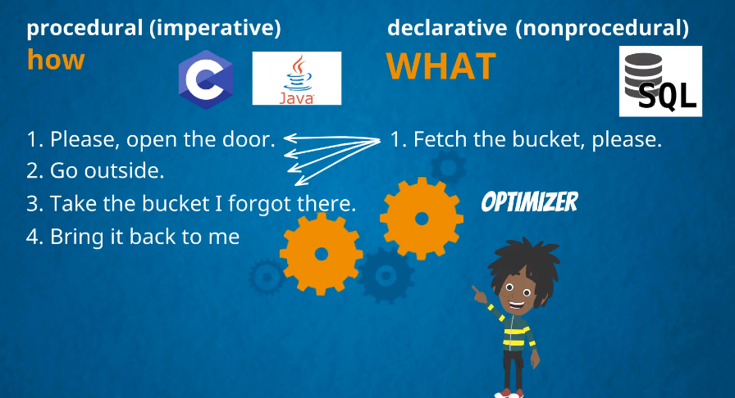

**What will separate your task into smaller steps and do the magic to give you the desired output? That’s what the sql optimizer does**

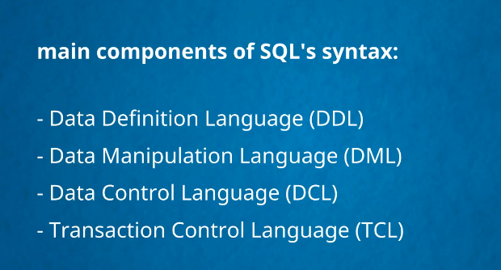

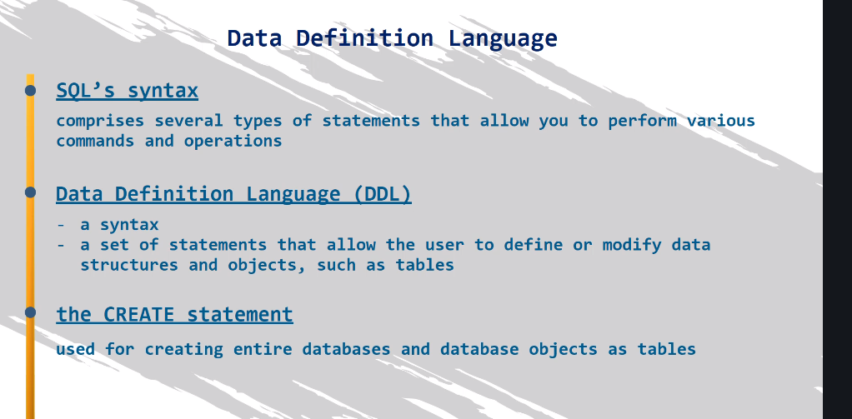

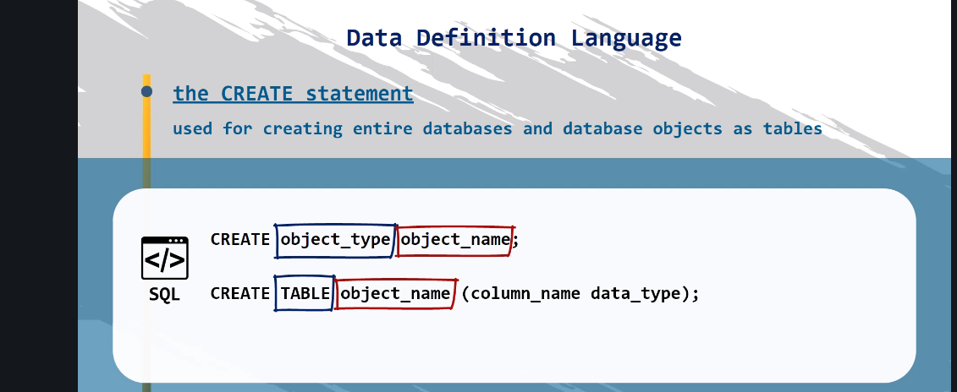

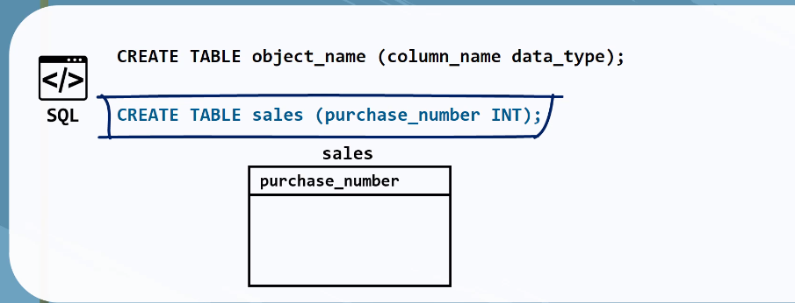

Another language

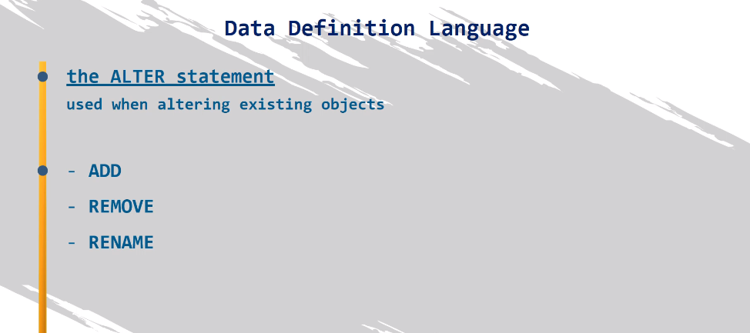

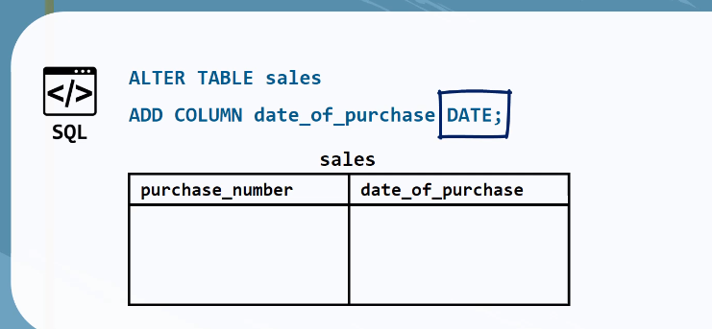

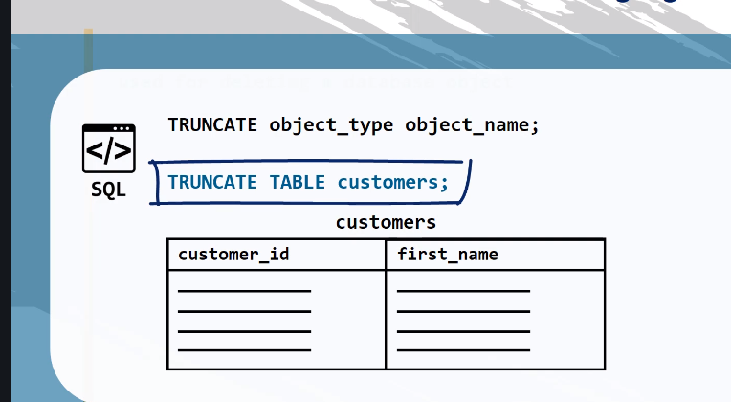

This keeps the table but deletes the contents.

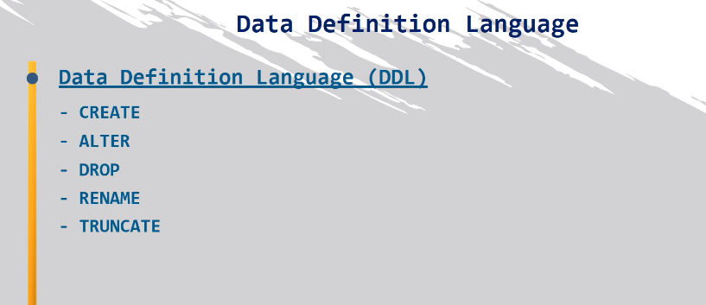



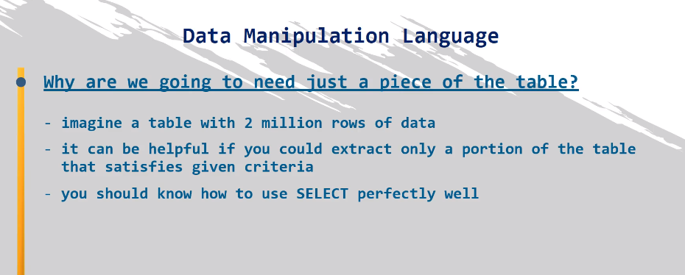

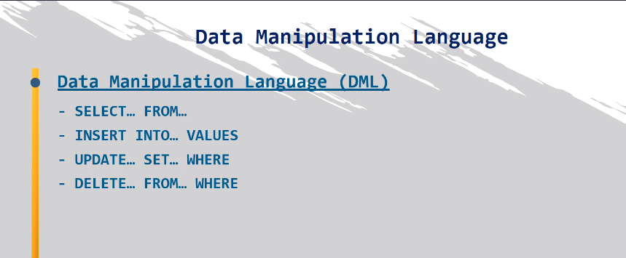

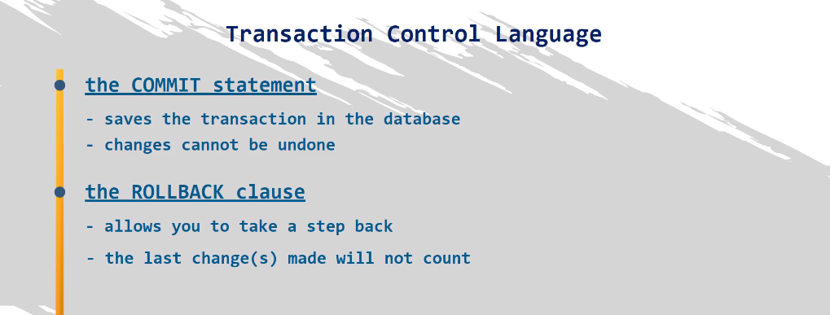

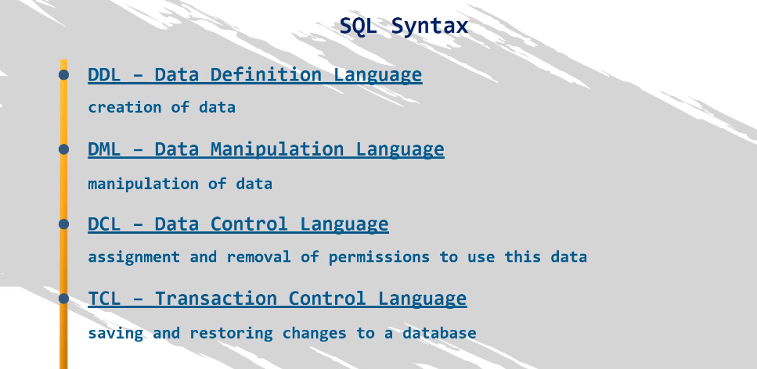

Data base can be relational or non relational. Relational is easy but non relational requires mathematics. When a database is too large it becomes slow but with the help of relational algebra the size is not too obvious

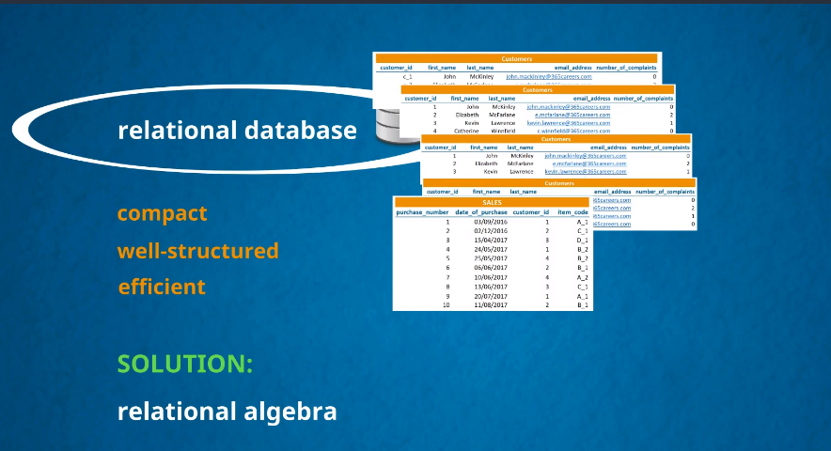

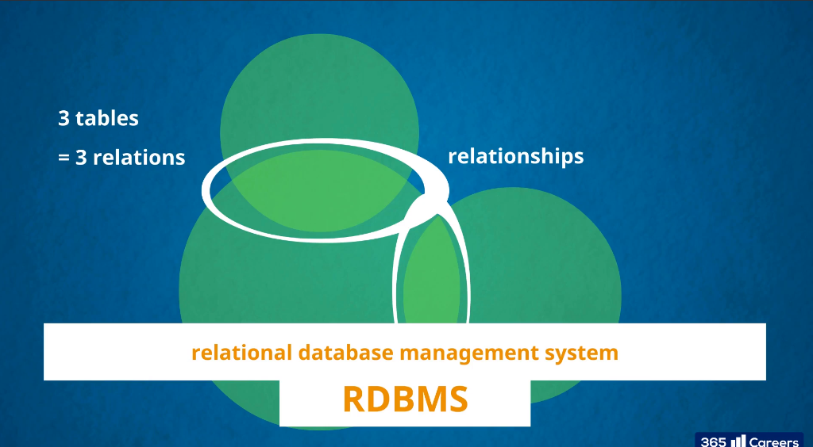



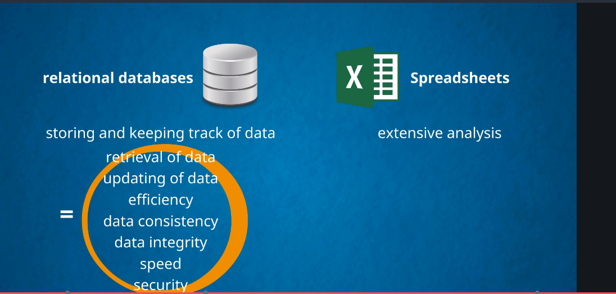

Terminology used

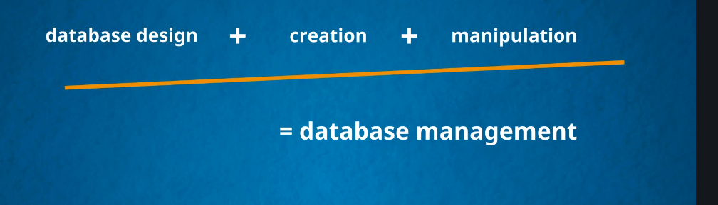

Entity relations

Relational schema

Database schema

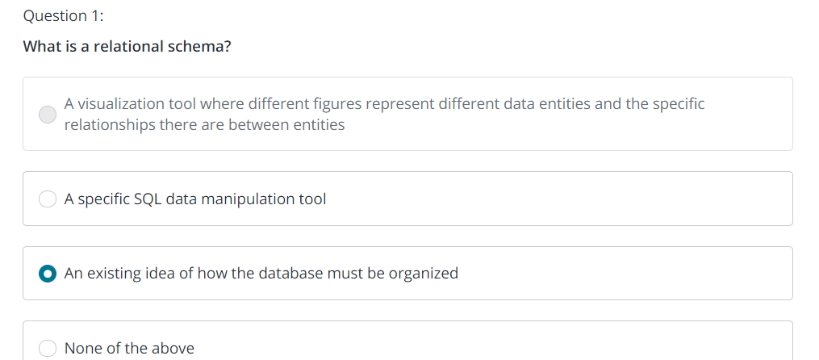

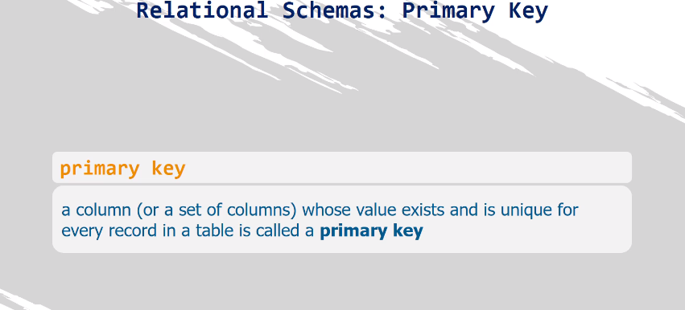

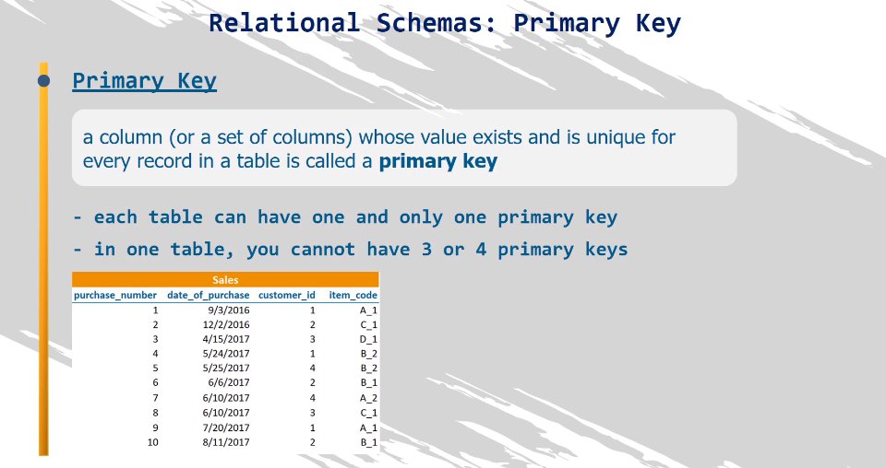

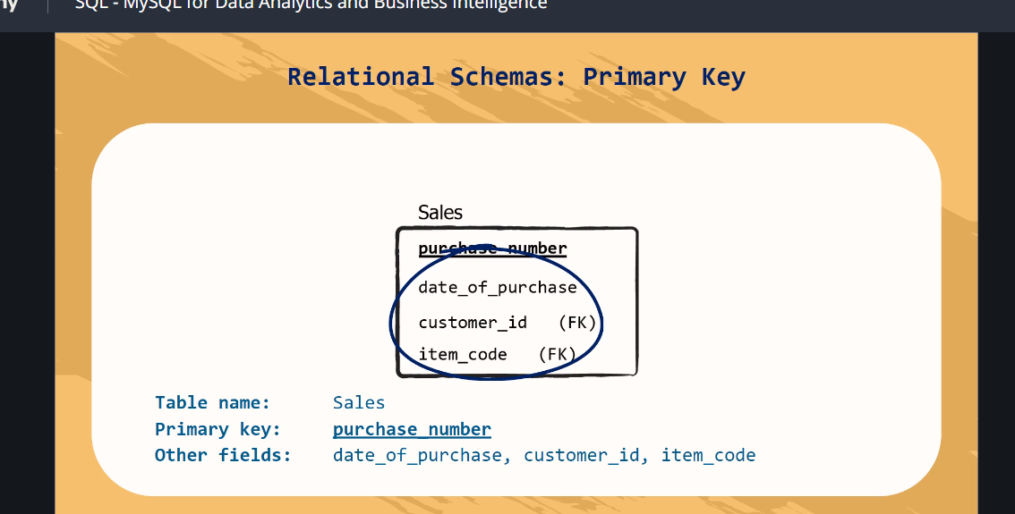

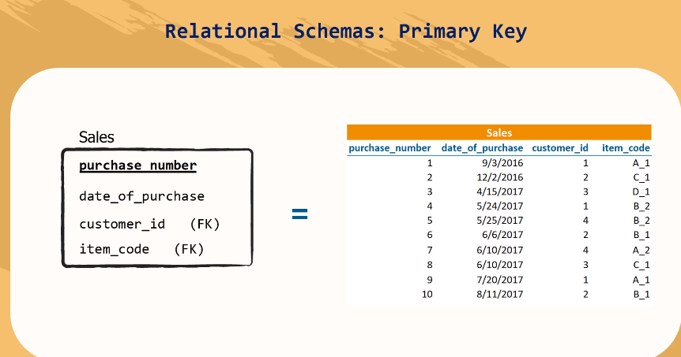

On rectangular table is relational schema

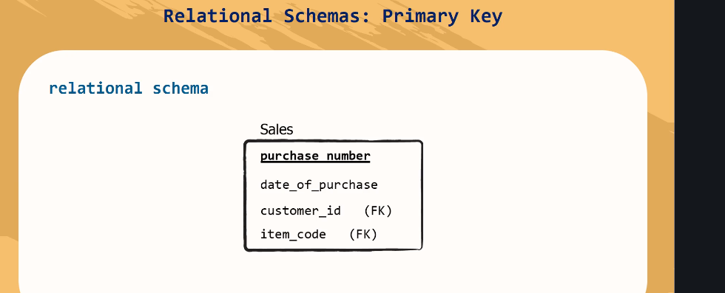

Combine the tables is database schmas

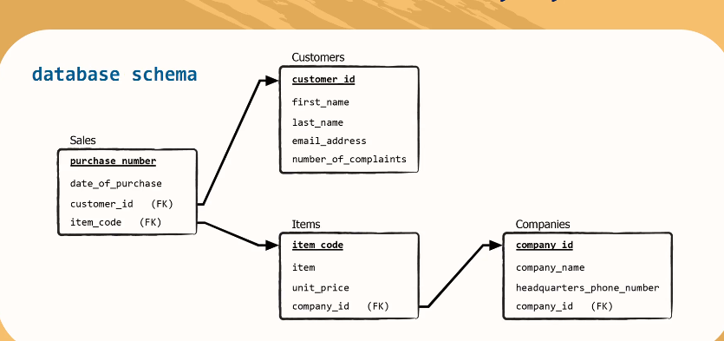

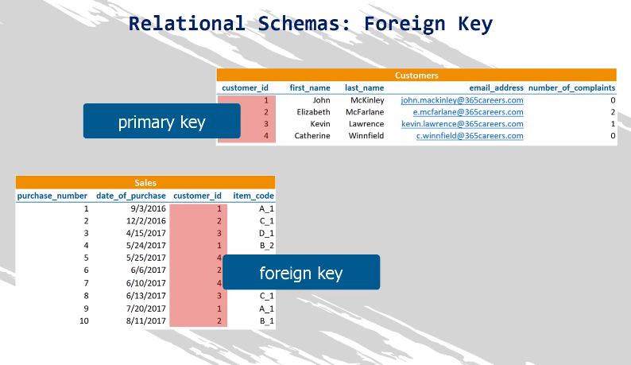

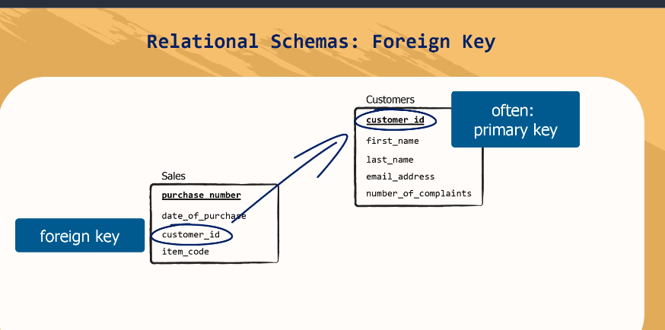

The relationship goes from a foreign key to a primary key.

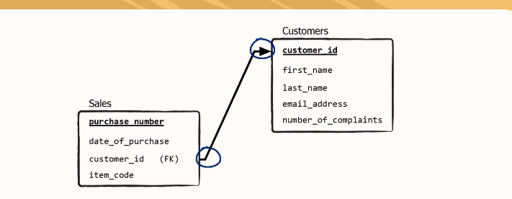

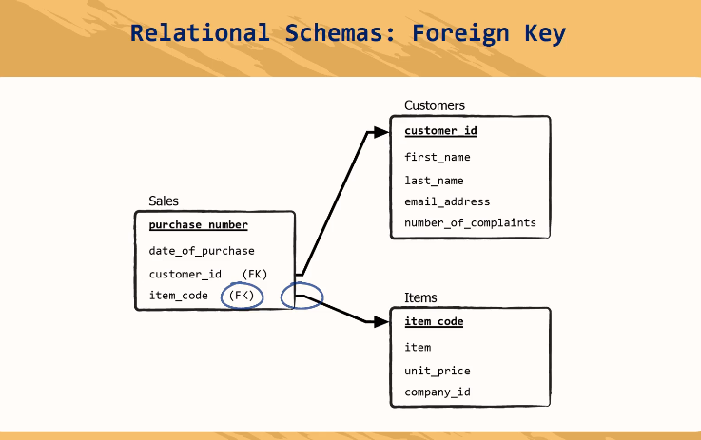

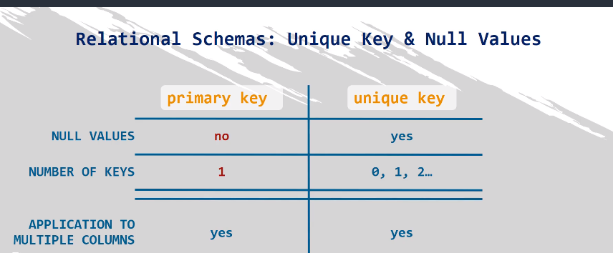

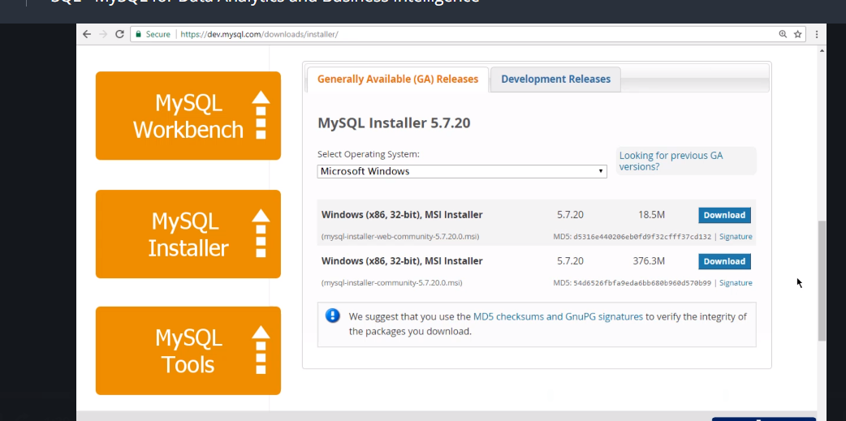

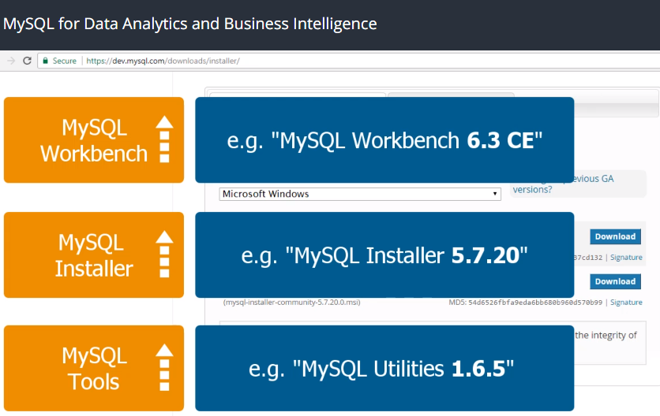

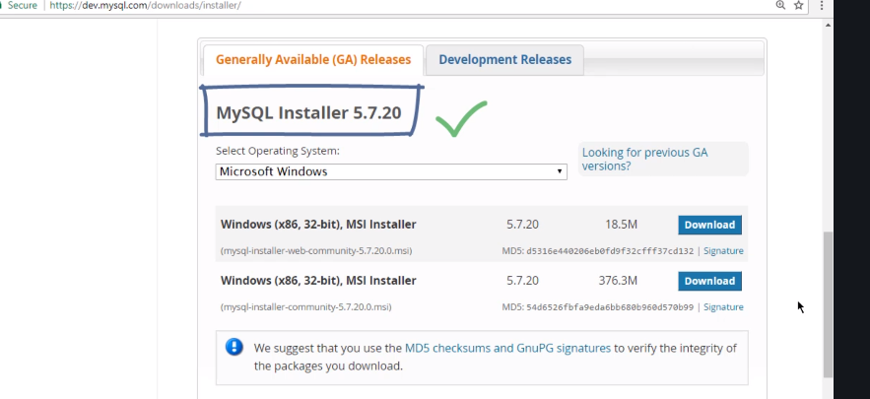

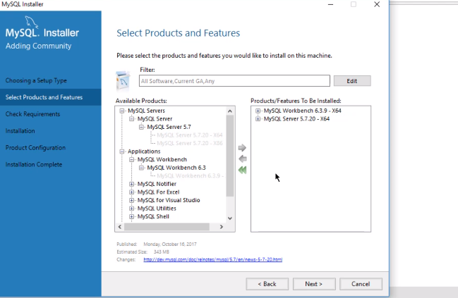

Where did we go to download work bench?...google…download mysql work bench and we had to download c separately

Why didn’t we use mysql installer?

Does the workbench we installed come with mysql tool mysql utilities, mysql installer?

Who created our D data base?

Who designed the tables?

How do we create a data base?

How do we move tables to that database.

So go to D window,

Select the table from door schema or database

Go to server

Data export

Select and click box and choose what you want to export to the new environment

C:\Users\JoshuaIdemudia\Documents\dumps\Dump20191206 this is the dump where it will besaved.

The difference norman left the default schema blank.

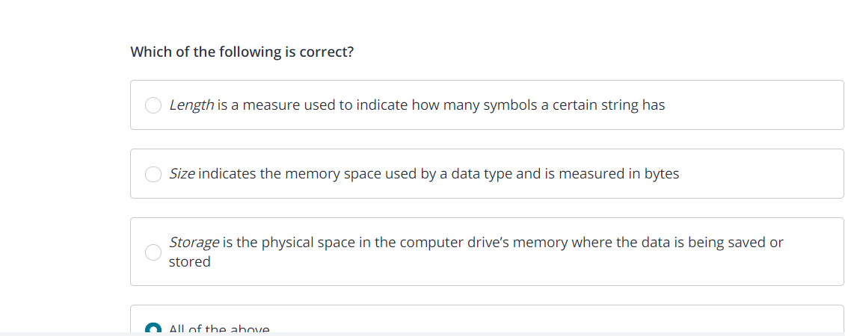

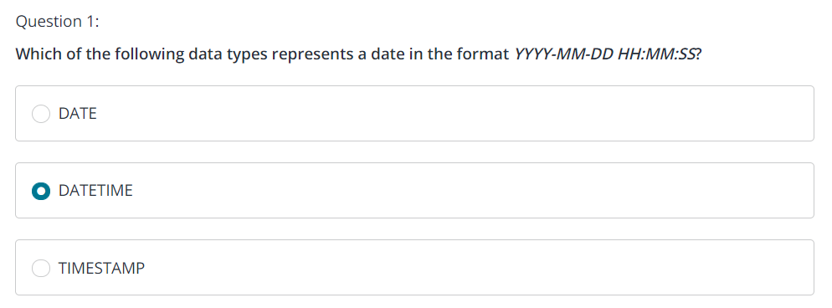

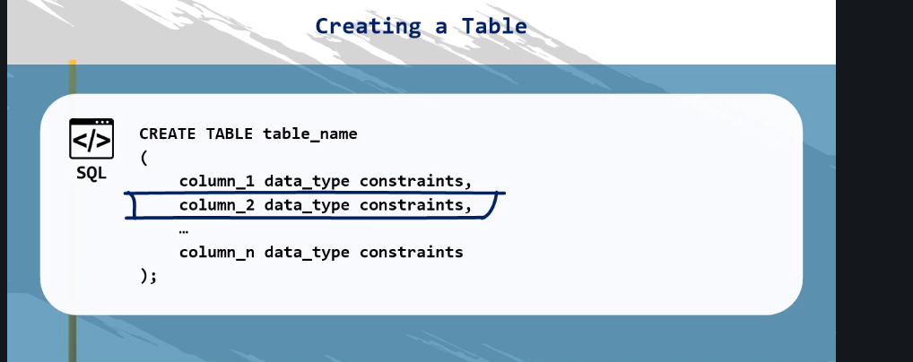

Now we create a table

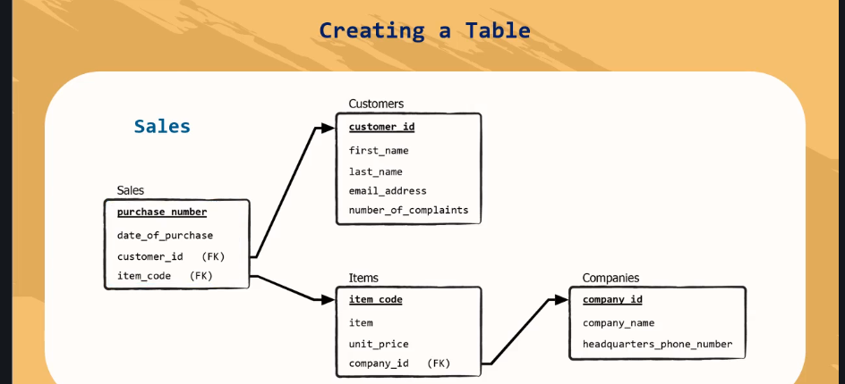

To delete a table after creating it

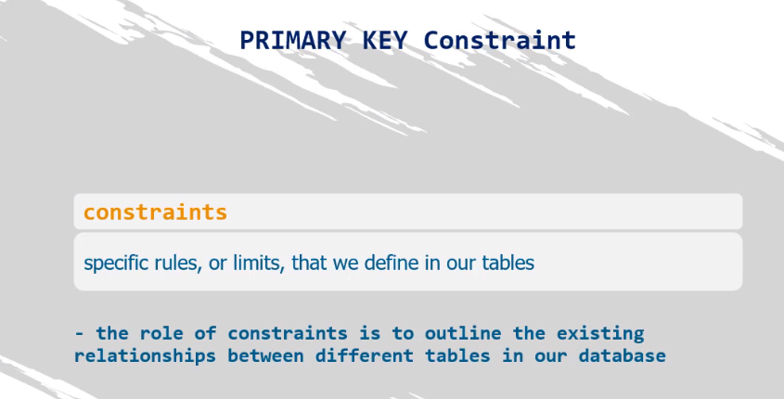

Not null

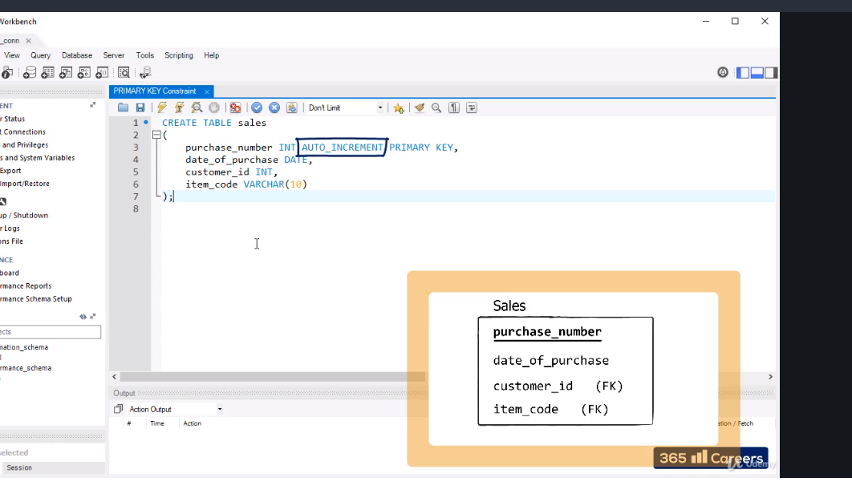

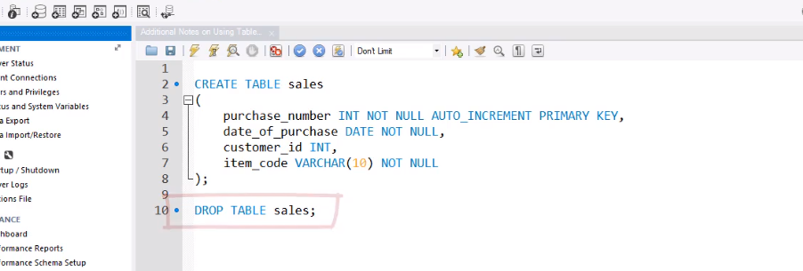

Can also be written like this

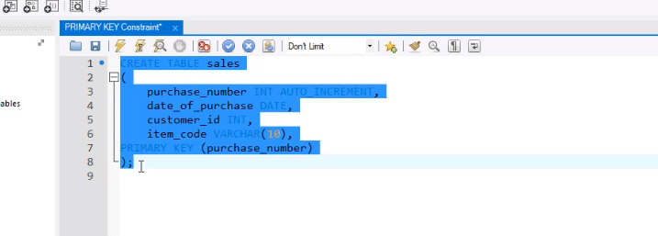

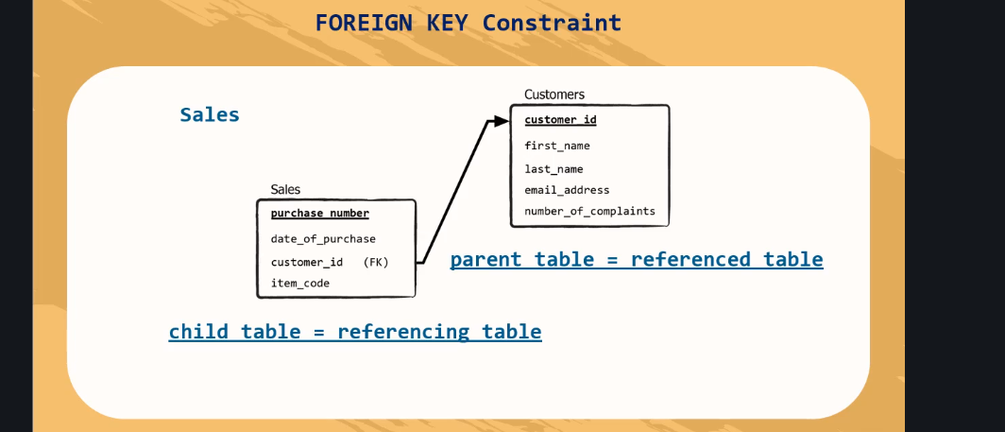

Why was there error dropping the customers table?

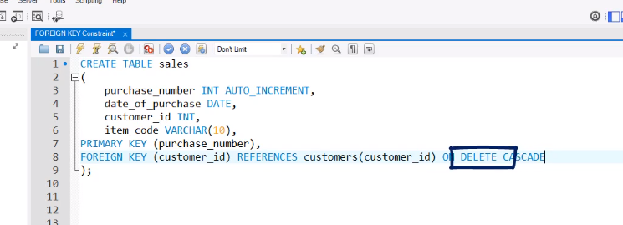

Link pk and fk

On delete cascade is added so if u delete one all is dleted parnent r child

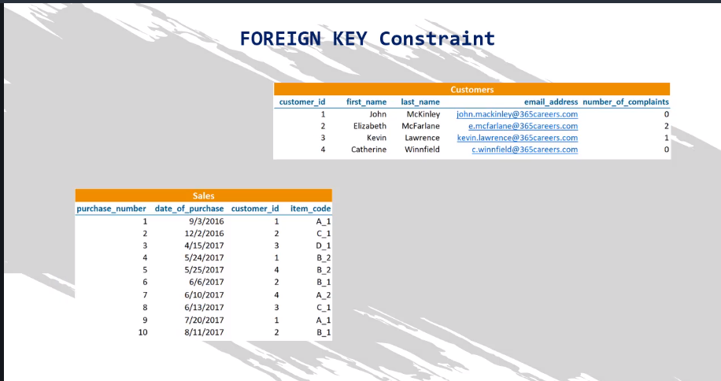

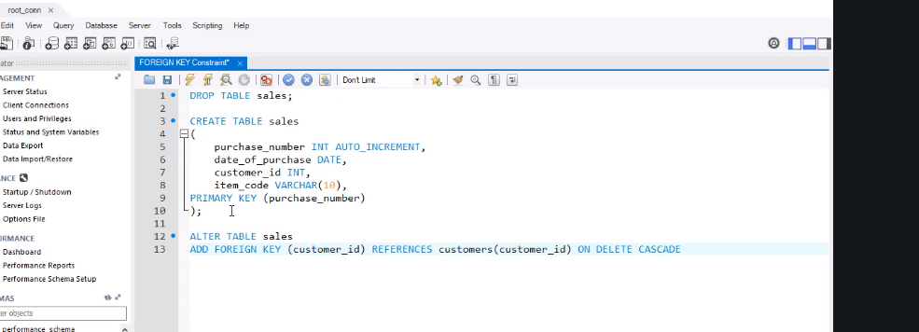

Another way to do it.

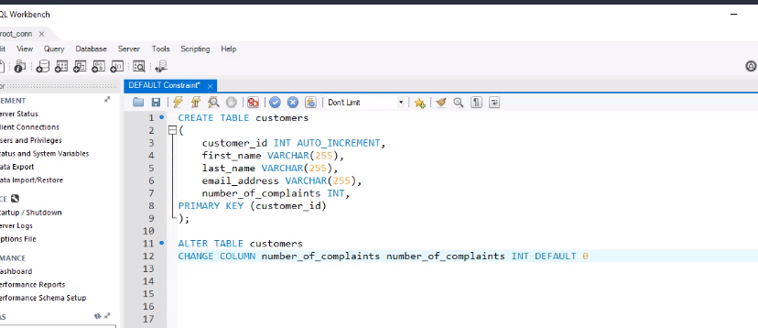

Or

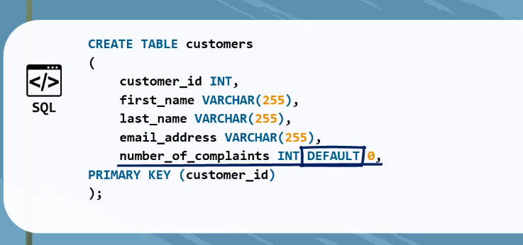

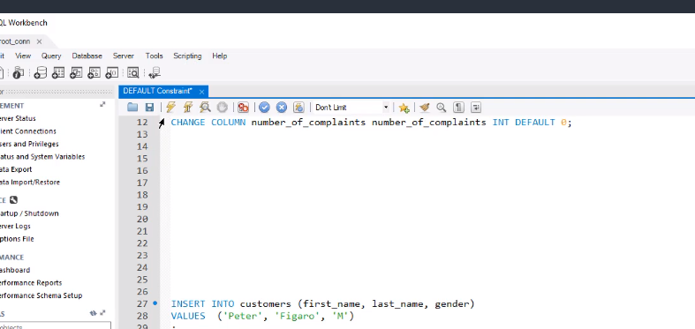

U can drop default

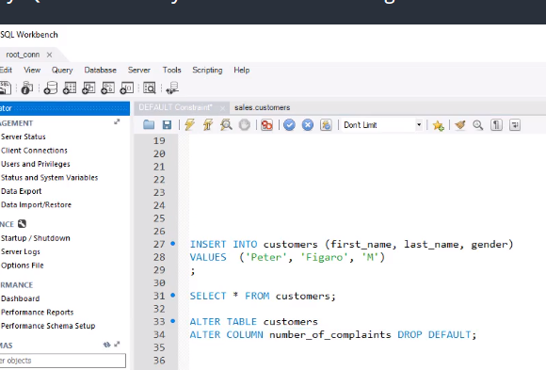

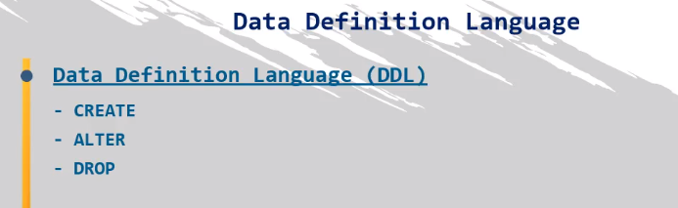

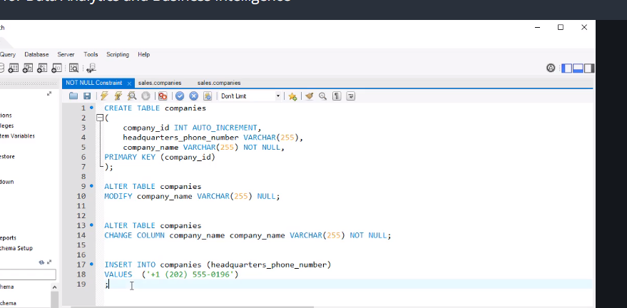

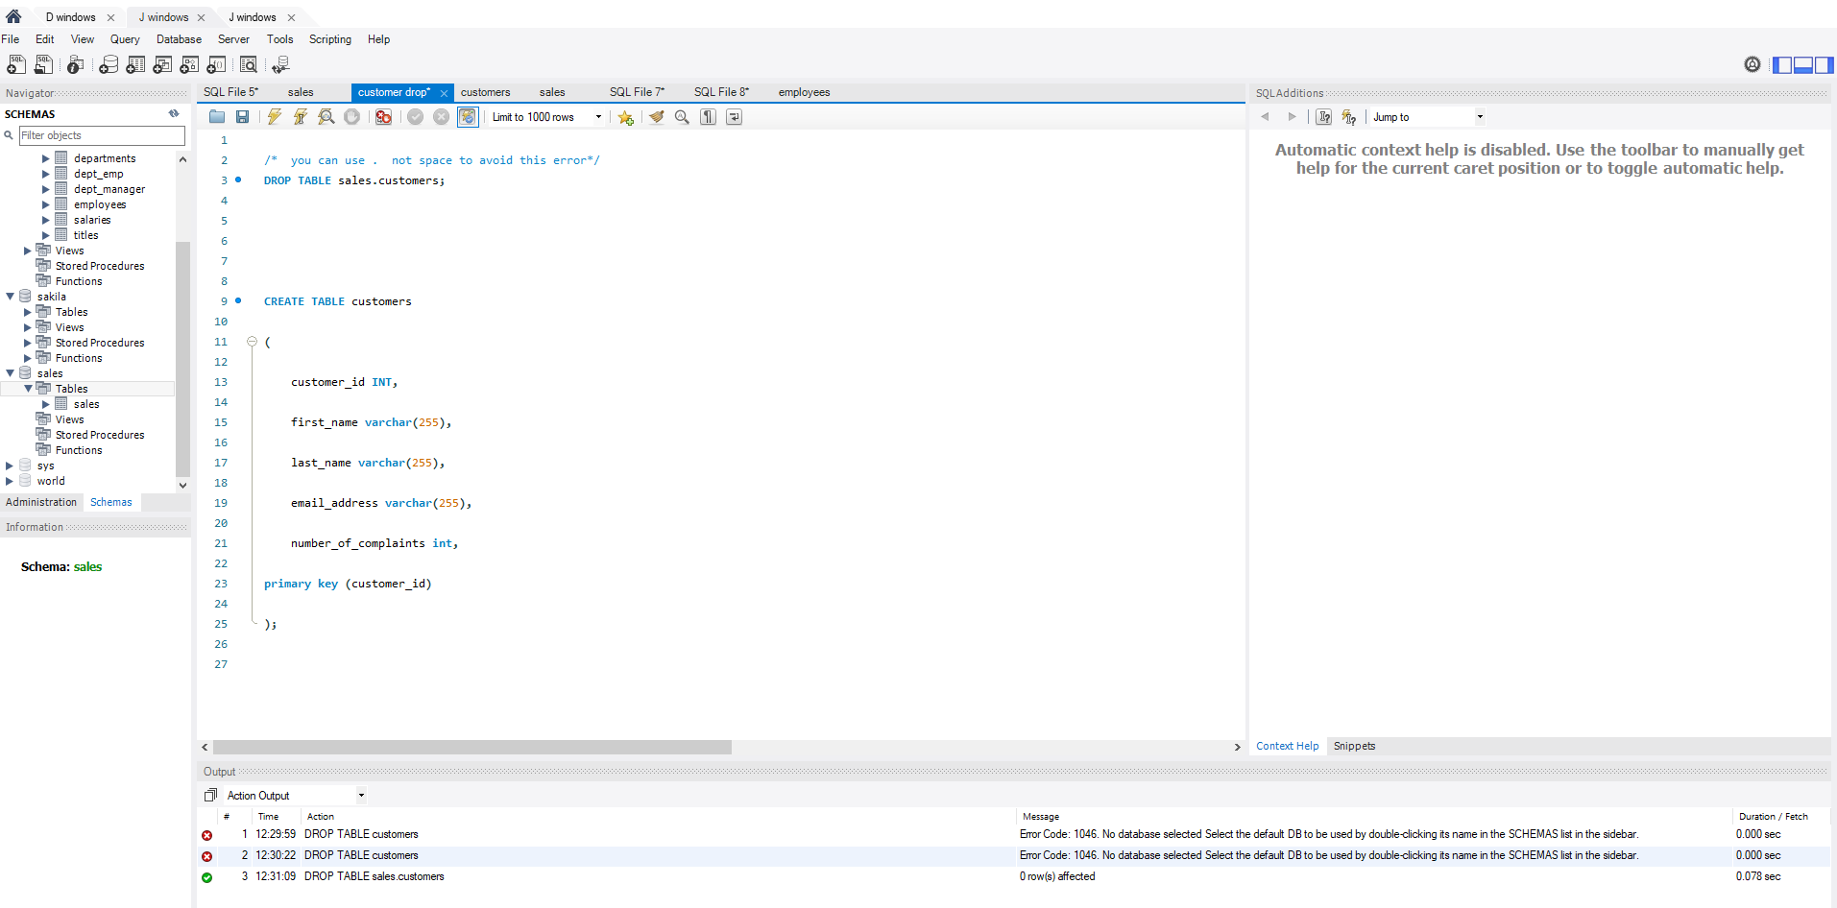

Now we start data manipulations

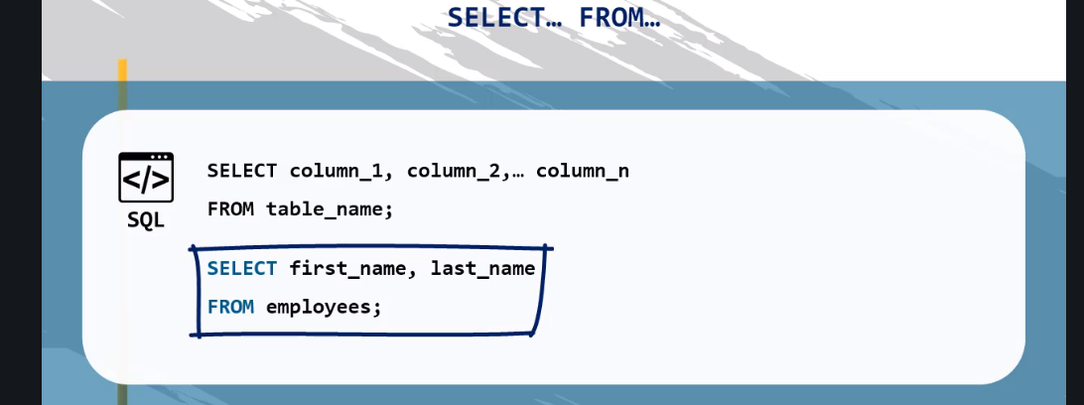

Remember one thing, if you have so many database open, u have to make one a default database by going to the database right click and choose default schema

Otherwise you have to do employee.employee

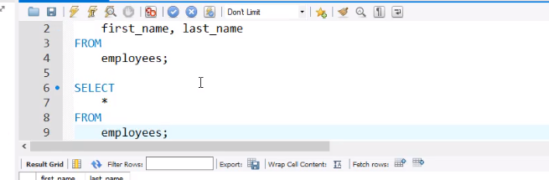

Note now that select * means select all……

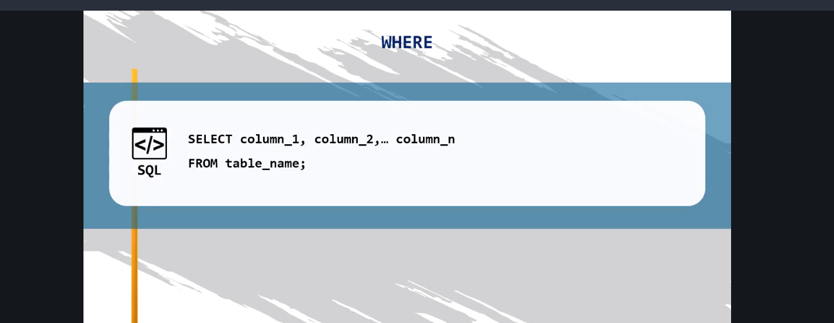

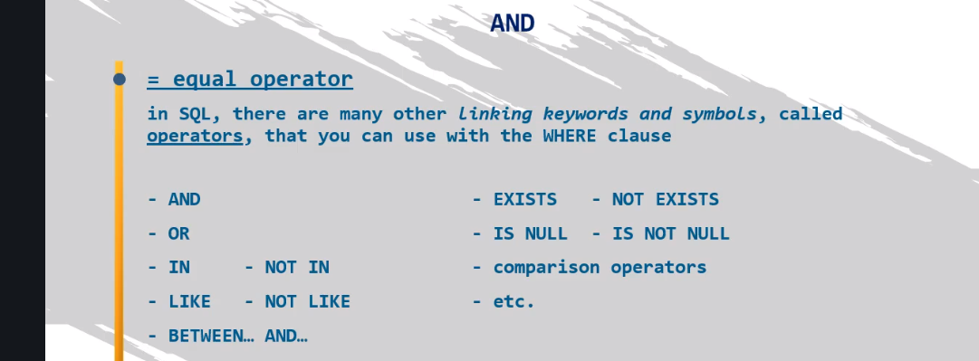

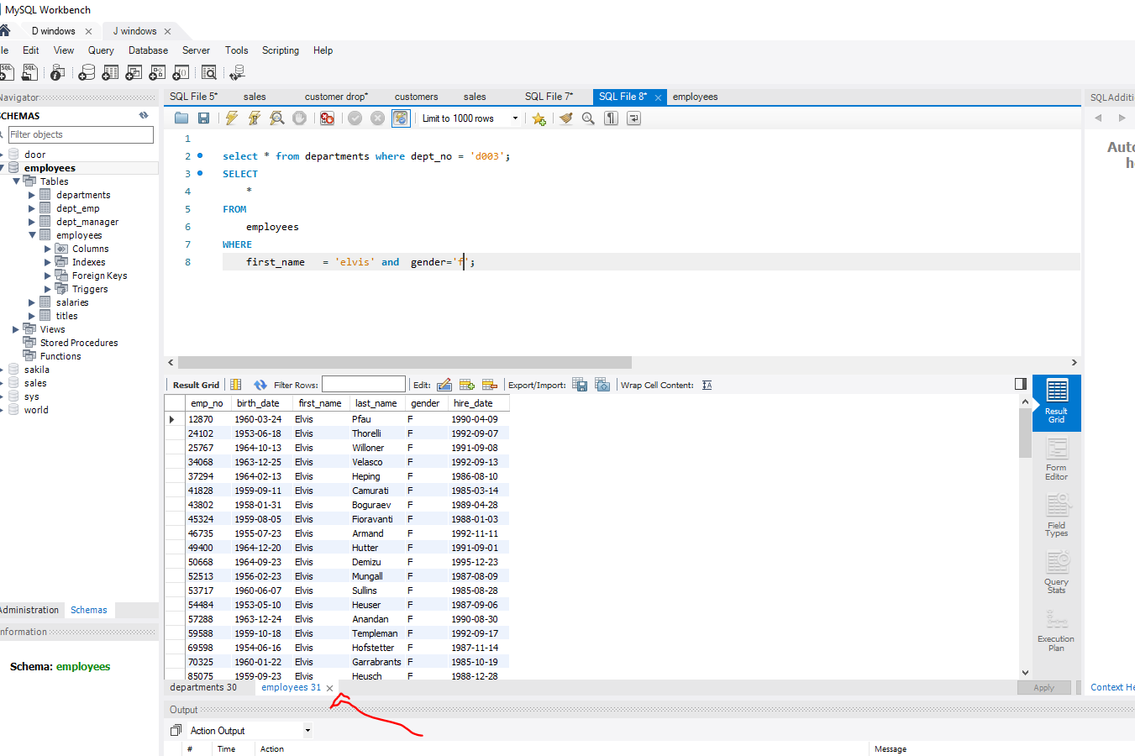

The result is actually counted at the bottom

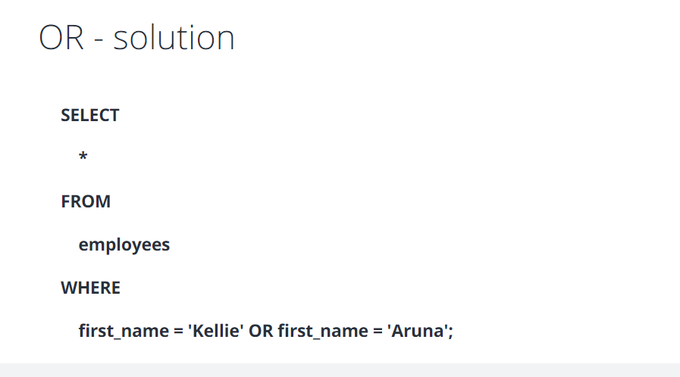

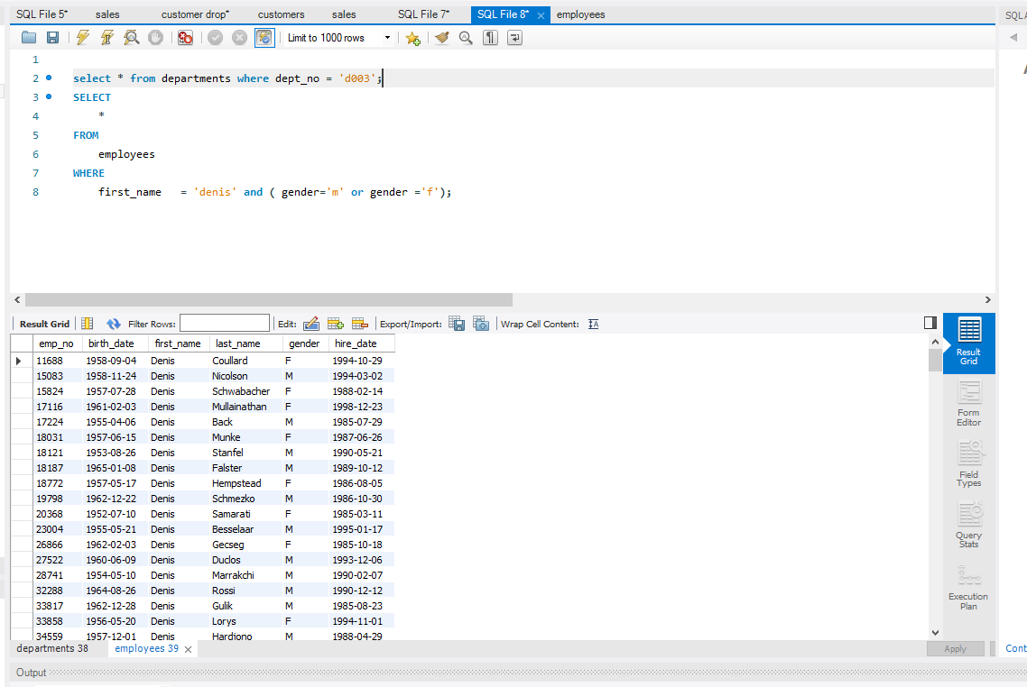

We used bracket here for Boolean operations

Now instead of typing so much condition to find three names like john or mark or josh we use the IN or if you do this and use not in, it will show everything except the not in

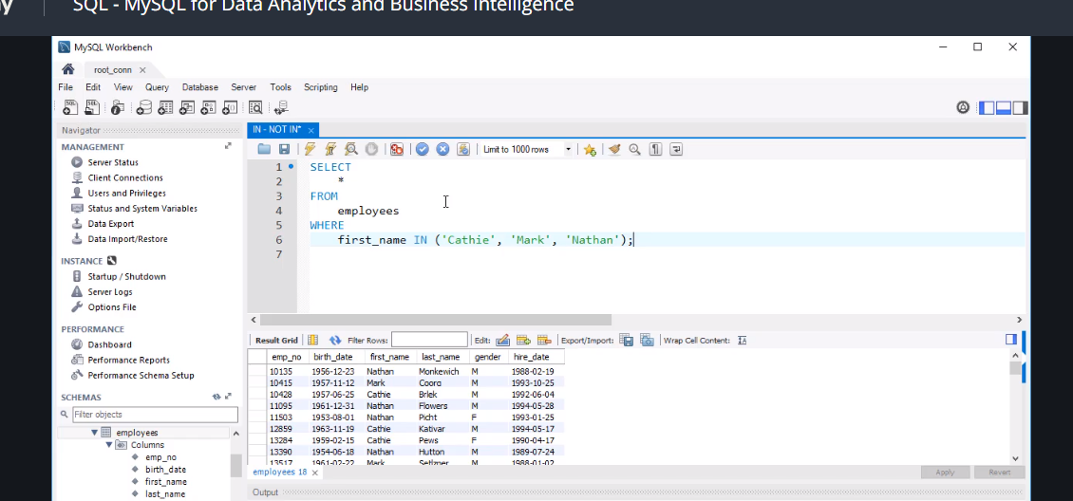

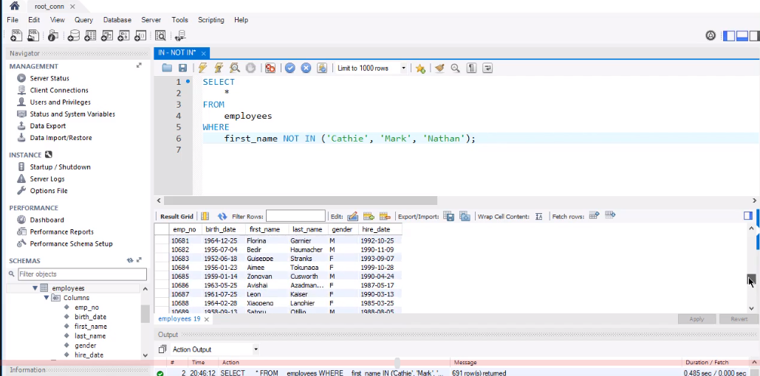

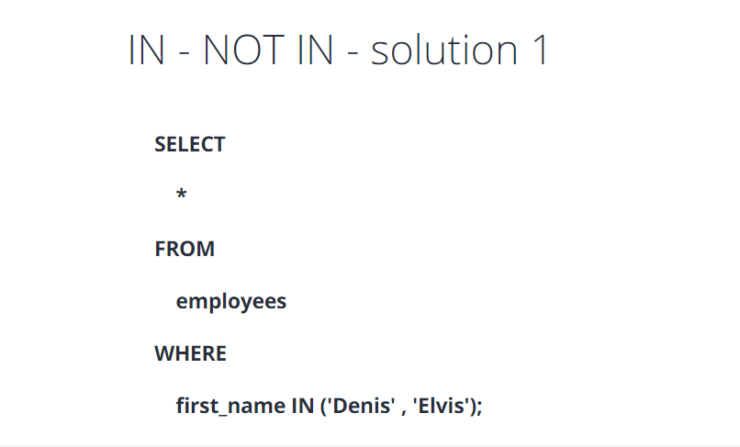

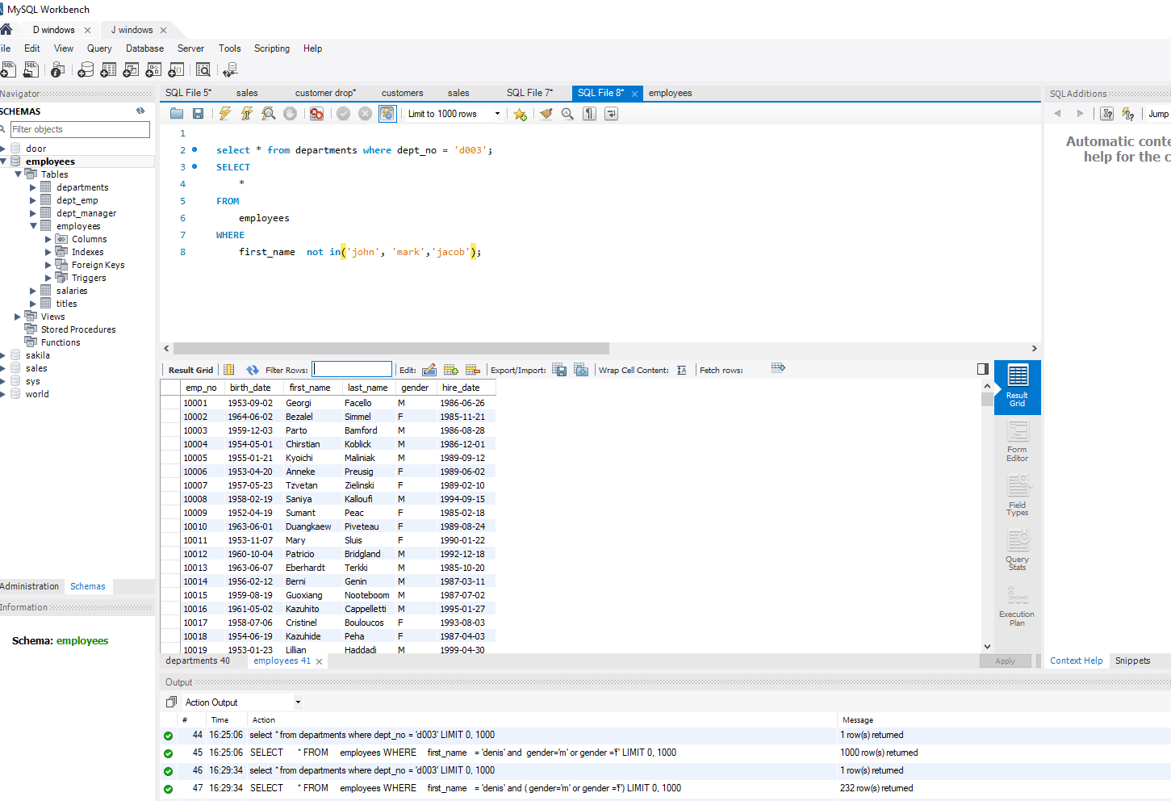

Now you can use pattern matching

So say you want every mar name

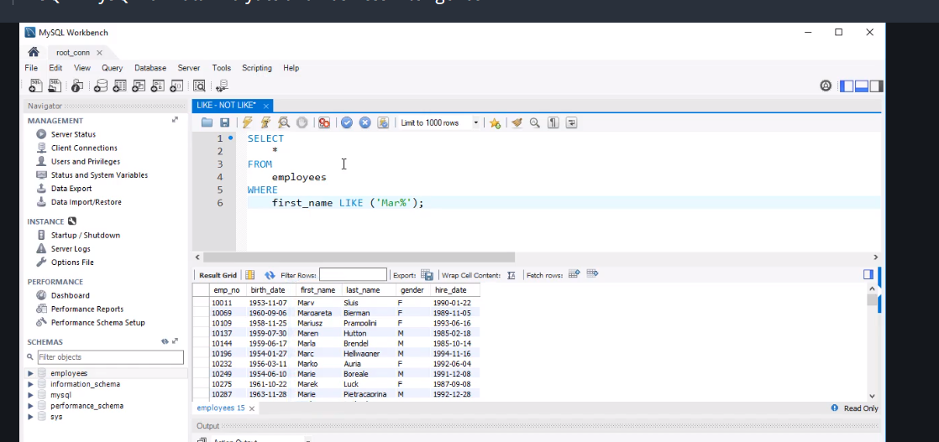

If you put % before the name it will show all names starting with mar and if ou put % at the end mar% the it show names with mar at the end but if you do %mar% then it will show names with mar in the middle

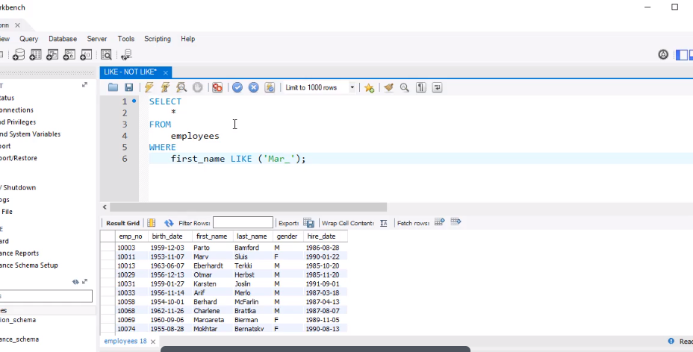

When _ is used mar_ means only show 4 words like mark

Working with the “employees” table, use the LIKE operator to select the data about all individuals, whose first name starts with “Mark”; specify that the name can be succeeded by any sequence of characters.

Retrieve a list with all employees who have been hired in the year 2000.

Retrieve a list with all employees whose employee number is written with 5 characters, and starts with “1000”.

**SELECT**

**\***

**FROM**

**employees**

**WHERE**

**first_name LIKE('Mark%');**

**SELECT**

**\***

**FROM**

**employees**

**WHERE**

**hire_date LIKE ('%2000%');**

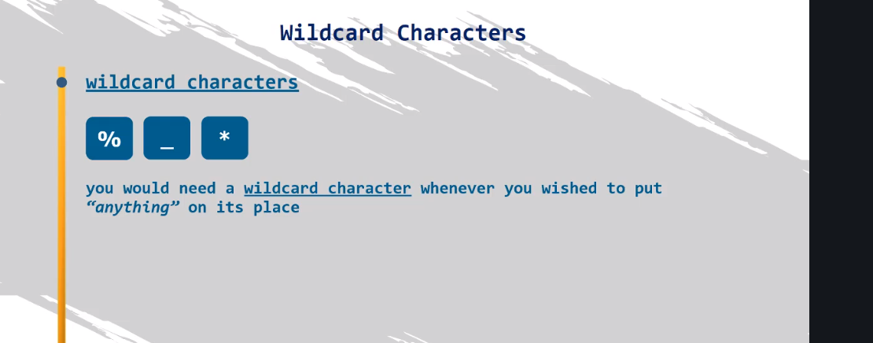

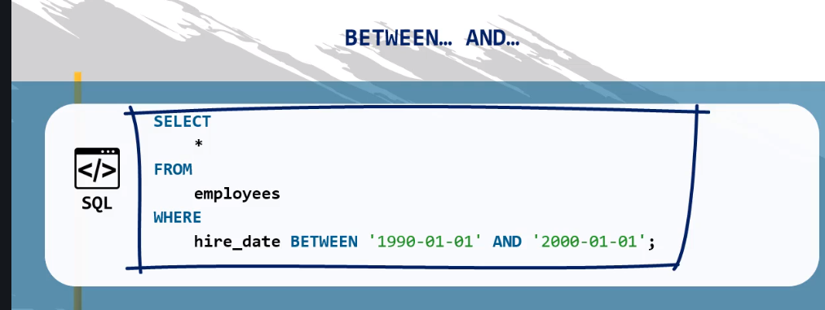

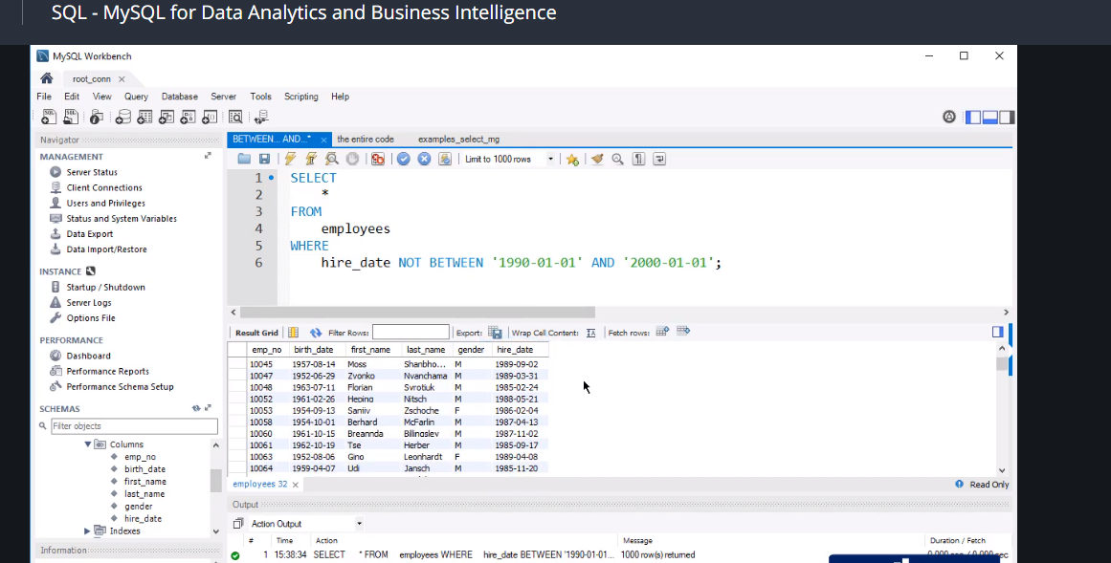

**SELECT**

**\***

**FROM**

**employees**

**WHERE**

**first_name not like 'jack%';**

**select * from salaries**

**where salary between '66000' and '70000';**

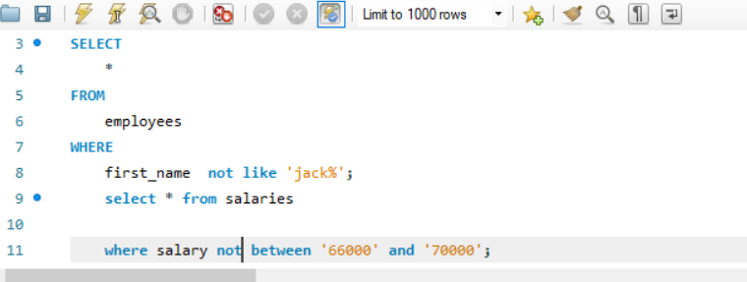

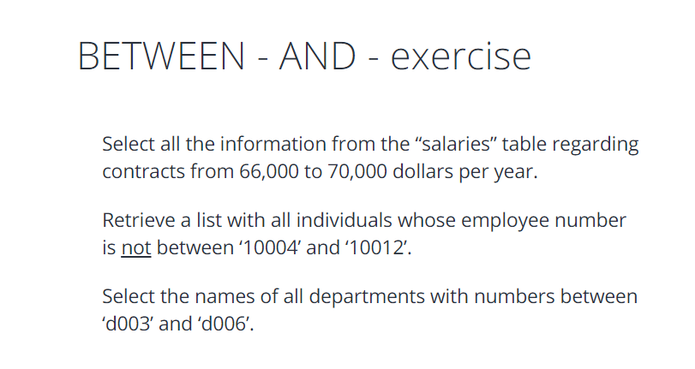

**SELECT**

**\***

**FROM**

**salaries;**

**SELECT**

**\***

**FROM**

**salaries**

**WHERE**

**salary BETWEEN 66000 AND 70000**

**;**

**SELECT**

**\***

**FROM**

**employees**

**WHERE**

**emp_no NOT BETWEEN '10004' AND '10012'**

**;**

**SELECT**

**dept_name**

**FROM**

**departments**

**WHERE**

**dept_no BETWEEN 'd003' AND 'd006';**

**using null operator**

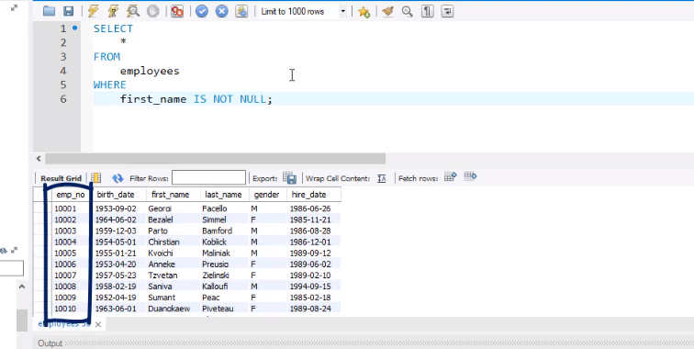

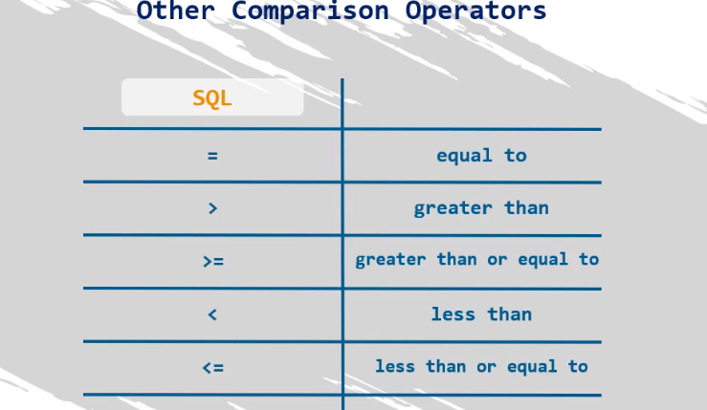

An example to see people who are on the list and their name is not mark

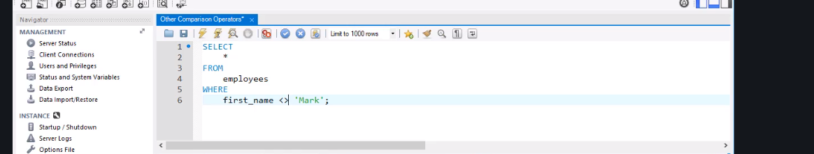

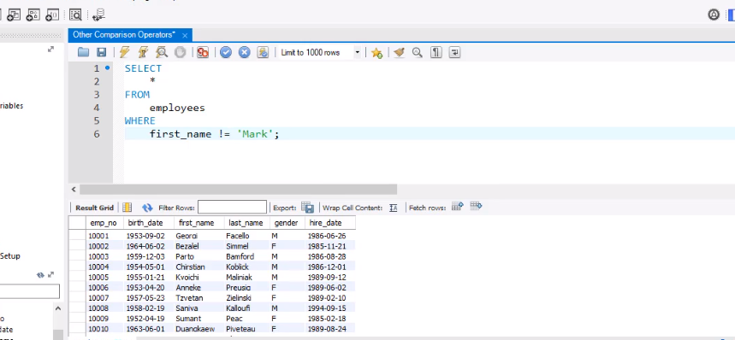

So exclamation mark and an equal sign s equal to the same as the equality sign above same outcome

Now if employer wants employee from 2001 jan

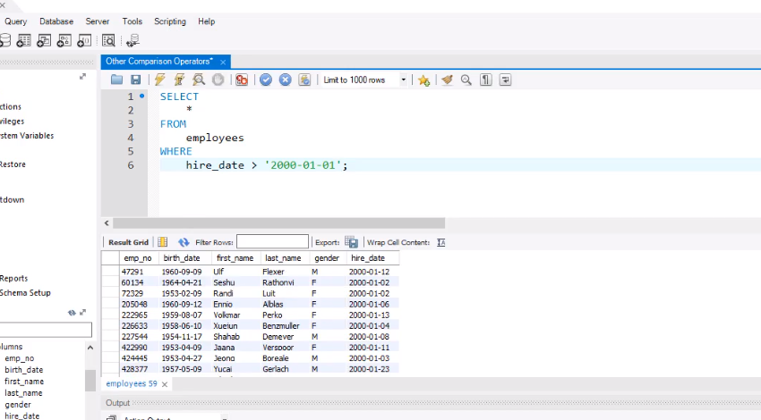

If to include jan 2001

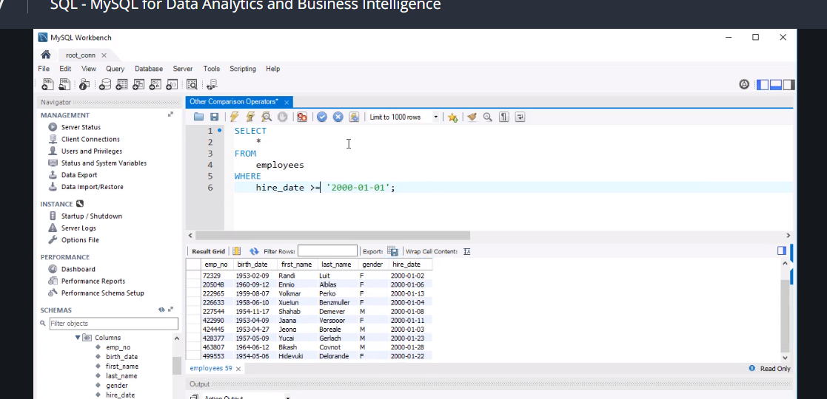

Now lets check if anybody was hired before the 1st of February 1985

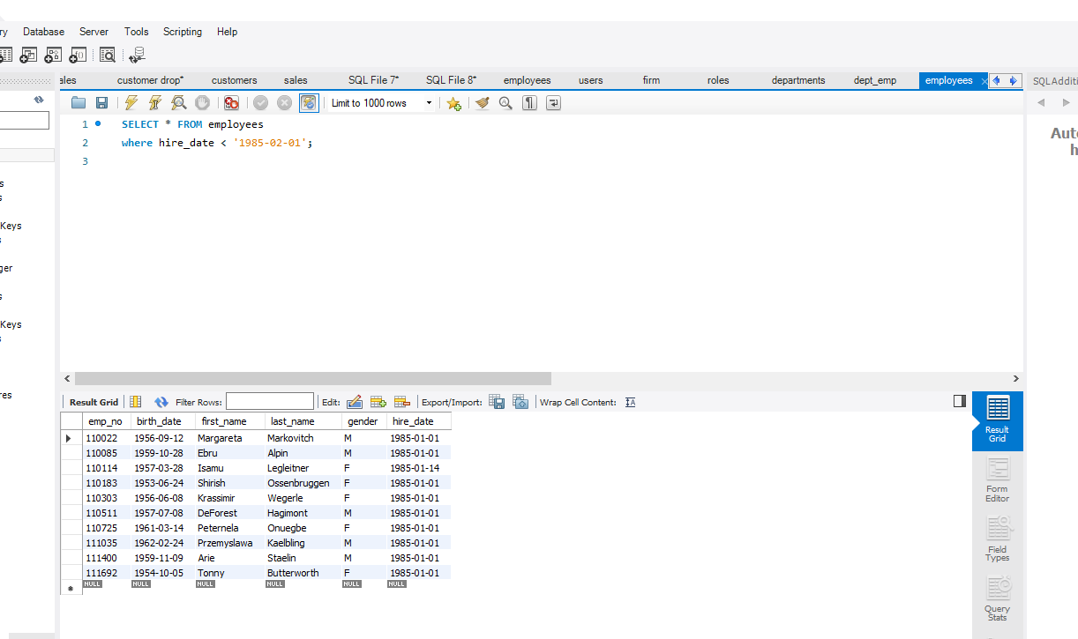

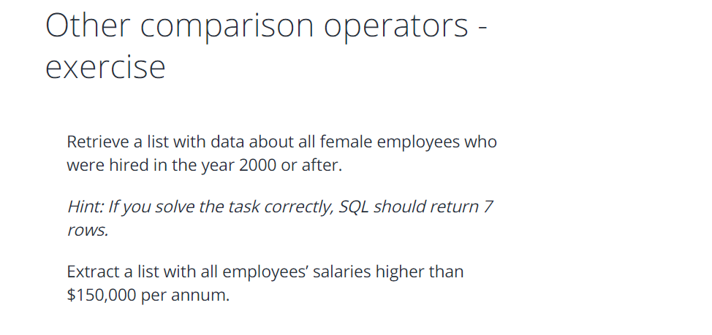

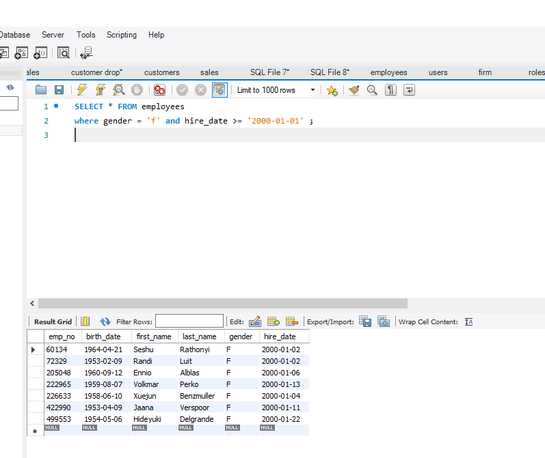

Solved 2000 females

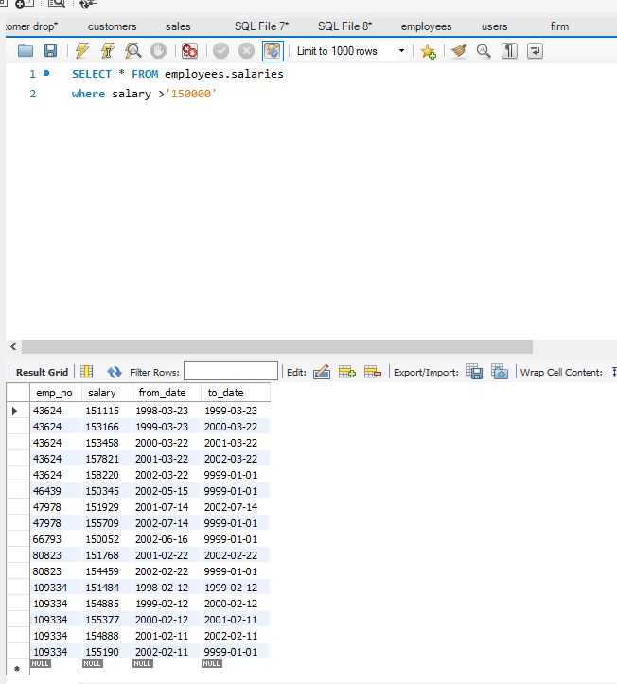

Now a situation obviously you have so many males and female but you just want to know if its male female bisexual and transgender so you use select distinct instead so no duplicates

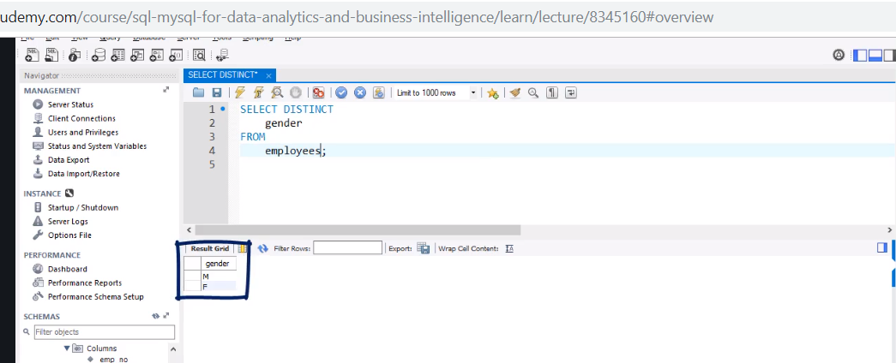

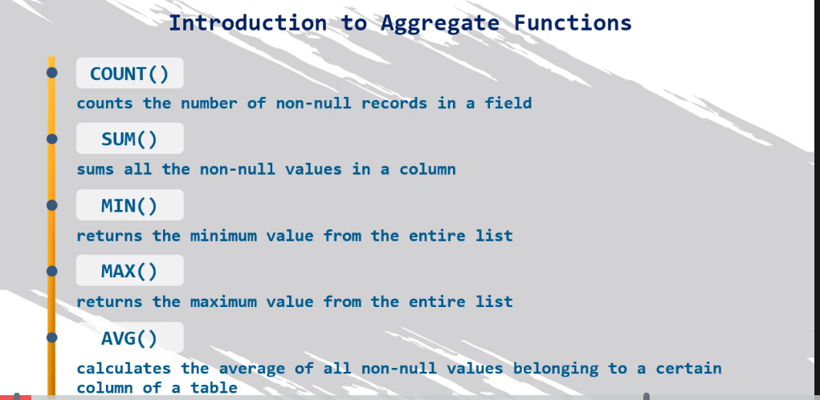

How many employees are registered in our database

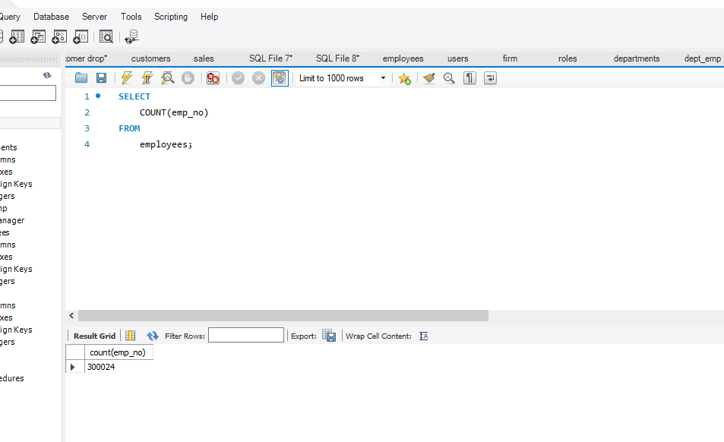

To count distinct we use so 1762 share a precise name

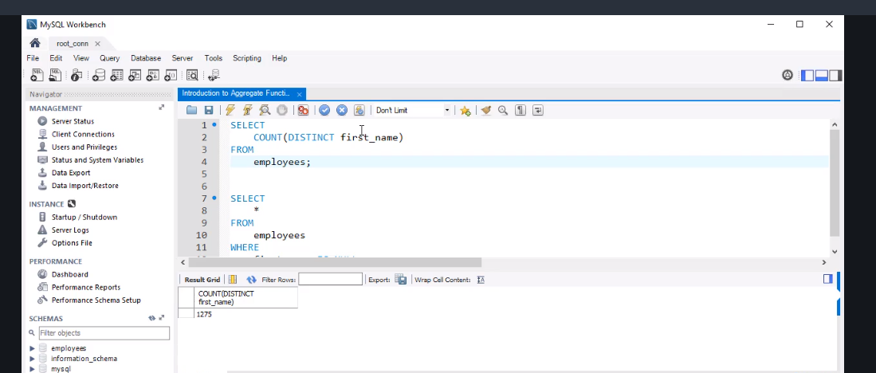

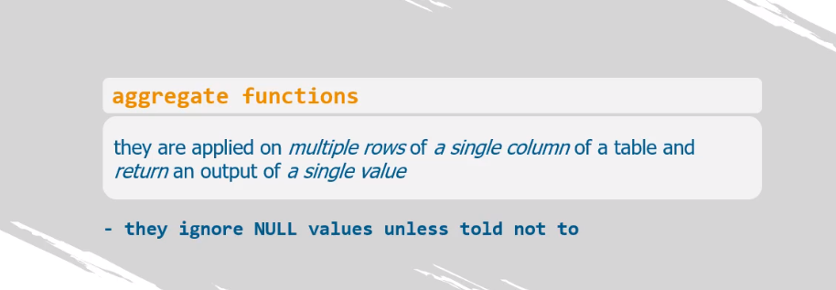

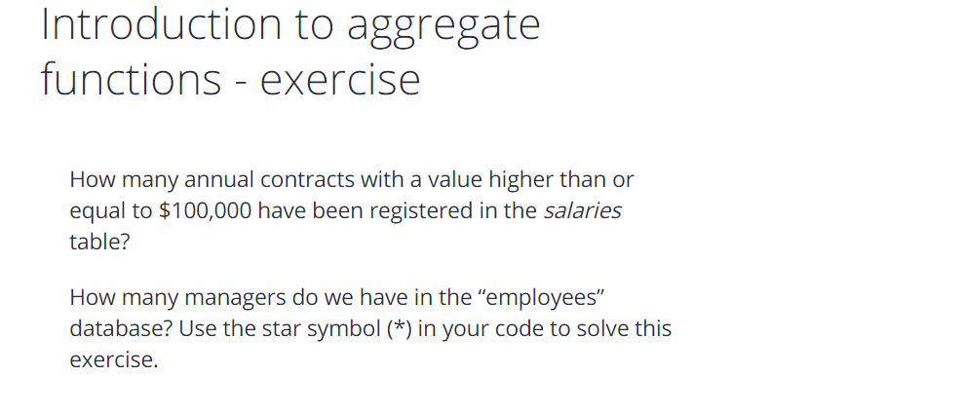

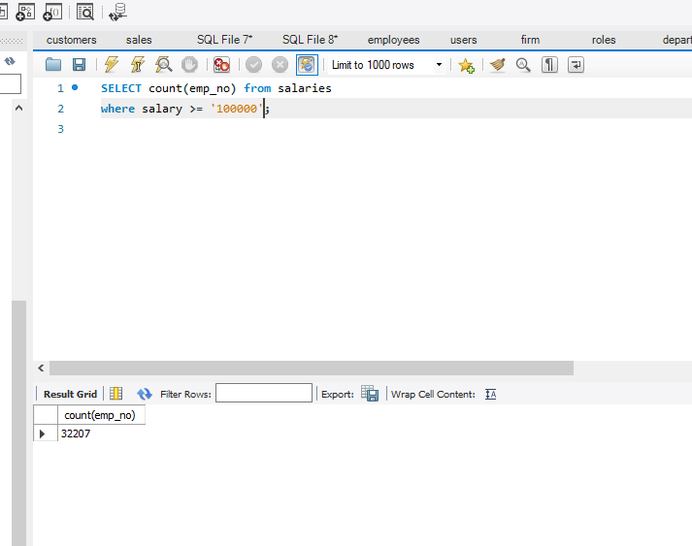

Now using order by….. this is used to arrange a column

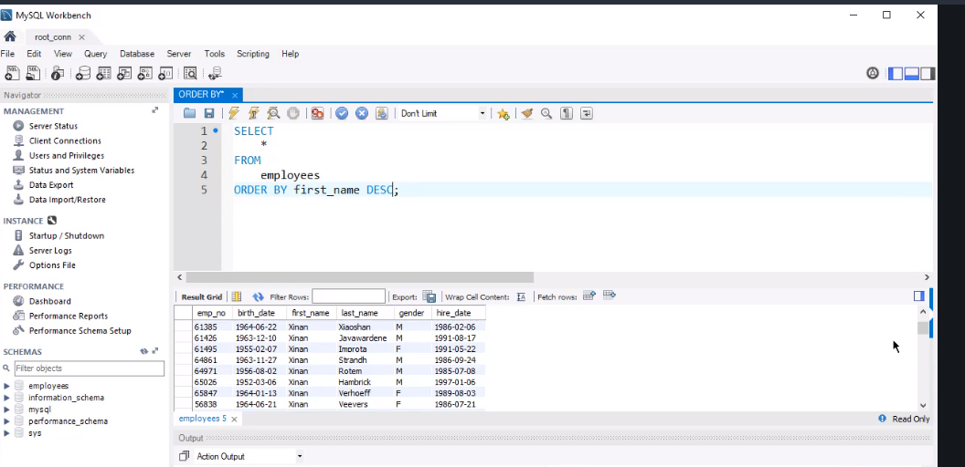

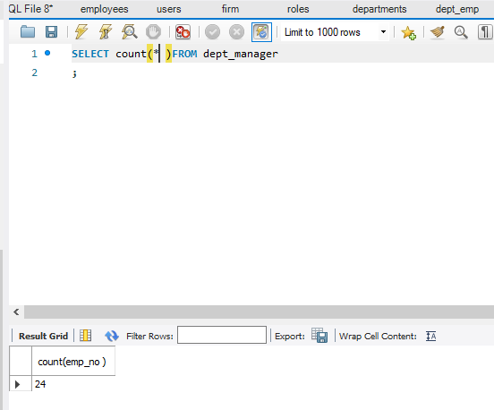

But their answer was

**SELECT**

**COUNT(*)**

**FROM**

**salaries**

**WHERE**

**salary >= 100000;**

**SELECT**

**COUNT(*)**

**FROM**

**dept_manager;**

you could use

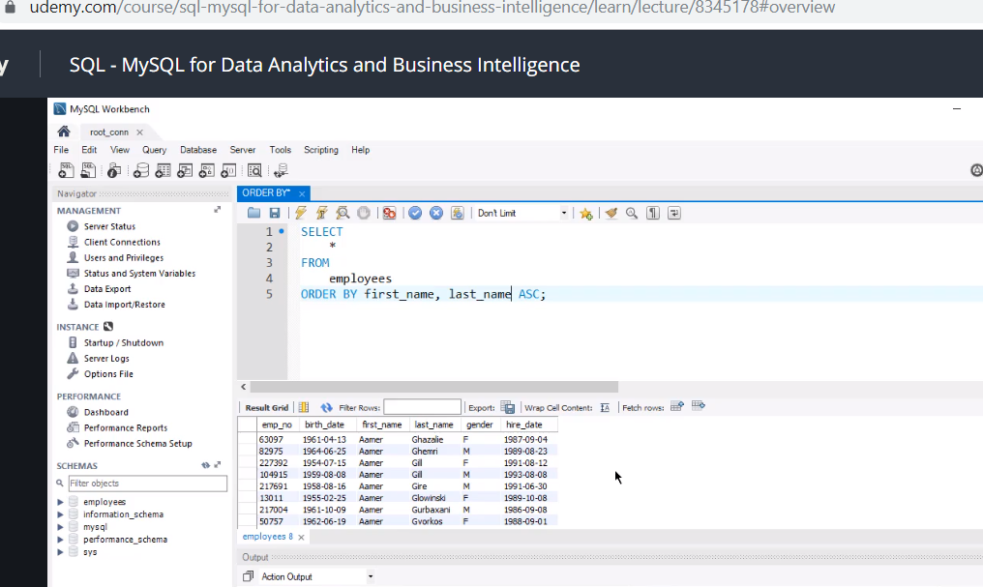

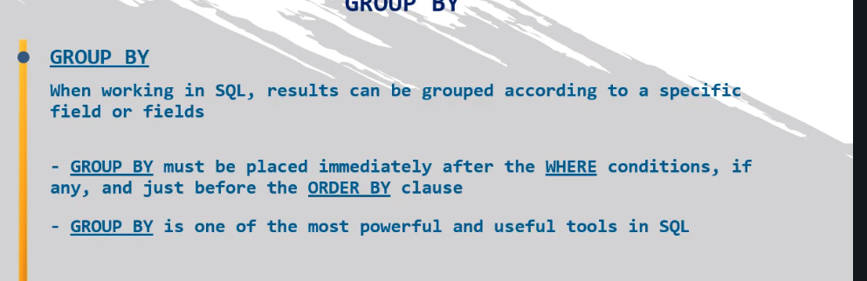

Very important

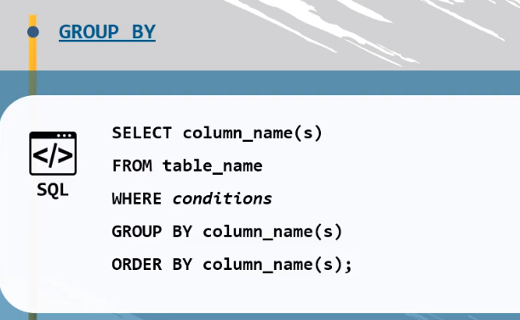

Its usually by order by

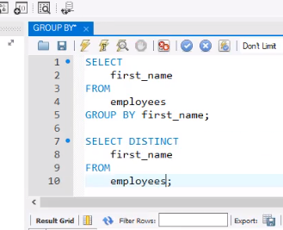

It’s the same like using distinct . below we have grouped the first name but also by adding first name at the beginning we can actually see the names

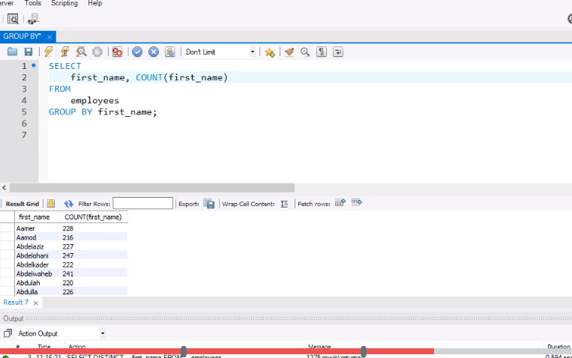

Then sort it with order by

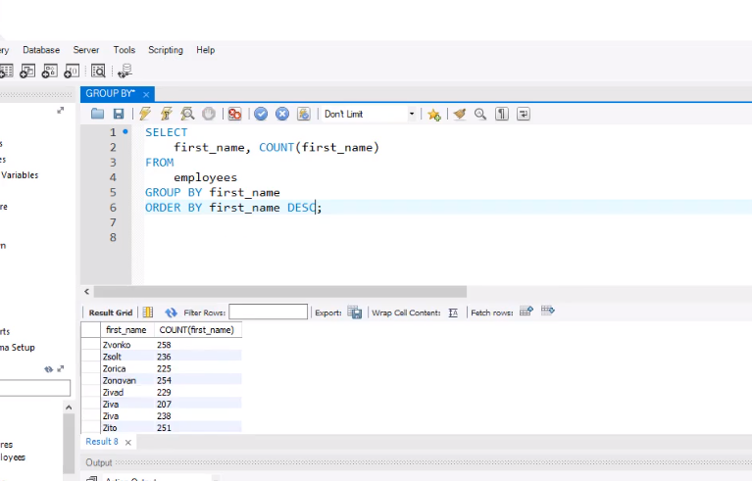

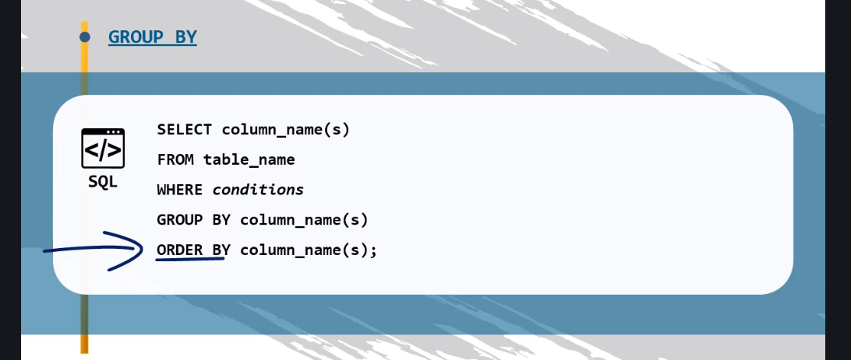

Learn this order.

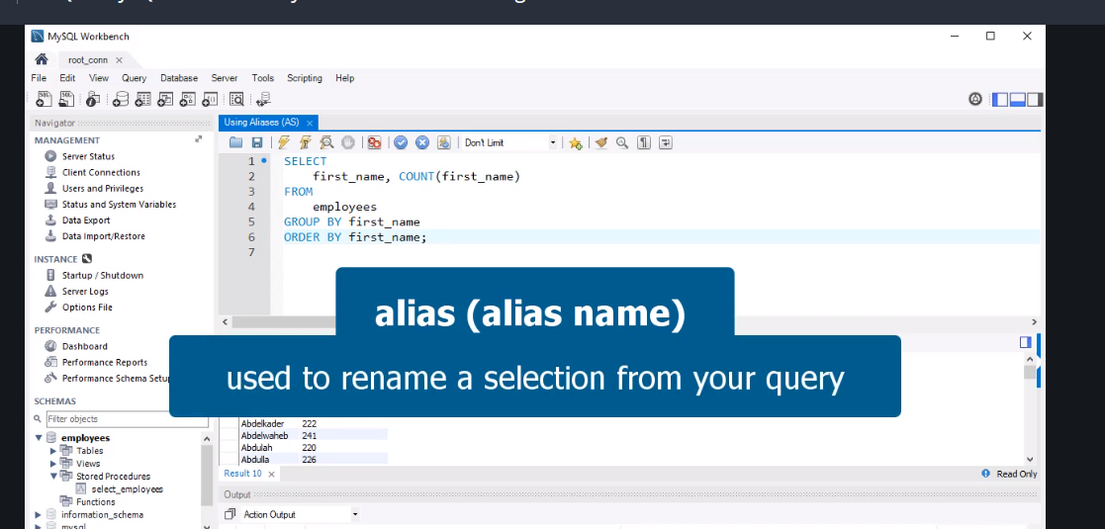

Use AS

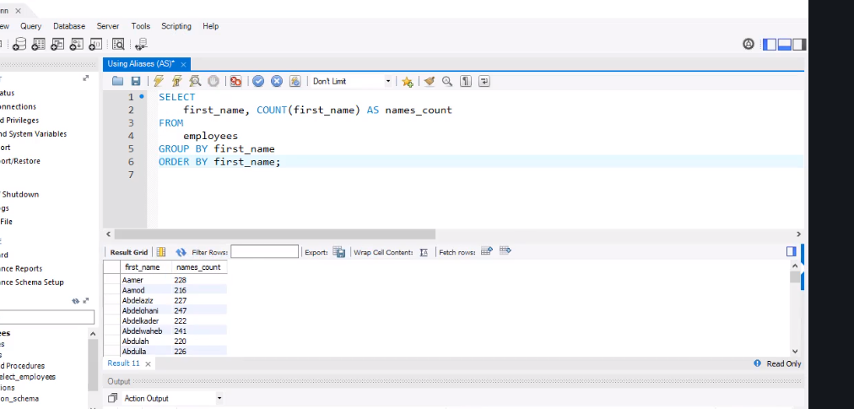

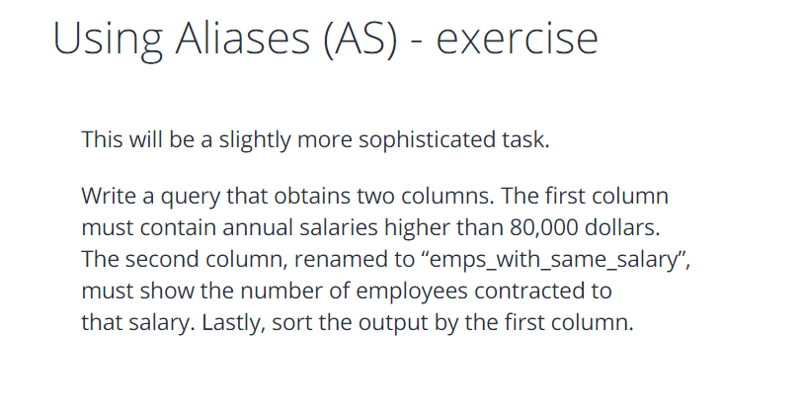

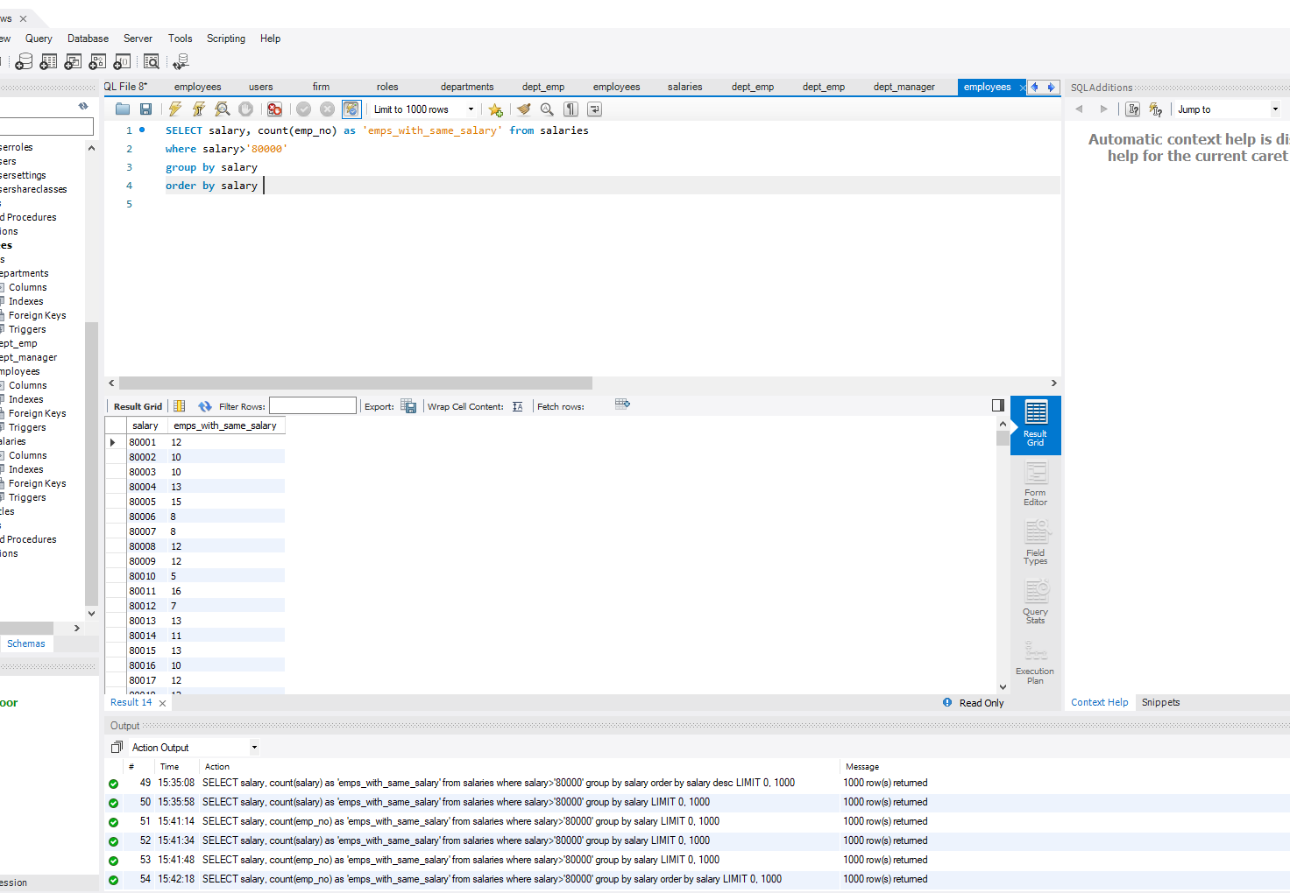

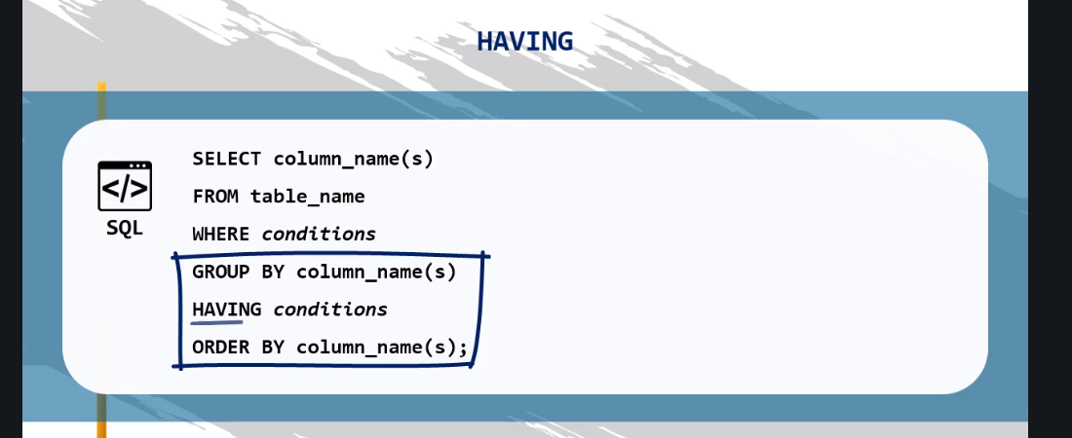

You can use having or where same answer. Only difference is where doesn’t handle aggregate functions

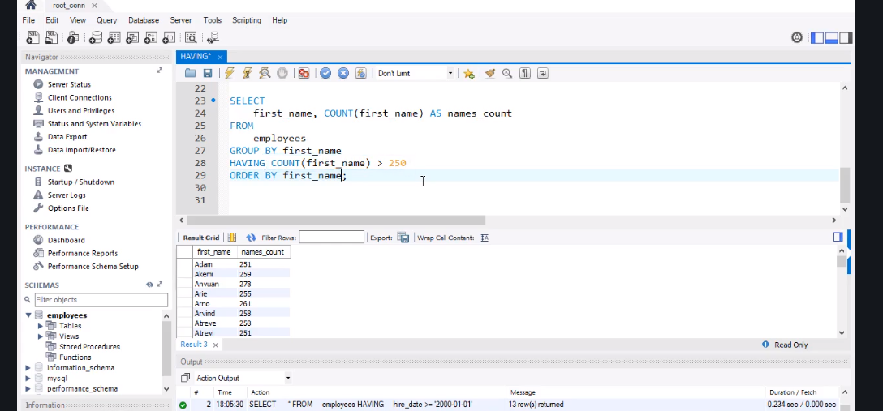

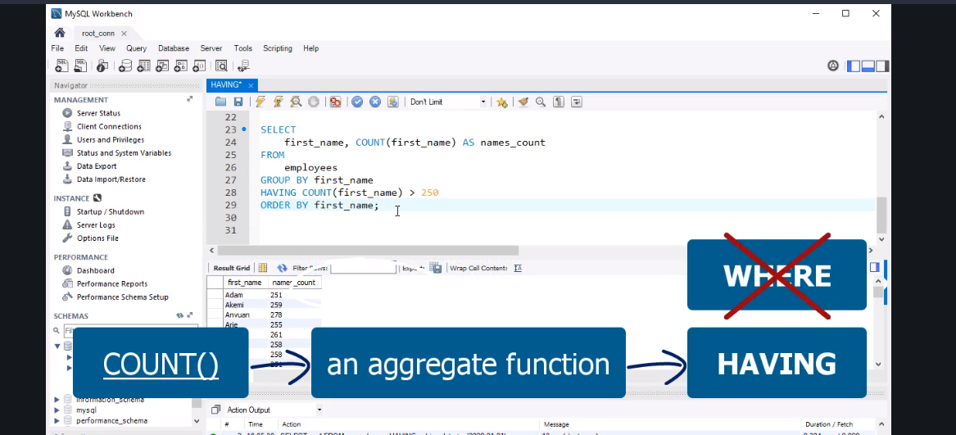

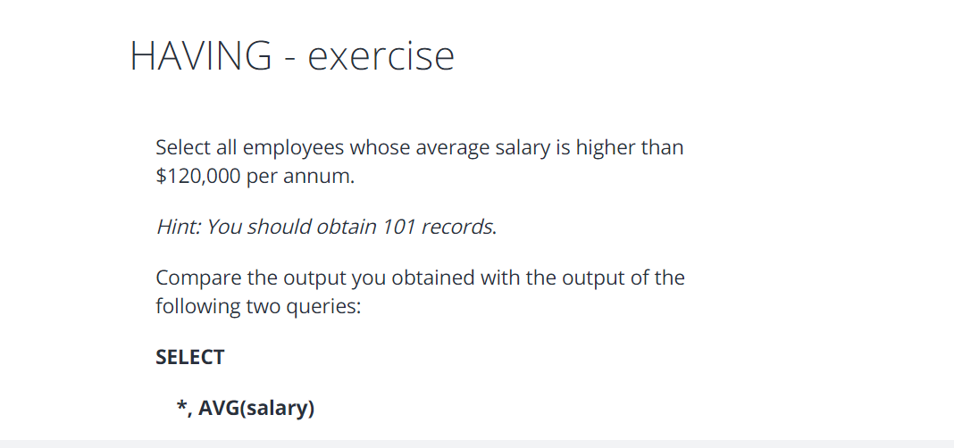

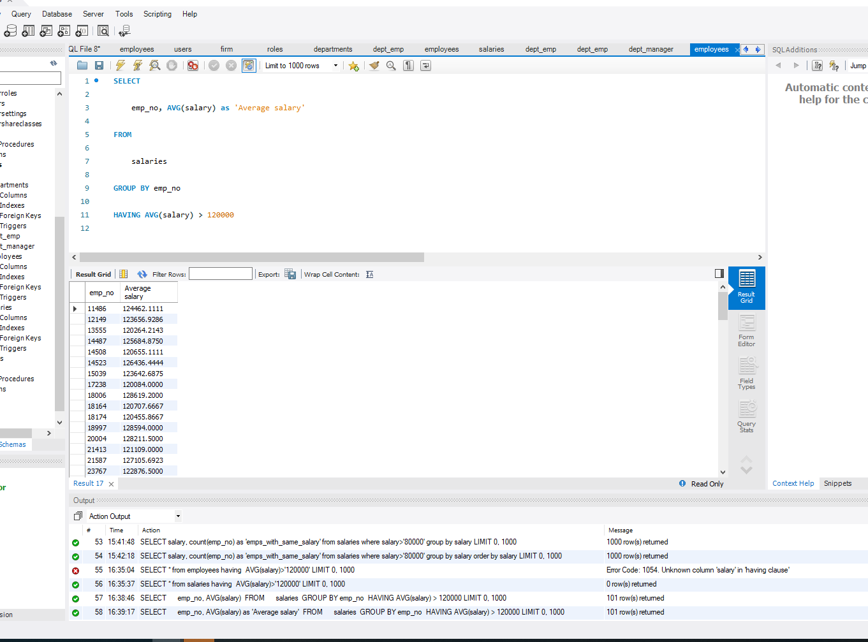

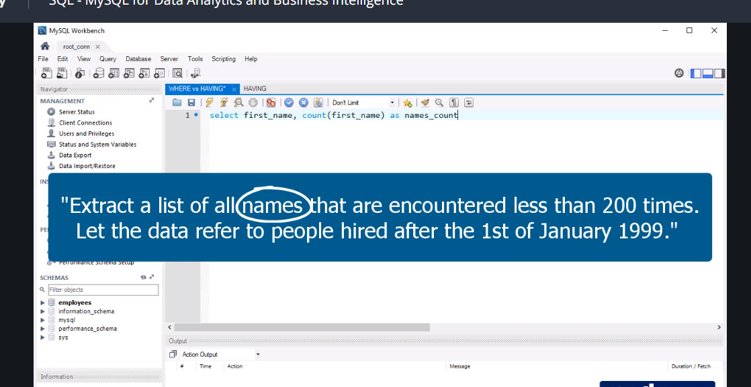

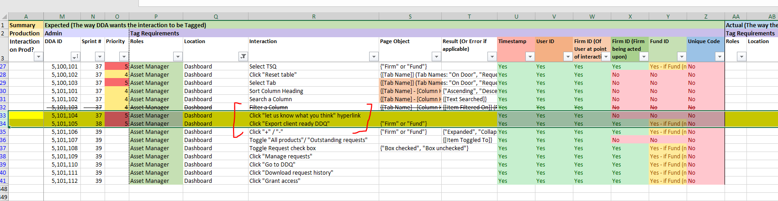

Excel spread sheet

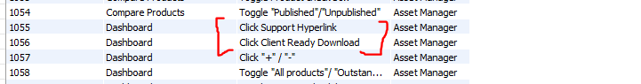

Database

joshuaidetest+fiqq@gmail.com

zjzT7m5&d%MDG#+c

question

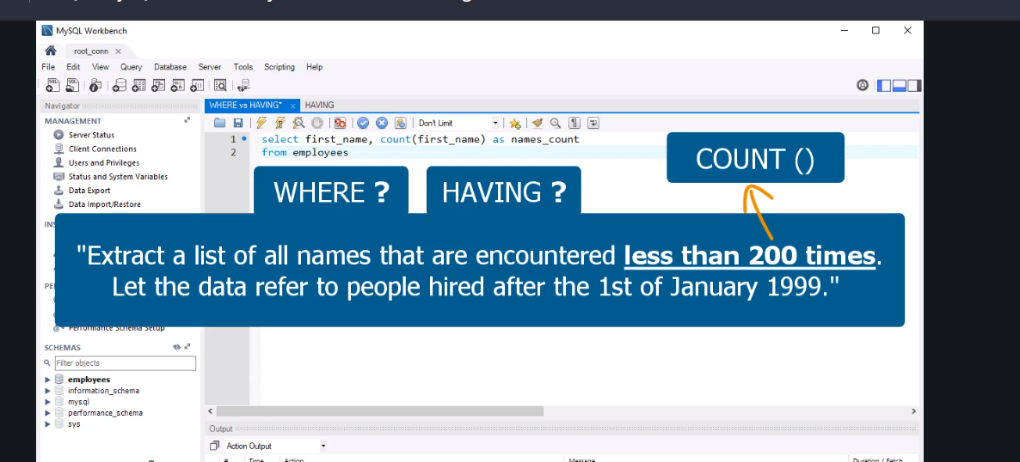

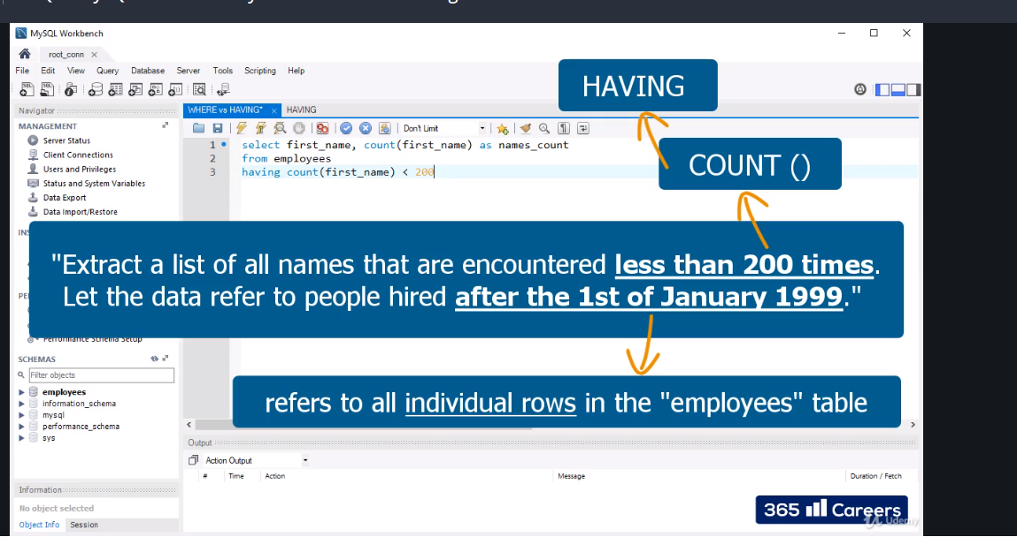

Or you can use where

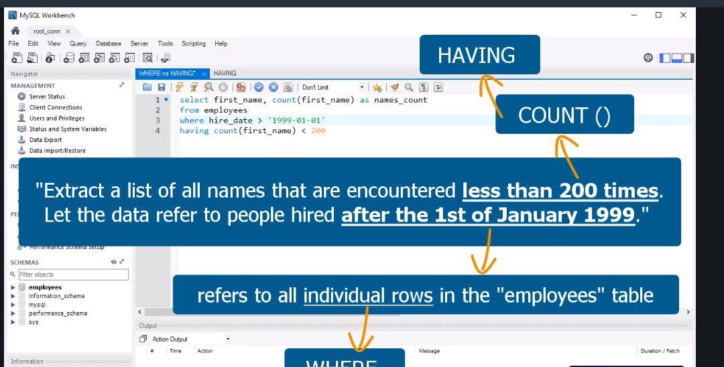

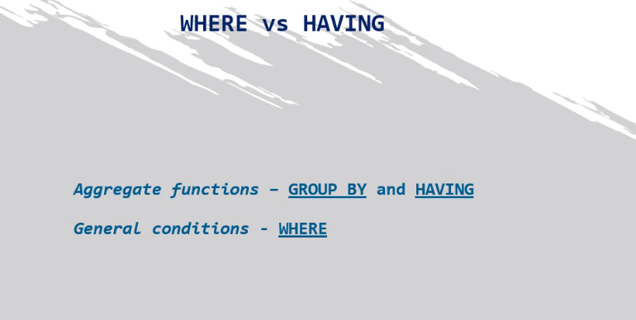

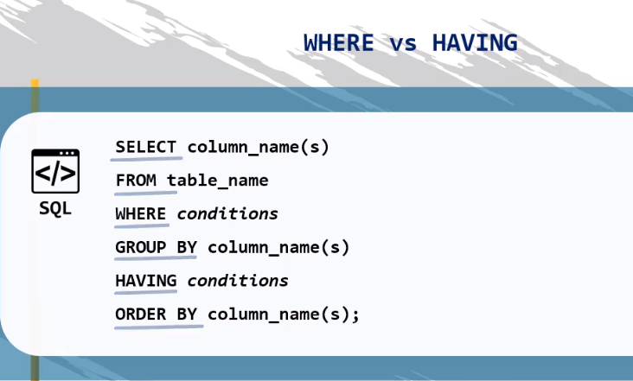

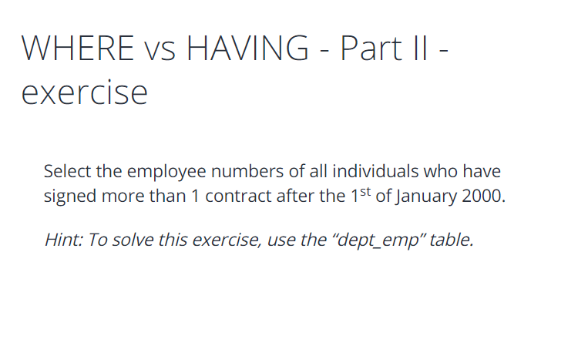

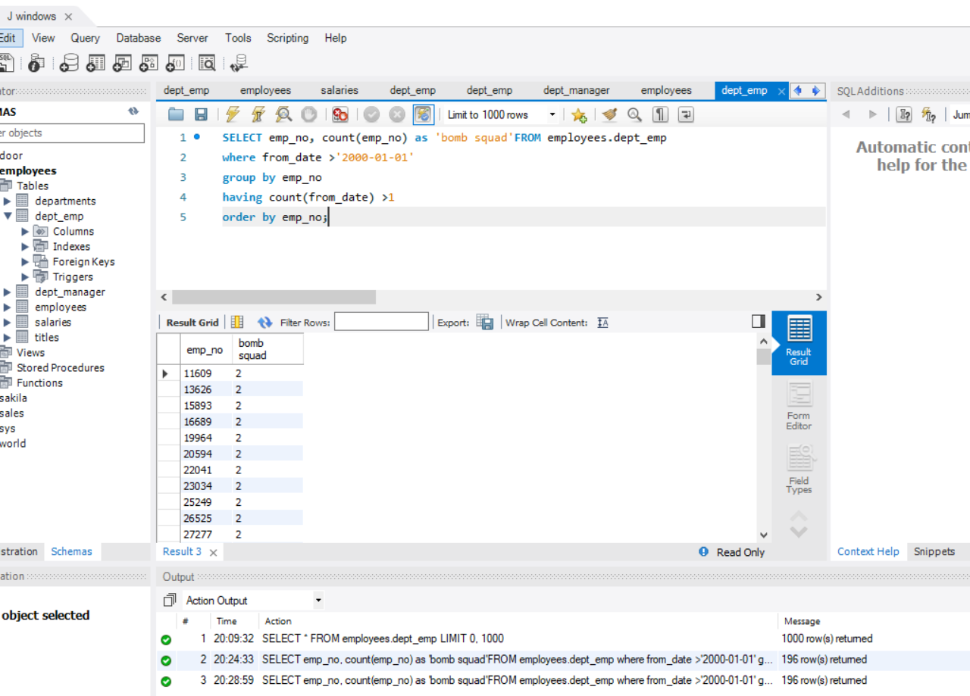

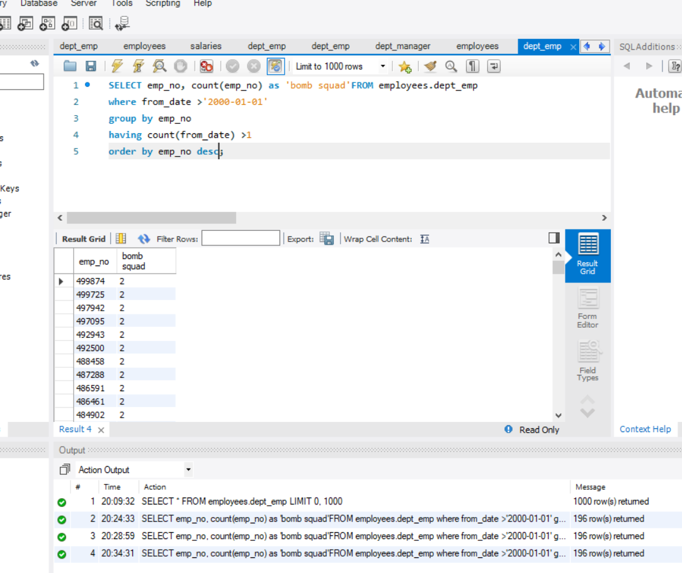

Now limit

To change limit

Go edit -preference-sql execution- change limit to anything or by coding

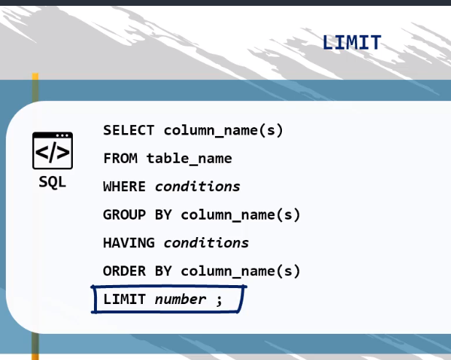

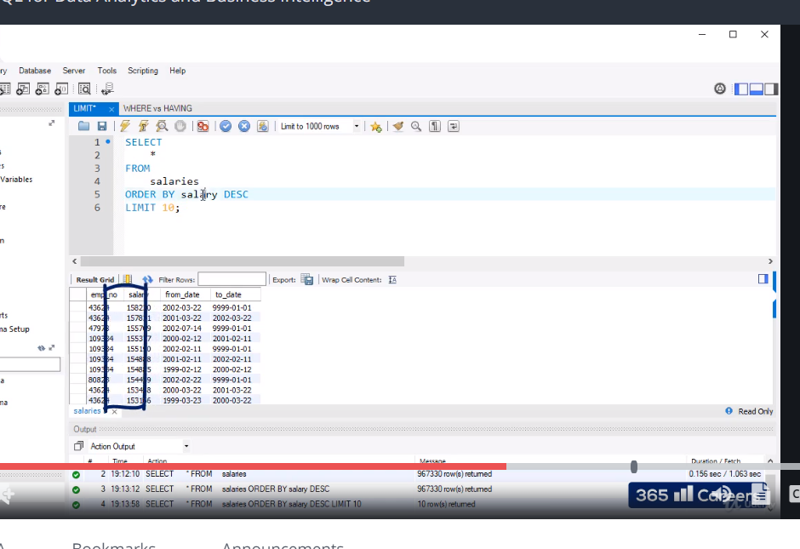

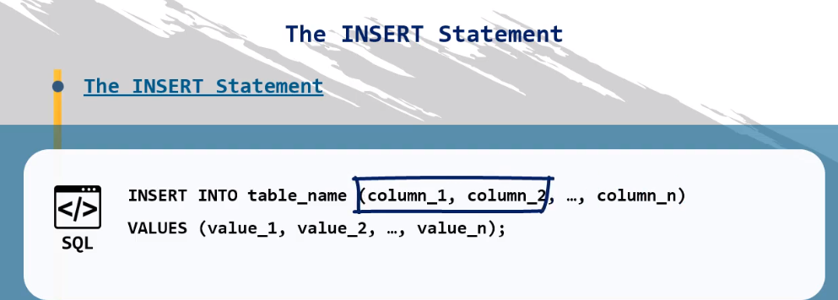

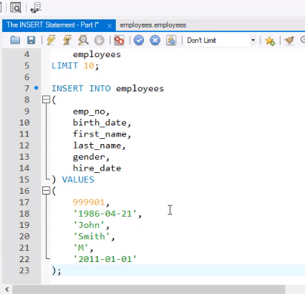

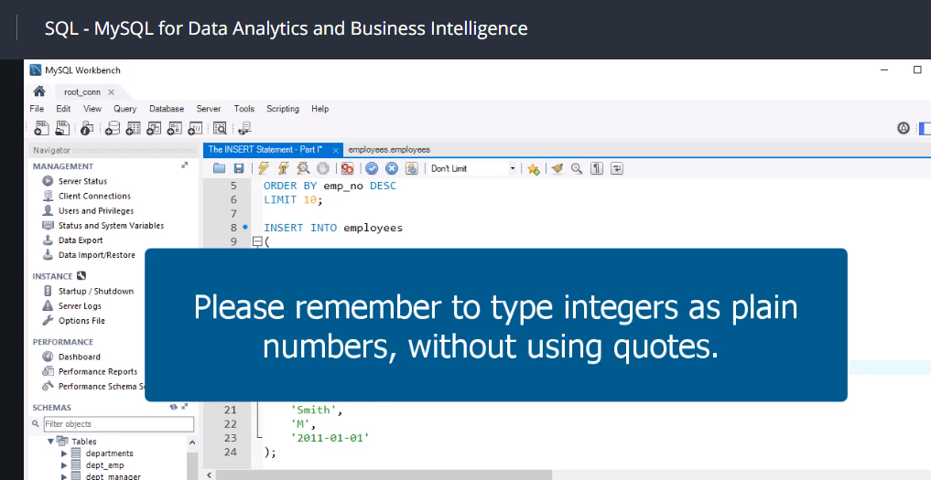

The INSERT statement - exercise 1

Select ten records from the “titles” table to get a better idea about its content.

Then, in the same table, insert information about employee number 999903. State that he/she is a “Senior Engineer”, who has started working in this position on October 1st, 1997.

At the end, sort the records from the “titles” table in descending order to check if you have successfully inserted the new record.

*Hint: To solve this exercise, you’ll need to insert data in only 3 columns!*

*Don’t forget, we assume that, apart from the code related to the exercises, you always execute all code provided in the lectures. This is particularly important for this exercise. If you have not run the code from the previous lecture, called ‘The INSERT Statement – Part II’, where you have to insert information about employee 999903, you might have trouble solving this exercise!*

*Code:*

**INSERT INTO employees**

**VALUES**

**(**

**999903,**

**'1977-09-14',**

**'Johnathan',**

**'Creek',**

**'M',**

**'1999-01-01'**

**);**

The INSERT statement - solution 1

**SELECT**

**\***

**FROM**

**titles**

**LIMIT 10;**

**insert into titles**

**(**

**emp_no,**

**title,**

**from_date**

**)**

**values**

**(**

**999903,**

**'Senior Engineer',**

**'1997-10-01'**

**);**

**SELECT**

**\***

**FROM**

**titles**

**ORDER BY emp_no DESC;**

The INSERT statement - exercise 2

Insert information about the individual with employee number 999903 into the “dept_emp” table. He/She is working for department number 5, and has started work on  October 1st, 1997; her/his contract is for an indefinite period of time.

*Hint: Use the date ‘9999-01-01’ to designate the contract is for an indefinite period.*

**SELECT**

**\***

**FROM**

**dept_emp**

**ORDER BY emp_no DESC**

**LIMIT 10;**

**insert into dept_emp**

**(**

**emp_no,**

**dept_no,**

**from_date,**

**to_date**

**)**

**values**

**(**

**999903,**

**'d005',**

**'1997-10-01',**

**'9999-01-01'**

**);**

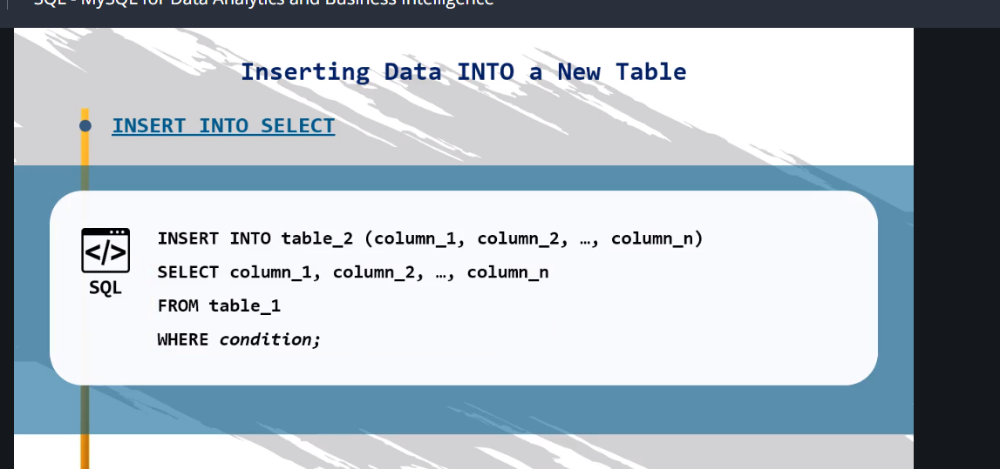

Inserting Data INTO a New Table - exercise

Create a new department called “Business Analysis”. Register it under number ‘d010’.

*Hint: To solve this exercise, use the “departments” table.*

Inserting Data INTO a New Table - solution

**INSERT INTO departments VALUES ('d010', 'Business Analysis');**

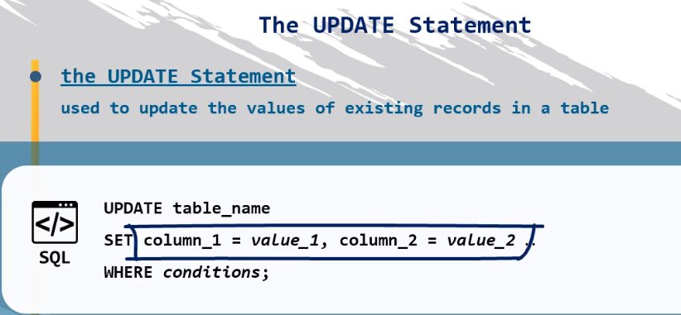

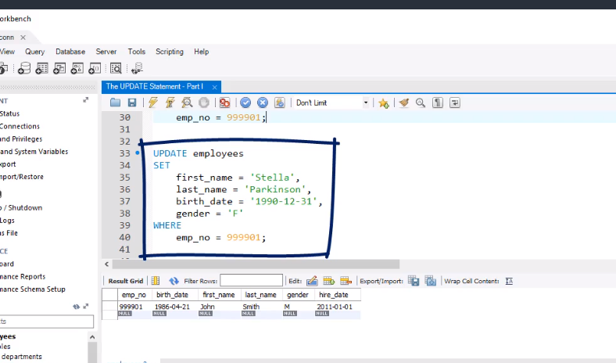

The UPDATE Statement – Part II - exercise

Change the “Business Analysis” department name to “Data Analysis”.

*Hint: To solve this exercise, use the “departments” table.*

The UPDATE Statement – Part II - solution

**UPDATE departments**

**SET**

**dept_name = 'Data Analysis'**

**WHERE**

**dept_no = 'd010';**

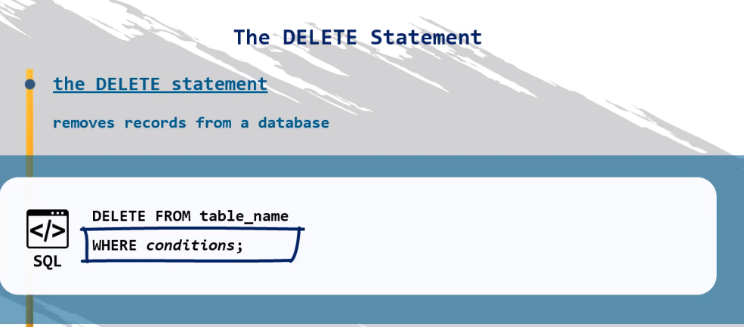

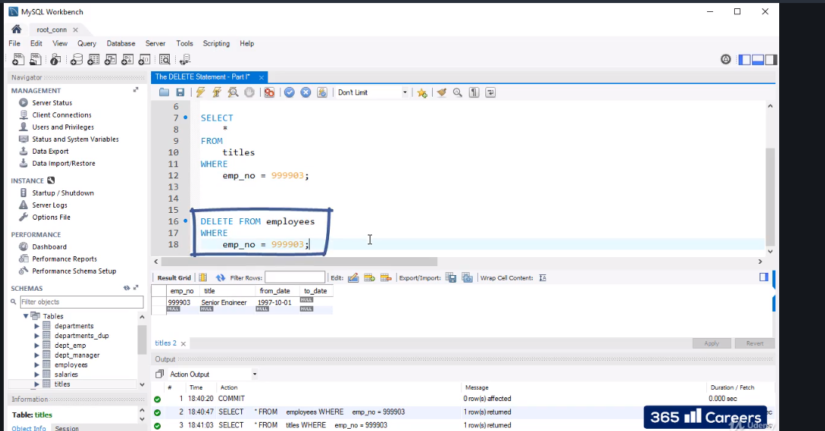

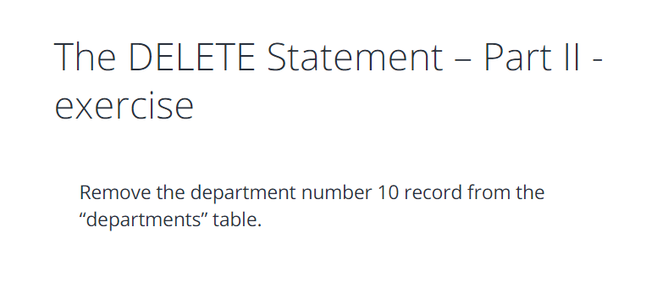

The DELETE Statement – Part II - solution

**DELETE FROM departments**

**WHERE**

**dept_no = 'd010';**

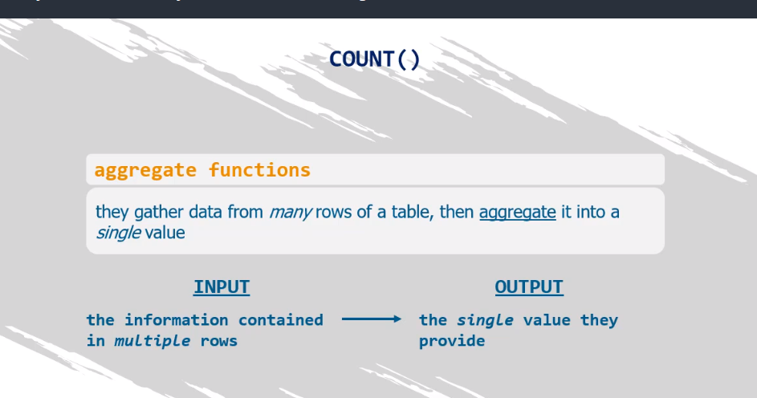

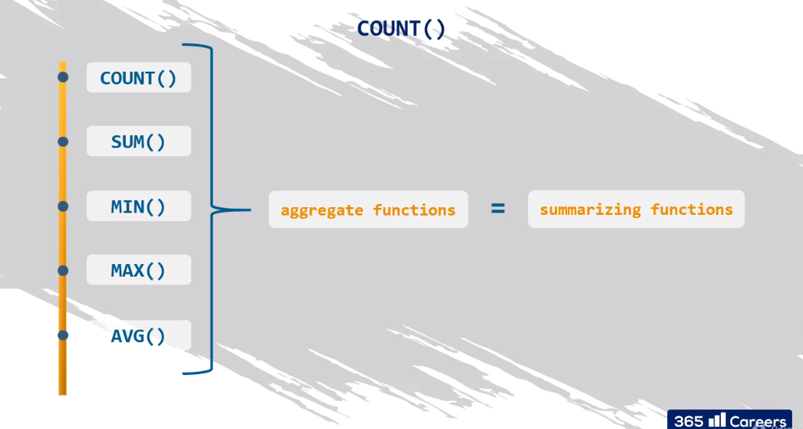

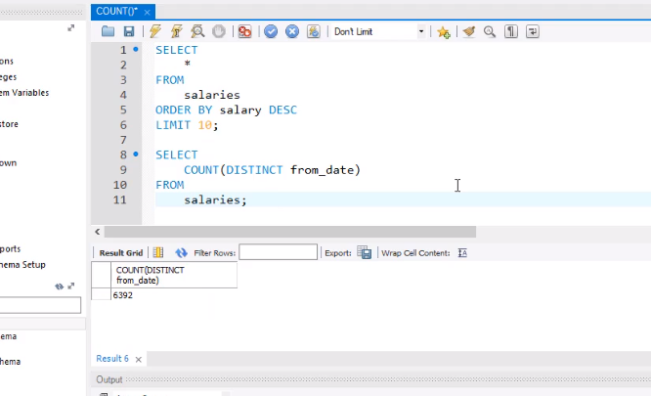

How many departments are there in the “employees” database? Use the ‘dept_emp’ table to answer the question.

COUNT() - solution

**SELECT**

**COUNT(DISTINCT dept_no)**

**FROM**

**dept_emp;**

now using sum aggregate function

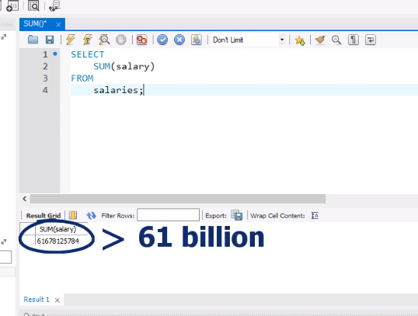

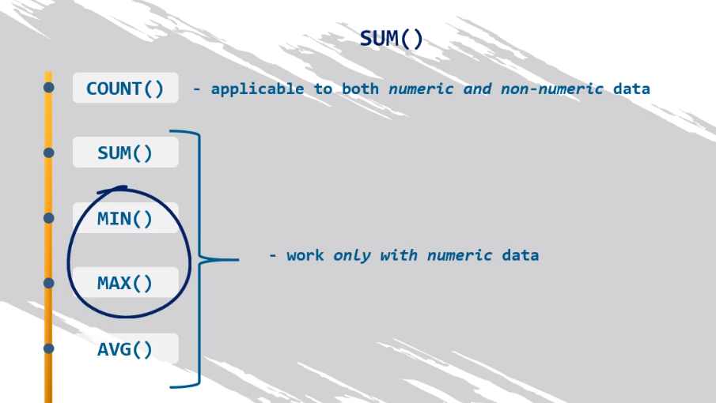

SUM() - exercise

What is the total amount of money spent on salaries for all contracts starting after the 1st of January 1997?

**SELECT**

**SUM(salary)**

**FROM**

**salaries**

**WHERE**

**from_date > '1997-01-01';**

now using maximum

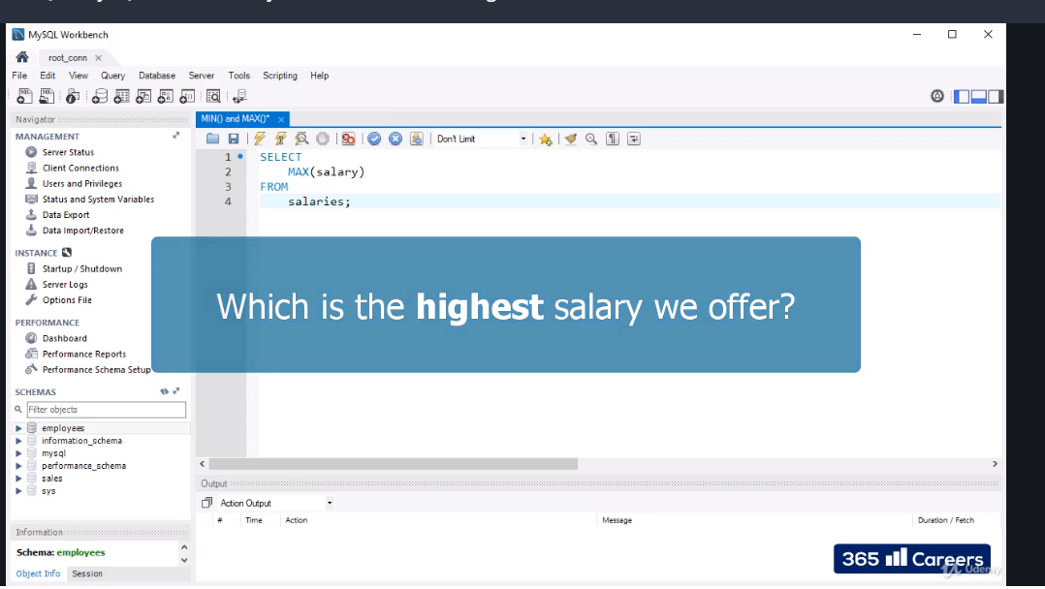

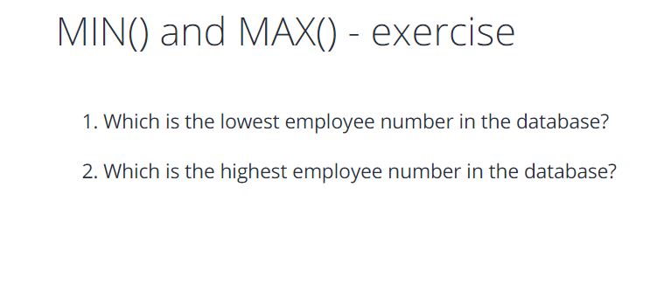

MIN() and MAX() - solution

**#1**

**SELECT**

**MIN(emp_no)**

**FROM**

**employees;**

**#2**

**SELECT**

**MAX(emp_no)**

**FROM**

**employees;**

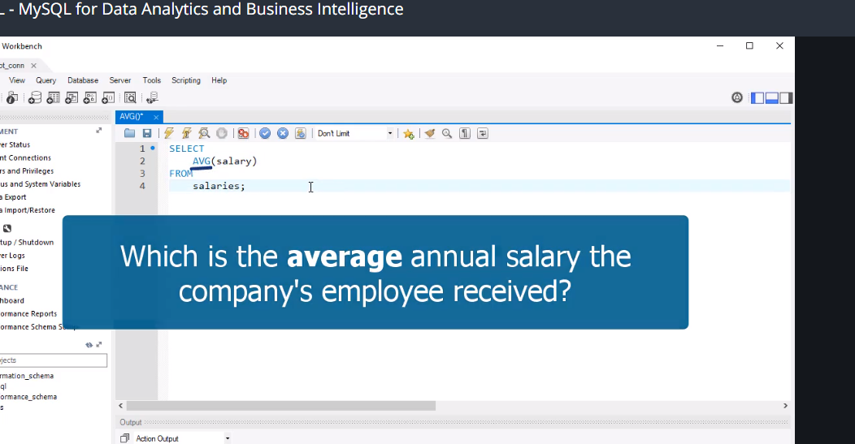

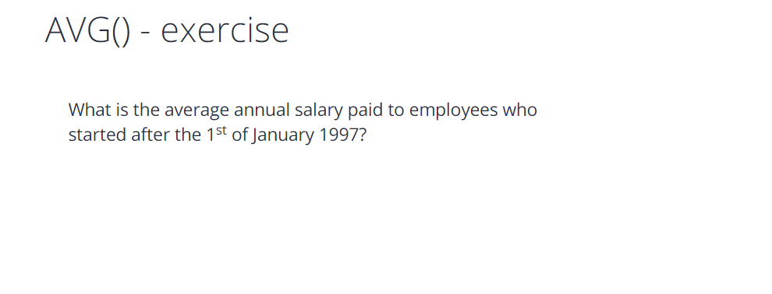

AVG() - solution

**SELECT**

**AVG(salary)**

**FROM**

**salaries**

**WHERE**

**from_date > '1997-01-01';**

using round

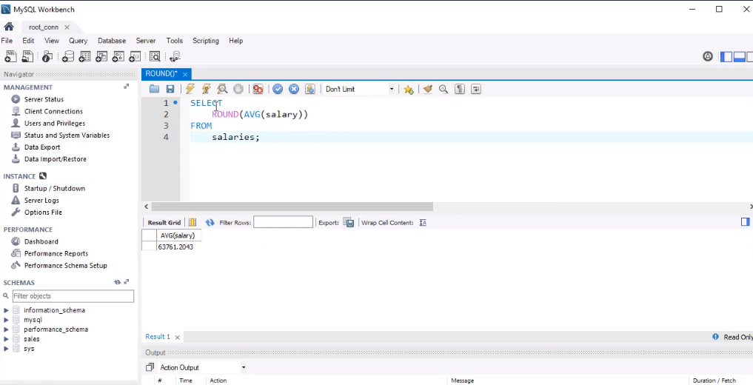

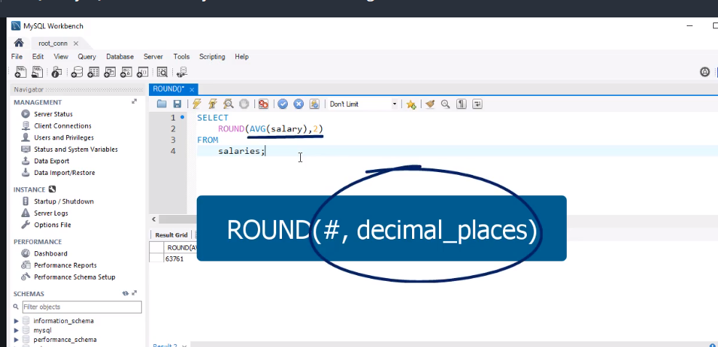

ROUND() - exercise

Round the average amount of money spent on salaries for all contracts that started after the 1st of January 1997 to a precision of cents.

Ifnull and coalesce

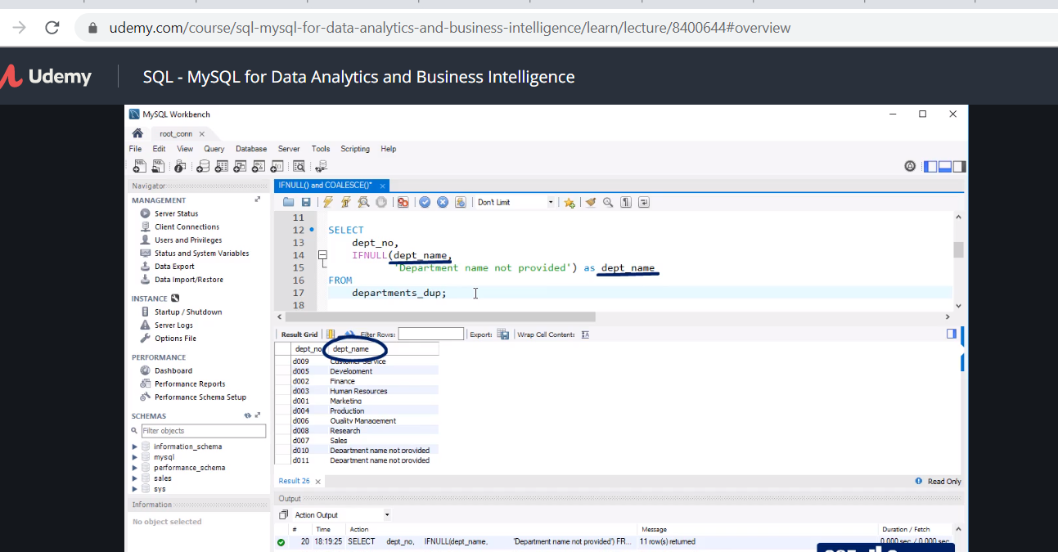

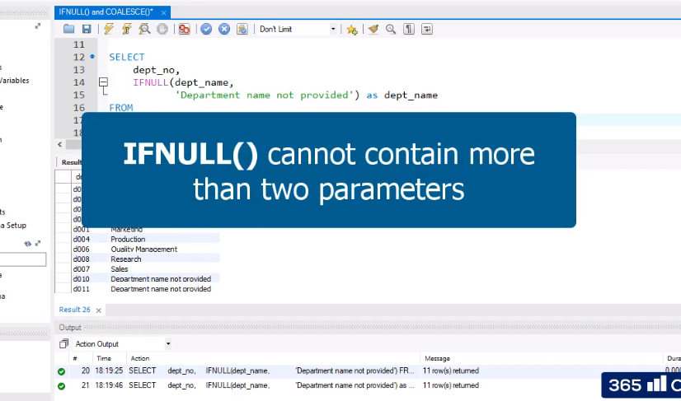

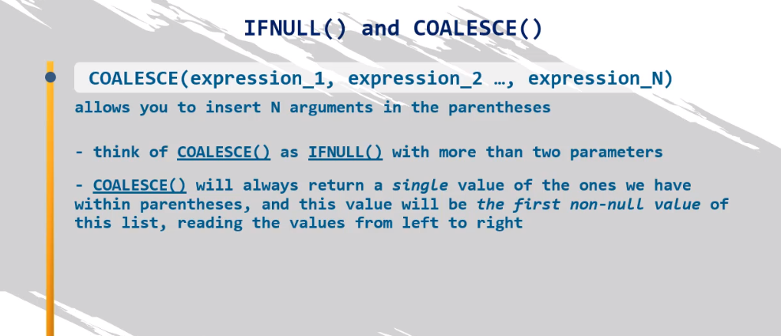

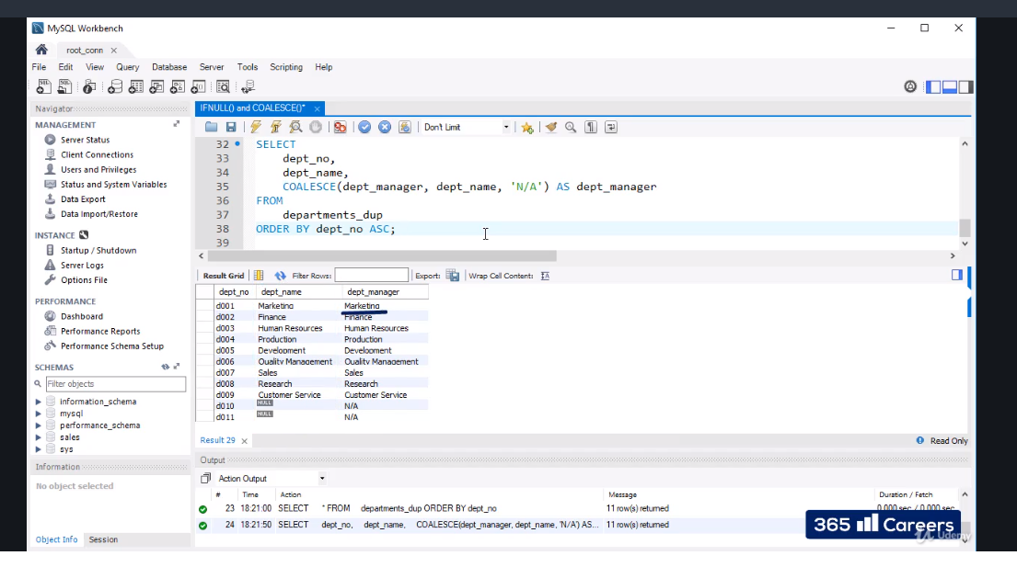

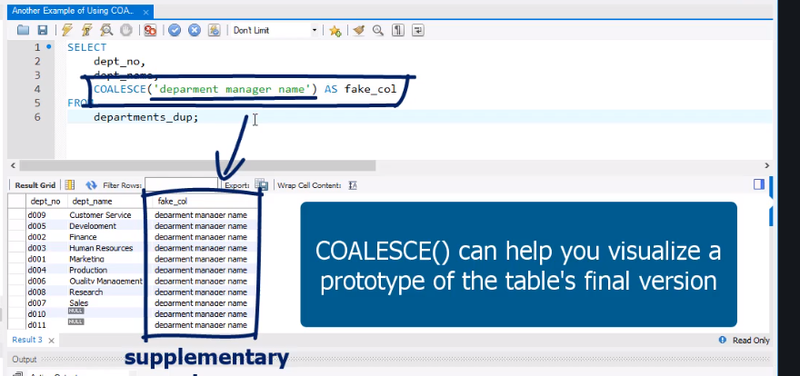

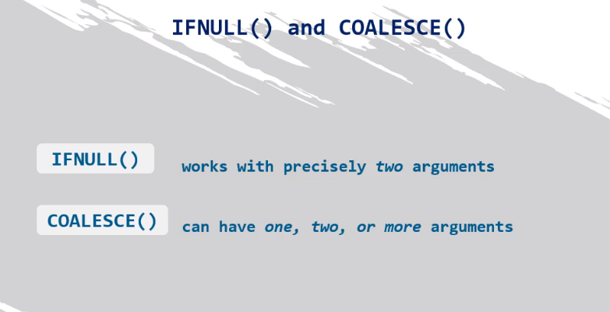

Another example of using COALESCE() - exercise 1

Select the department number and name from the ‘departments_dup’ table and add a third column where you name the department number (‘dept_no’) as ‘dept_info’. If ‘dept_no’ does not have a value, use ‘dept_name’.

Another example of using COALESCE() - solution 1

**SELECT**

**dept_no,**

**dept_name,**

**COALESCE(dept_no, dept_name) AS dept_info**

**FROM**

**departments_dup**

**ORDER BY dept_no ASC;**

Another example of using COALESCE() - exercise 2

Modify the code obtained from the previous exercise in the following way. Apply the IFNULL() function to the values from the first and second column, so that ‘N/A’ is displayed whenever a department number has no value, and ‘Department name not provided’ is shown if there is no value for ‘dept_name’.

Another example of using COALESCE() - solution 2

**SELECT**

**IFNULL(dept_no, 'N/A') as dept_no,**

**IFNULL(dept_name,**

**'Department name not provided') AS dept_name,**

**COALESCE(dept_no, dept_name) AS dept_info**

**FROM**

**departments_dup**

**ORDER BY dept_no ASC;**

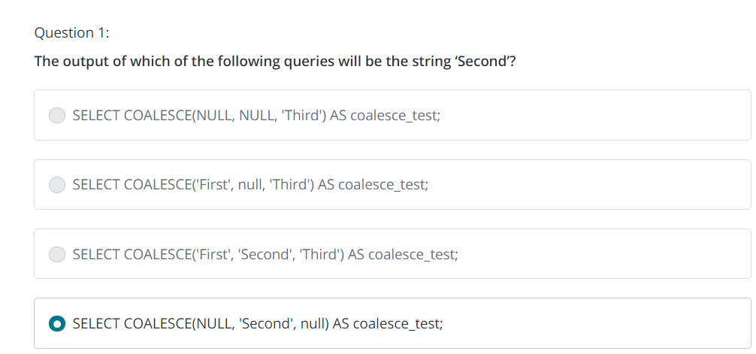

JOIN

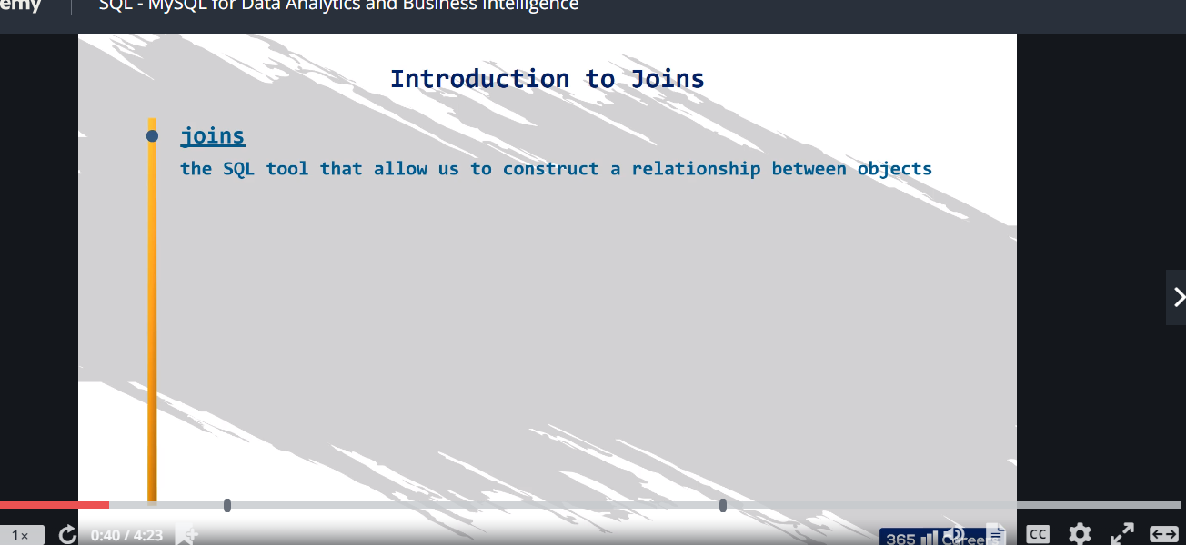

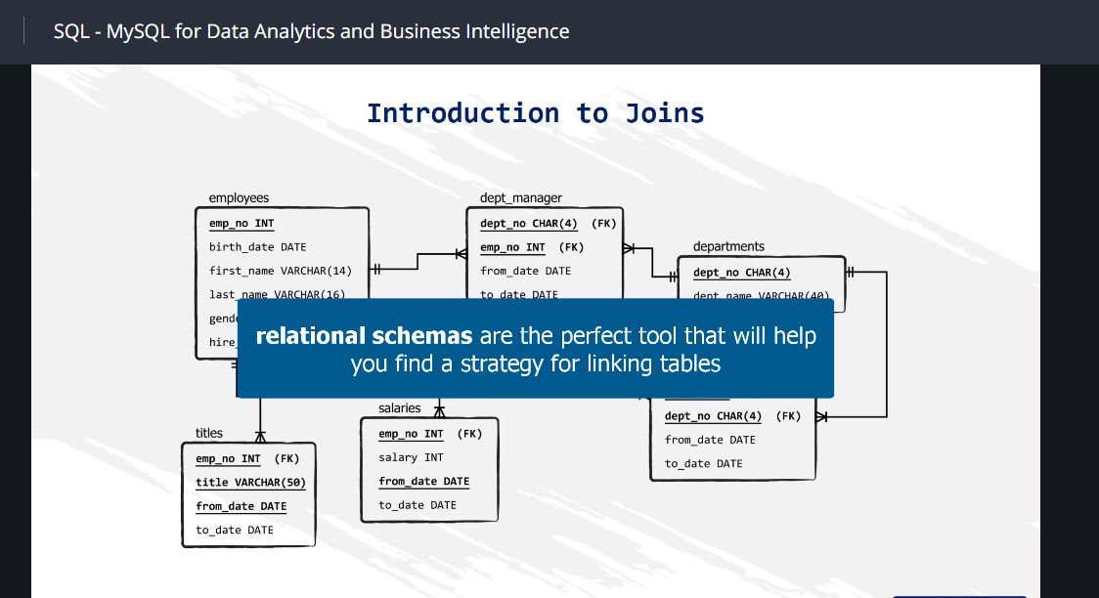

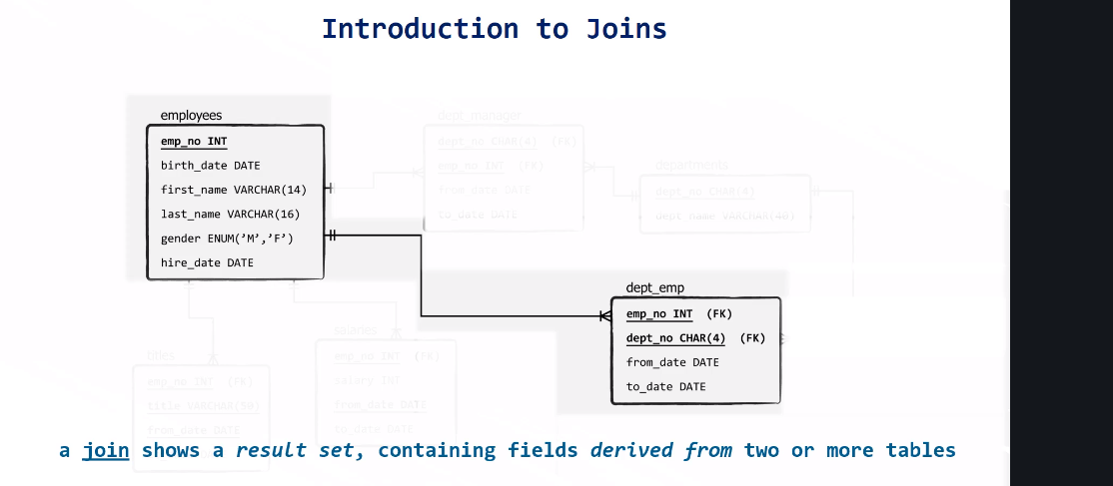

Now before we join we have to revisit this

Insert table into new table. Retrieve information from another table and put it in new able.

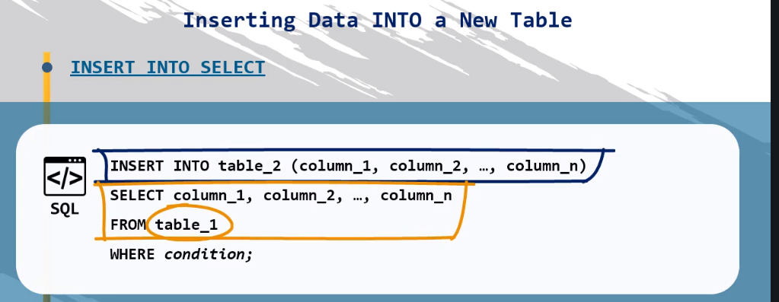

First table with limit

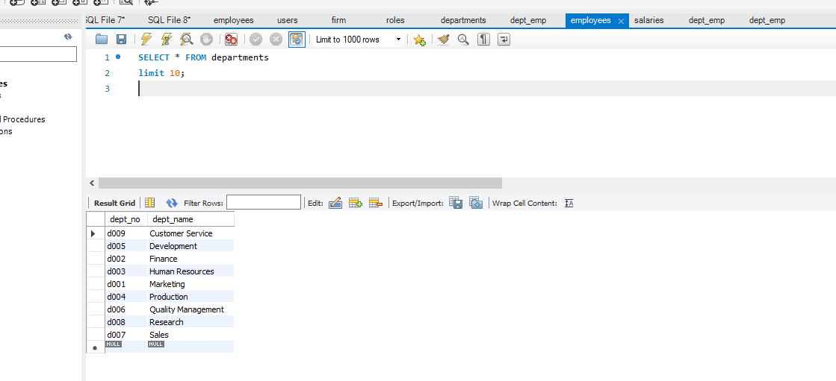

Create duplicate table

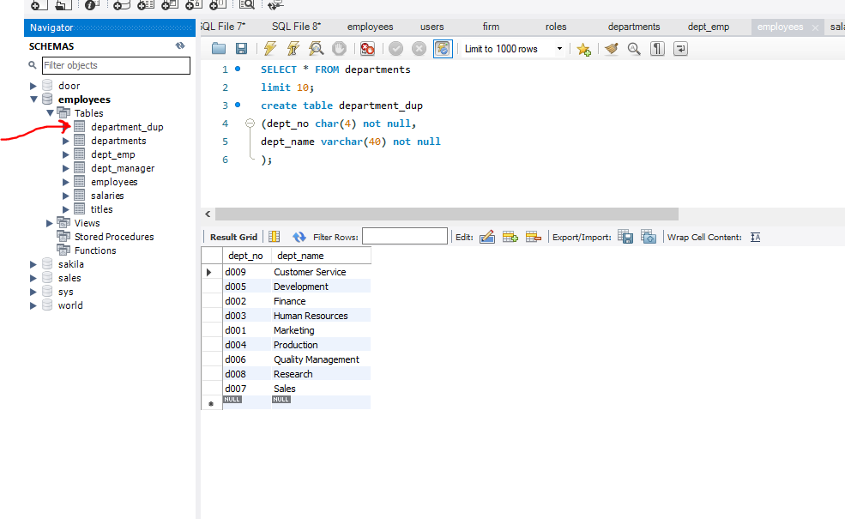

New table created by copying the first table

This then transfer the content to the table

insert into department_dup

(dept_no,

dept_name)

select*from departments;

now take note we want to add a record(row)

SELECT * FROM employees.department_dup

order by dept_no desc;

INSERT INTO department_dup VALUES ('d010', 'Public relations');

Back to join

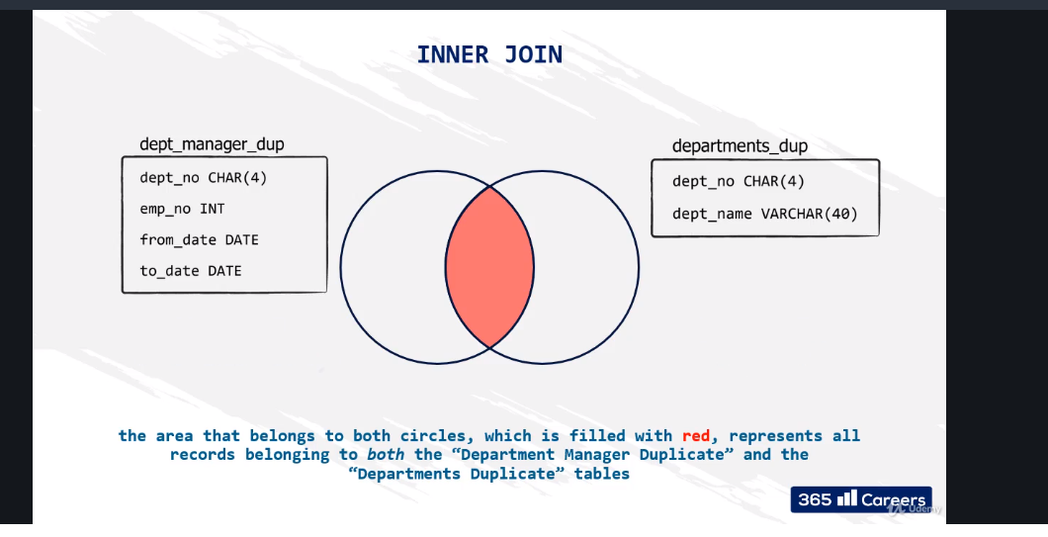

You notice they both have dept_no as the same so therefore to inner join we use result set.

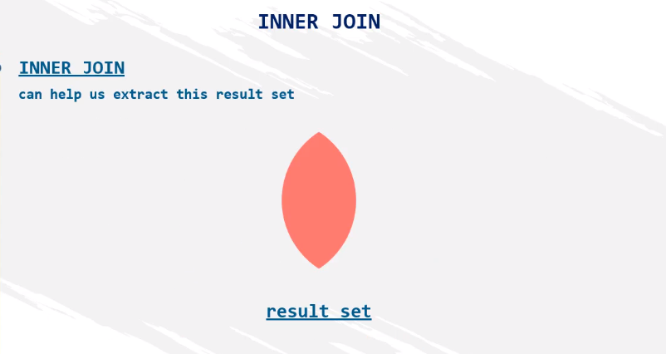

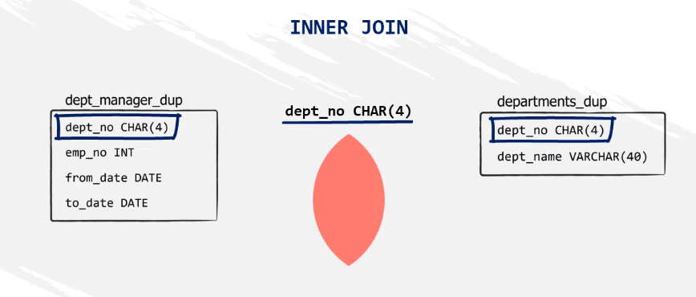

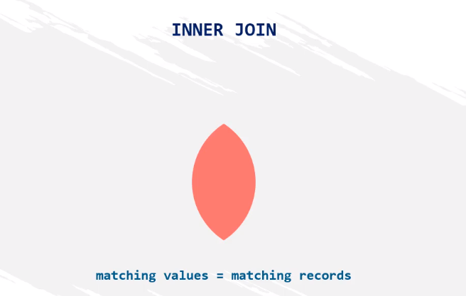

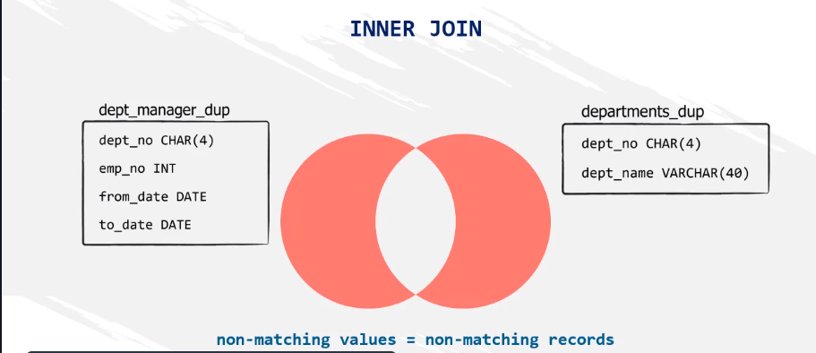

This will not appear for the join since they dnt match

This is to create table and copy from another table

CREATE TABLE dep_manager_dup (

emp_no int(11) NULL,

dept_no char(4) NOT NULL,

from_date date NOT NULL,

to_date date NOT NULL

);

INSERT INTO dep_manager_dup (emp_no, dept_no, from_date,to_date)

SELECT * FROM dept_manager;

Now this is how to add to table using insert

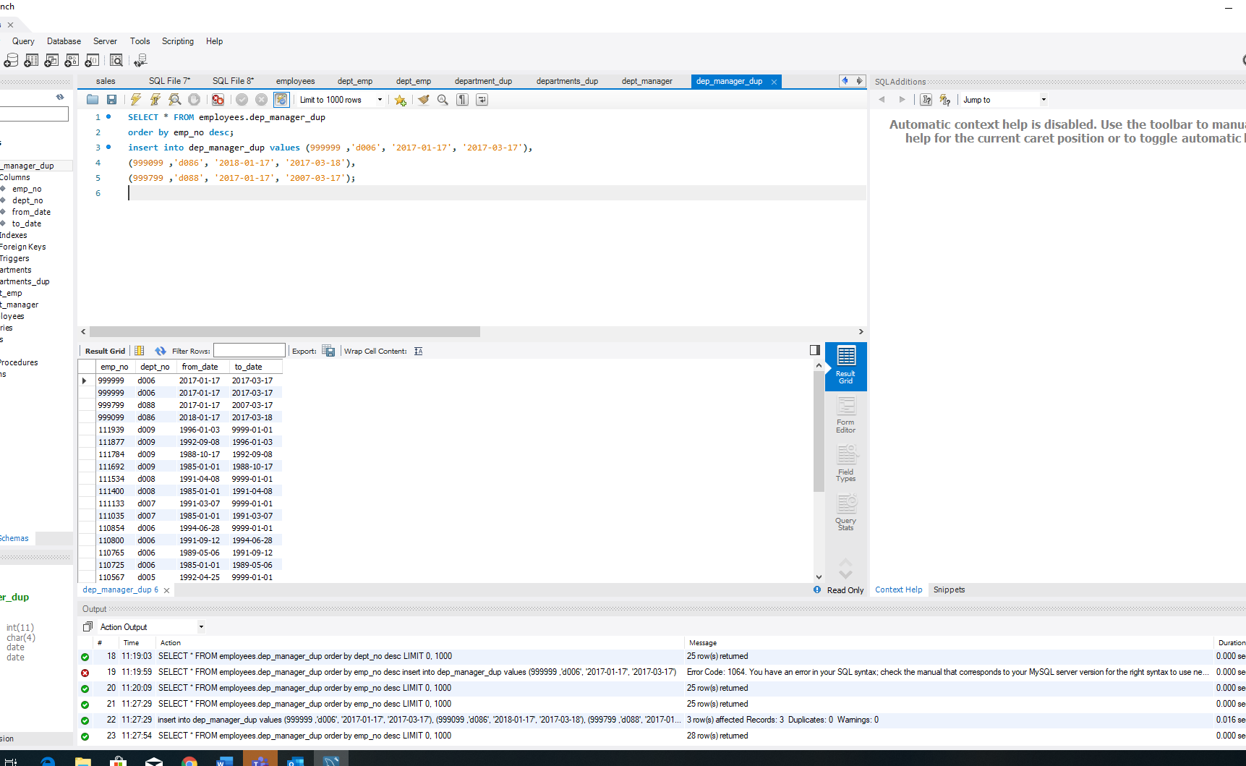

Back to join

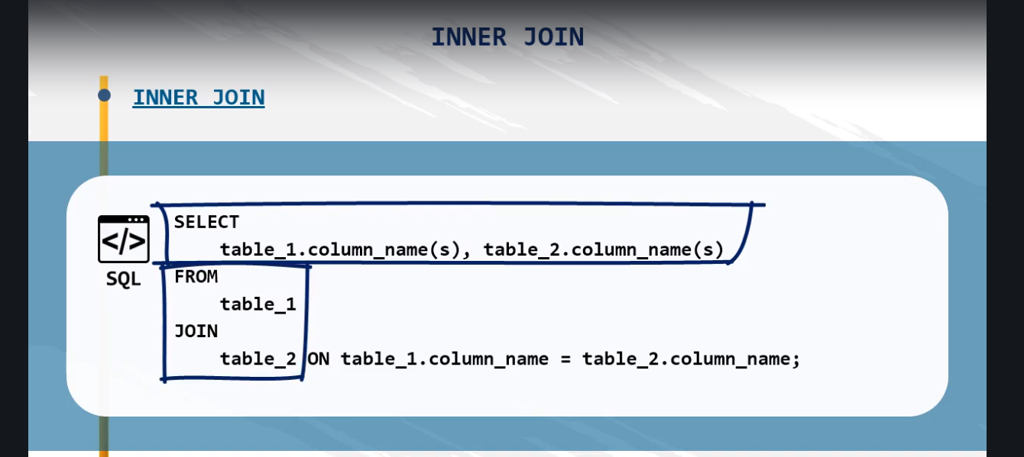

Aliases are you to rename tables

M and D are liases here

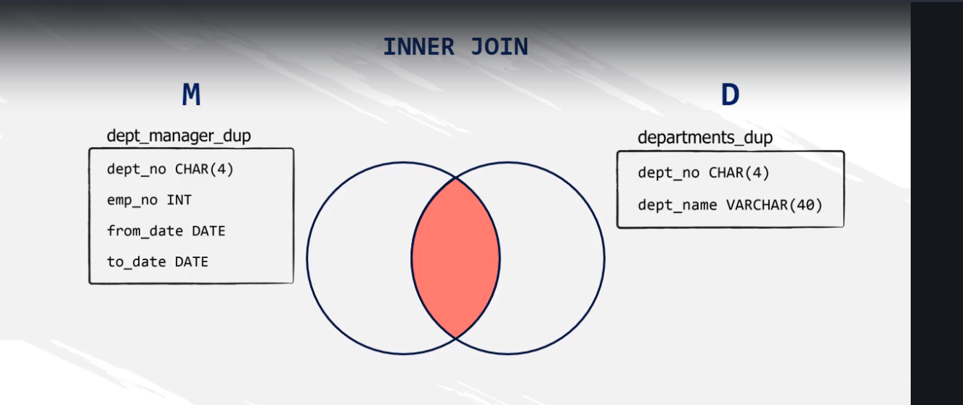

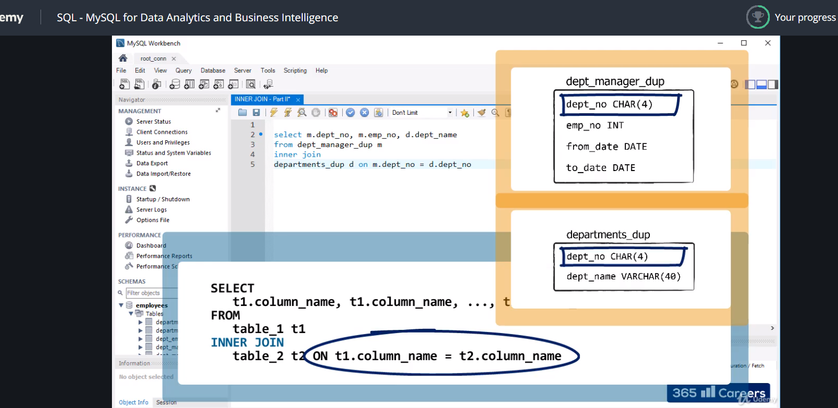

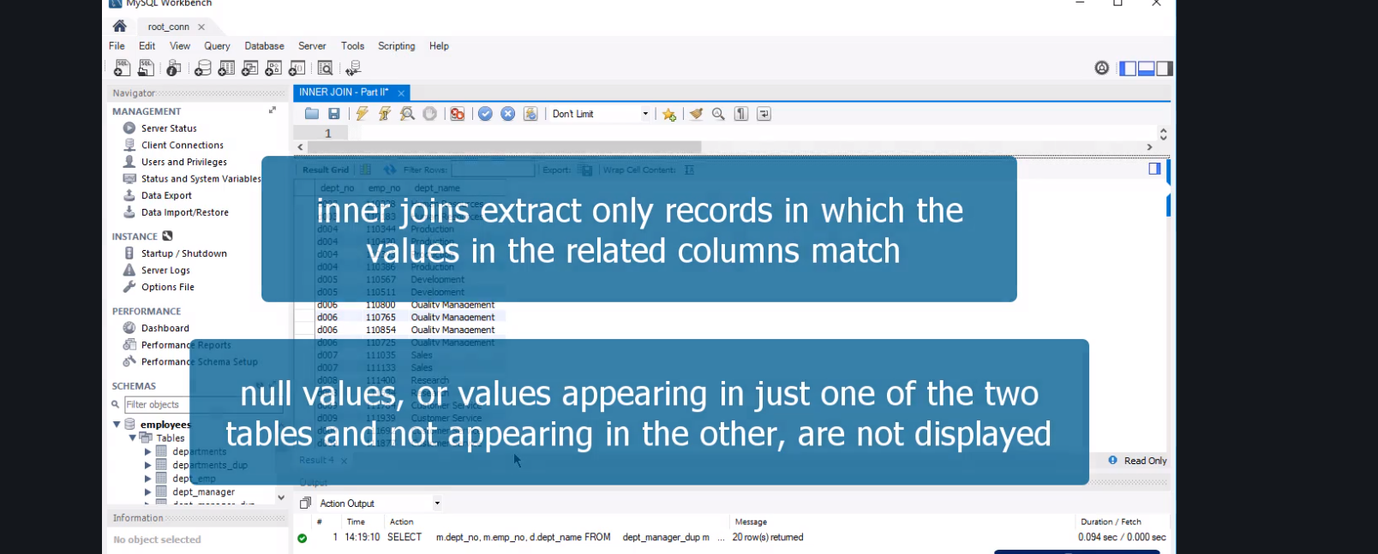

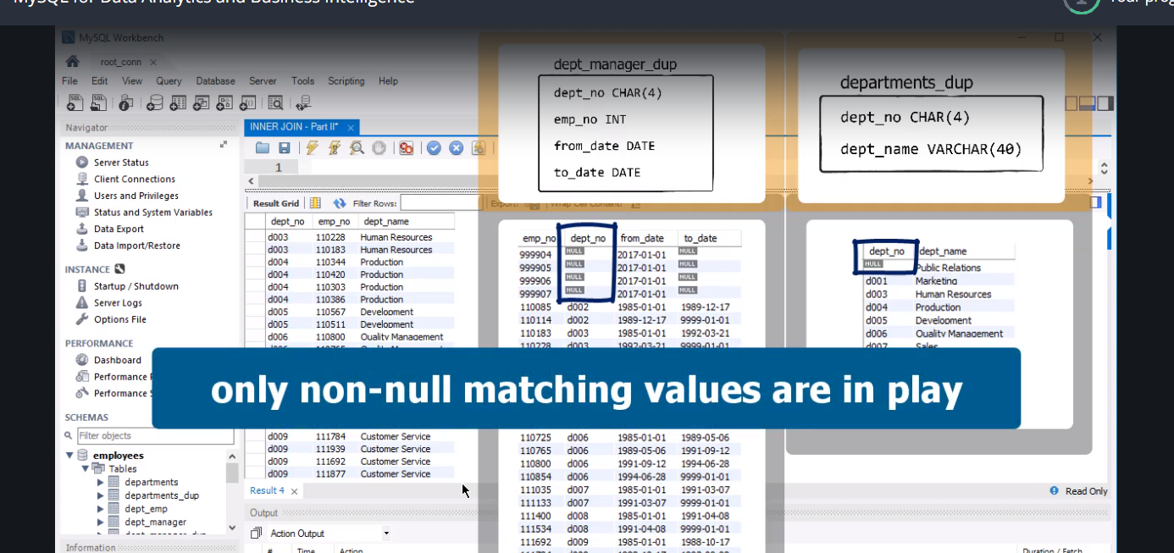

INNER JOIN - Part II - exercise

Extract a list containing information about all managers’ employee number, first and last name, department number, and hire date.

INNER JOIN - Part II - solution

**SELECT**

**e.emp_no,**

**e.first_name,**

**e.last_name,**

**dm.dept_no,**

**e.hire_date**

**FROM**

**employees e**

**JOIN**

**dept_manager dm ON e.emp_no = dm.emp_no;**

**dublicate tables: handling duplicates**

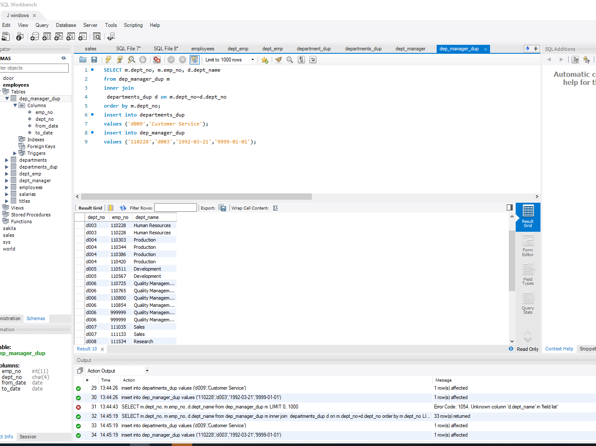

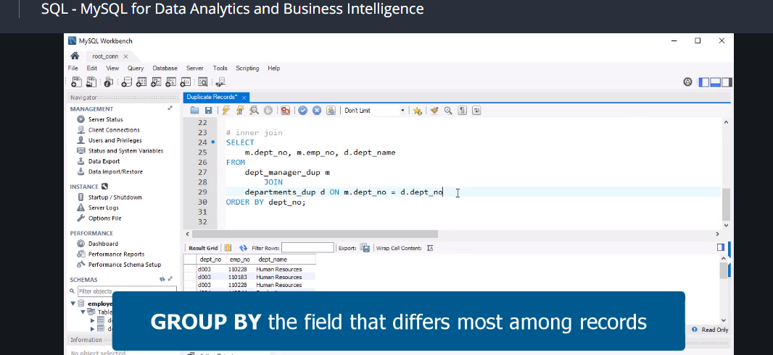

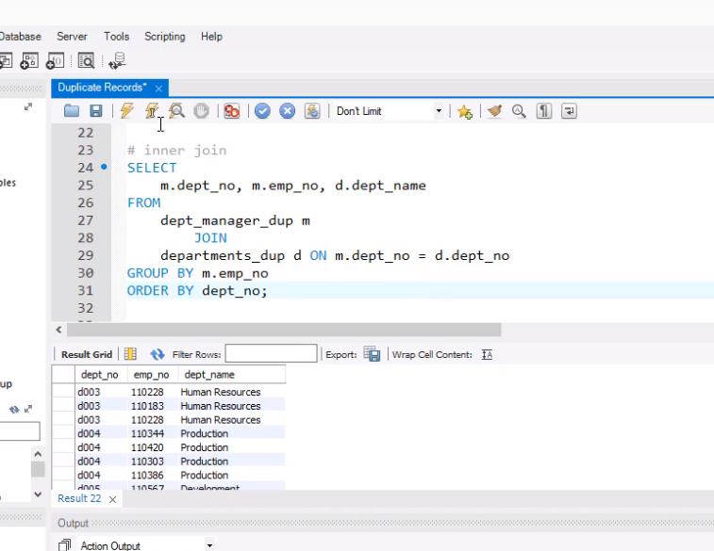

Then delete

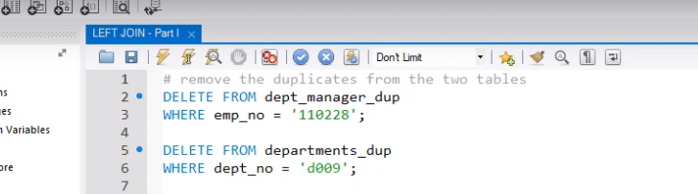

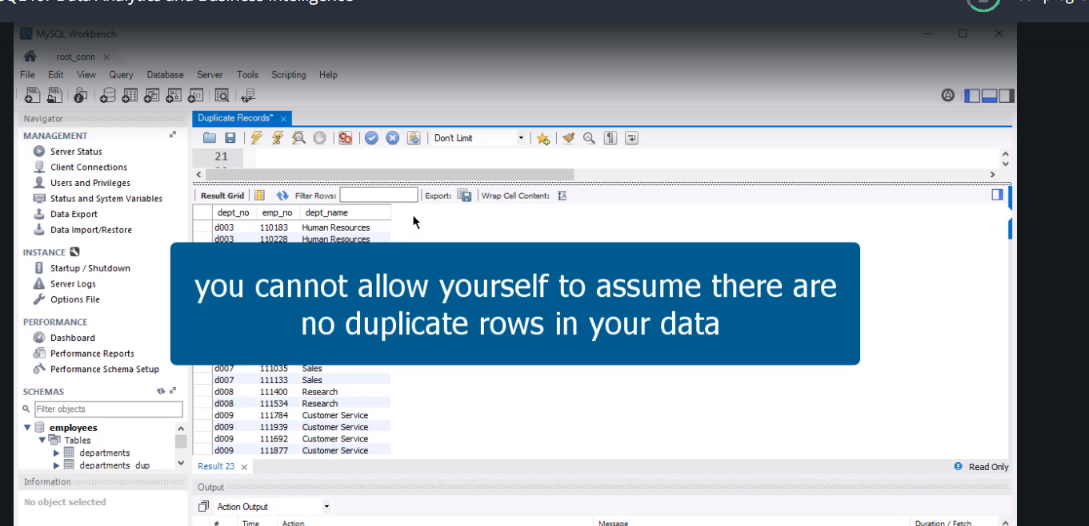

**Left join….**

**Now same process as join but change it to “left join**

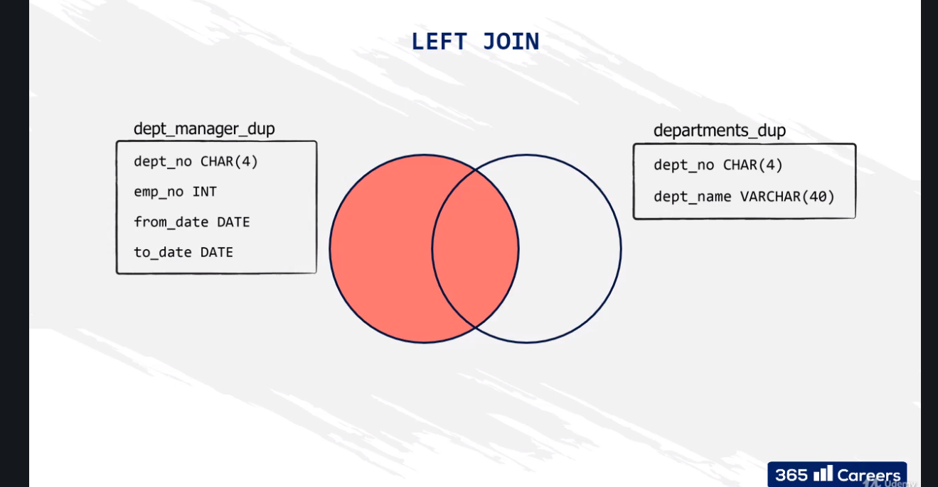

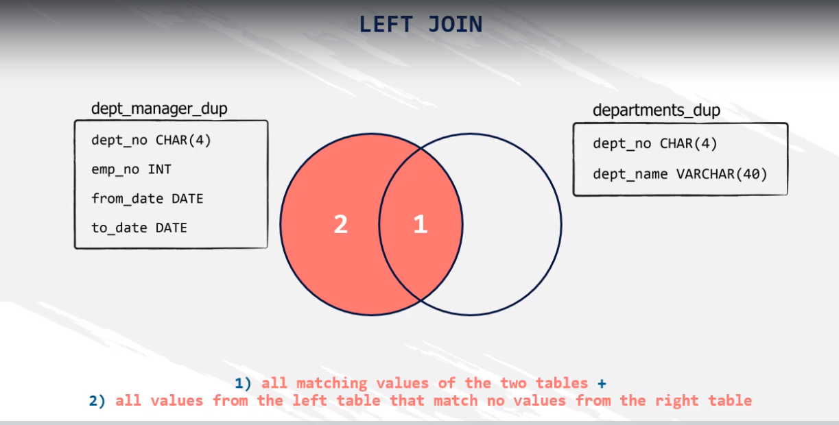

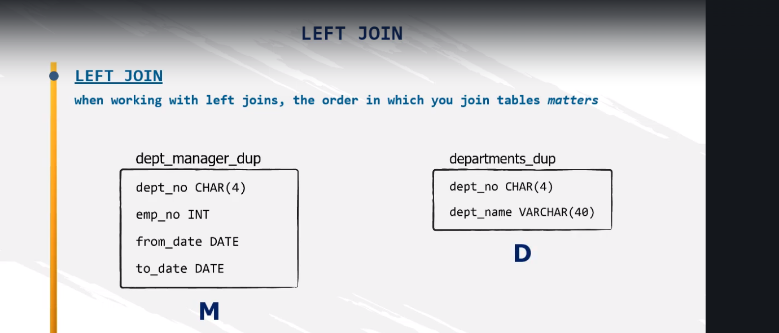

**M and D matter in this case.**

**Note**

**Left join = Left outer join**

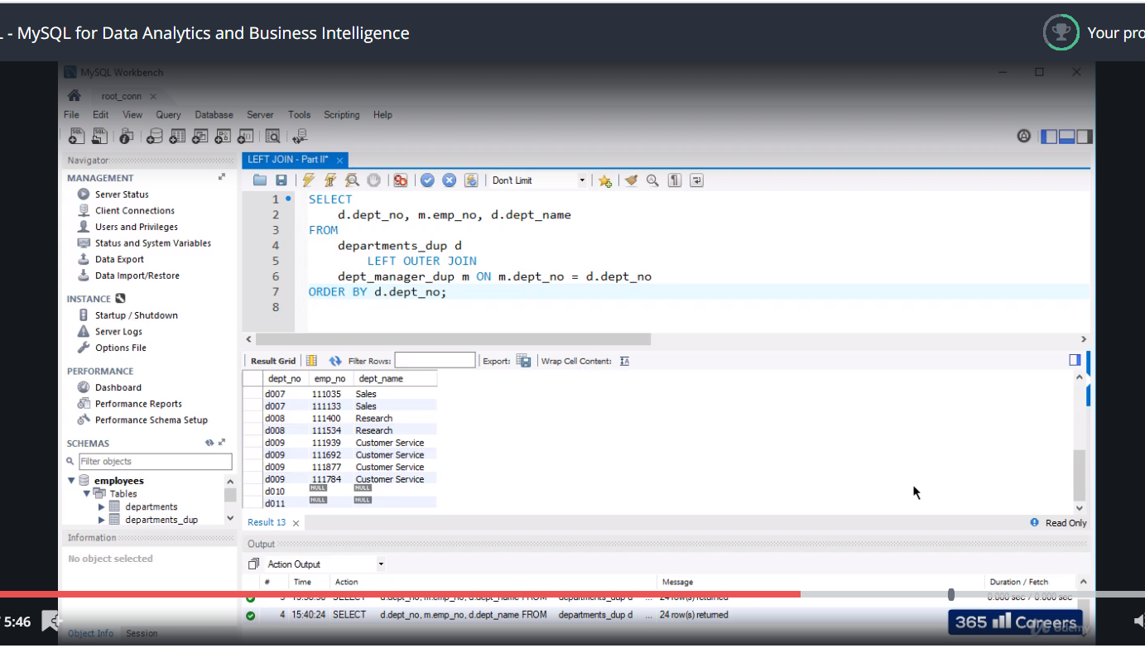

LEFT JOIN - Part II - exercise

Join the 'employees' and the 'dept_manager' tables to return a subset of all the employees whose last name is Markovitch. See if the output contains a manager with that name.

*Hint: Create an output containing information corresponding to the following fields: ‘emp_no’, ‘first_name’, ‘last_name’, ‘dept_no’, ‘from_date’. Order by 'dept_no' descending, and then by 'emp_no'.*

LEFT JOIN - Part II - solution

**SELECT**

**e.emp_no,**

**e.first_name,**

**e.last_name,**

**dm.dept_no,**

**dm.from_date**

**FROM**

**employees e**

**LEFT JOIN**

**dept_manager dm ON e.emp_no = dm.emp_no**

**WHERE**

**e.last_name = 'Markovitch'**

**ORDER BY dm.dept_no DESC, e.emp_no;**

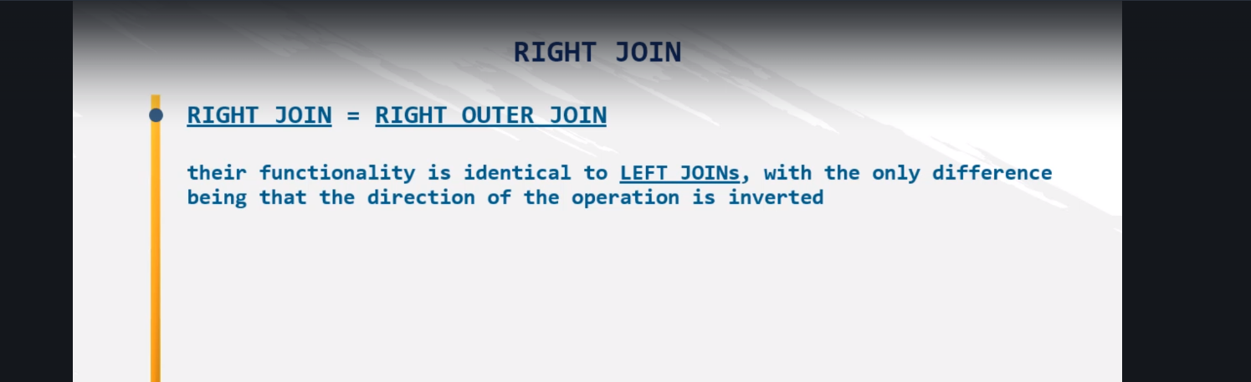

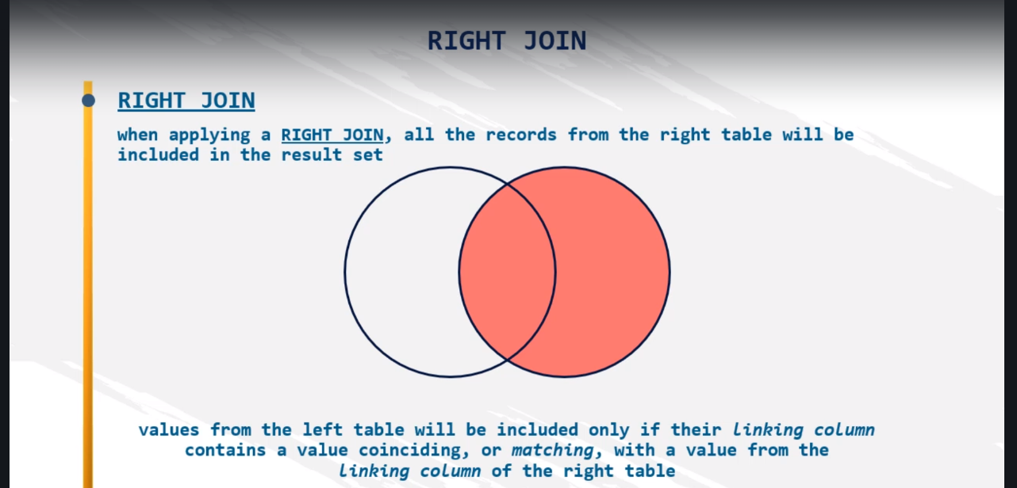

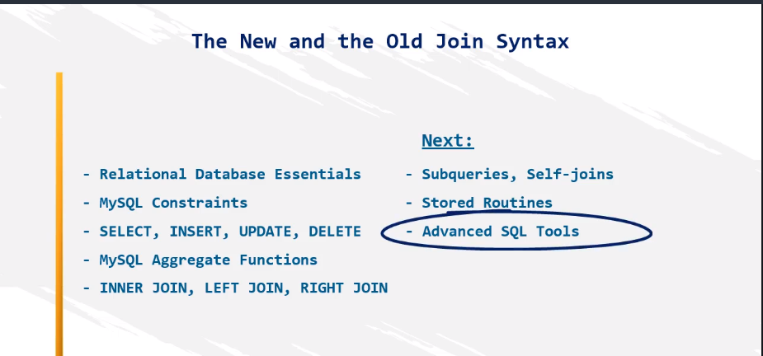

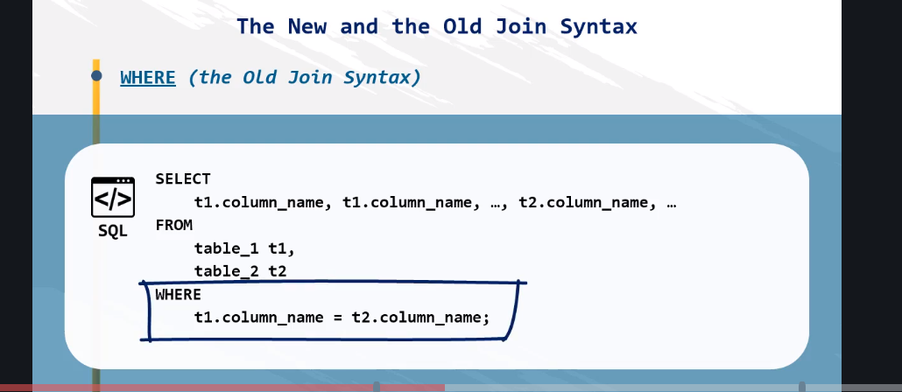

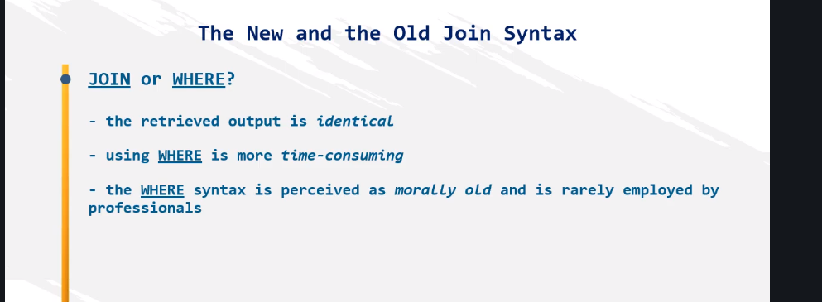

The new and the old join syntax - exercise

Extract a list containing information about all managers’ employee number, first and last name, department number, and hire date. Use the old type of join syntax to obtain the result.

The new and the old join syntax - solution

**SELECT**

**e.emp_no,**

**e.first_name,**

**e.last_name,**

**dm.dept_no,**

**e.hire_date**

**FROM**

**employees e,**

**dept_manager dm**

**WHERE**

**e.emp_no = dm.emp_no;**

*New Join Syntax:*

**SELECT**

**e.emp_no,**

**e.first_name,**

**e.last_name,**

**dm.dept_no,**

**e.hire_date**

**FROM**

**employees e**

**JOIN**

**dept_manager dm ON e.emp_no = dm.emp_no;**

**using join and where**

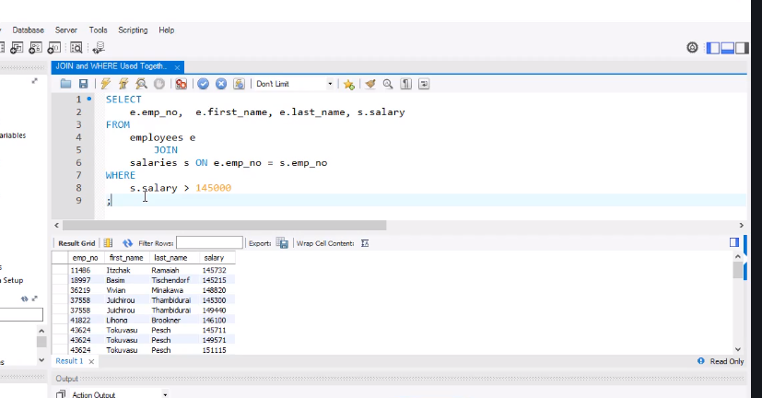

Important – Prevent Error Code: 1055!

Depending on your operating system and version of MySQL, you will be working with different SQL settings.

To make sure you can take some of the remaining lectures of the course without unnecessary interruption, ***we strongly advise you to execute the following query now.***

set @@global.sql_mode := replace(@@global.sql_mode, 'ONLY_FULL_GROUP_BY', '');

***If you’re interested in the reason we are asking you to do this, you can read the technical description below.*** *Please be aware that it may sound a bit too abstract at this stage. However, you can always refer back to it once you have completed the lectures about the different types of SQL variables found in the Advanced SQL Tools section of the course.*

JOIN and WHERE Used Together - exercise

Select the first and last name, the hire date, and the job title of all employees whose first name is “Margareta” and have the last name “Markovitch”.

JOIN and WHERE Used Together - solution

**SELECT**

**e.first_name, e.last_name, e.hire_date, t.title**

**FROM**

**employees e**

**JOIN**

**titles t ON e.emp_no = t.emp_no**

**WHERE**

**first_name = 'Margareta'**

**AND last_name = 'Markovitch'**

**ORDER BY e.emp_no**

**;**

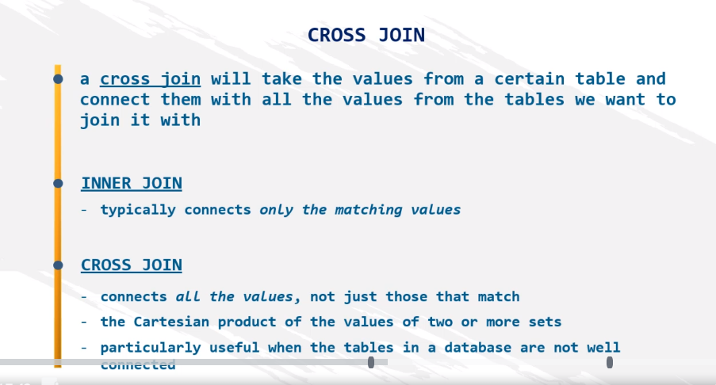

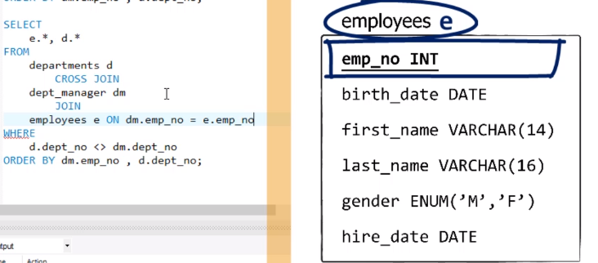

CROSS JOIN - exercise 1

Use a CROSS JOIN to return a list with all possible combinations between managers from the *dept_manager* table and department number 9.

CROSS JOIN - solution 1

**SELECT**

**dm.*, d.\***

**FROM**

**departments d**

**CROSS JOIN**

**dept_manager dm**

**WHERE**

**d.dept_no = 'd009'**

**ORDER BY d.dept_name;**

CROSS JOIN - exercise 2

Return a list with the first 10 employees with all the departments they can be assigned to.

*Hint: Don’t use LIMIT; use a WHERE clause.*

CROSS JOIN - solution 2

**SELECT**

**e.*, d.\***

**FROM**

**employees e**

**CROSS JOIN**

**departments d**

**WHERE**

**e.emp_no < 10011**

**ORDER BY e.emp_no, d.dept_name;**

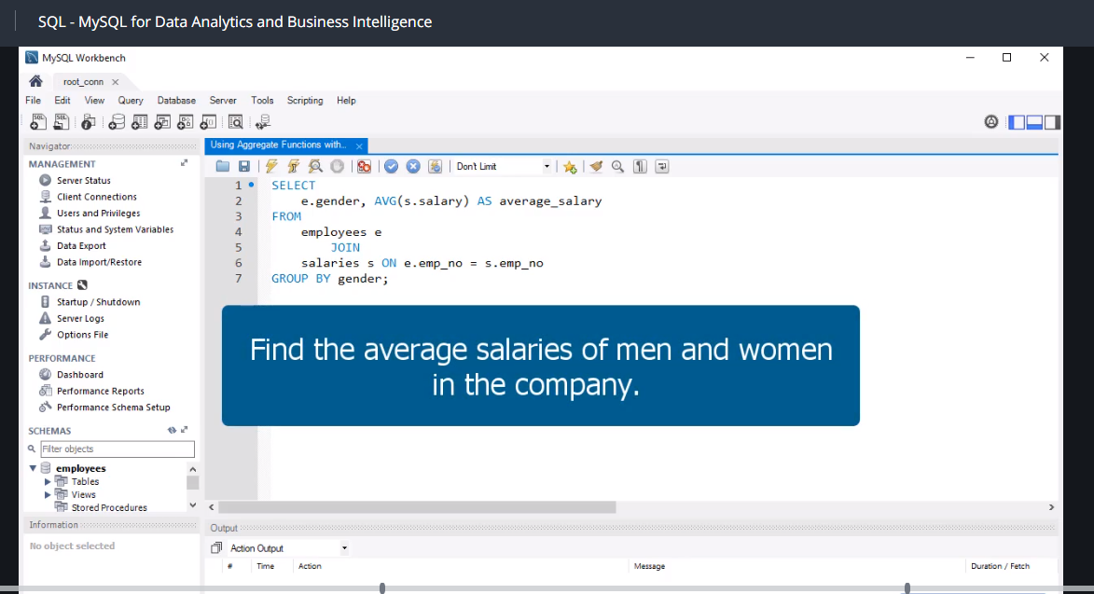

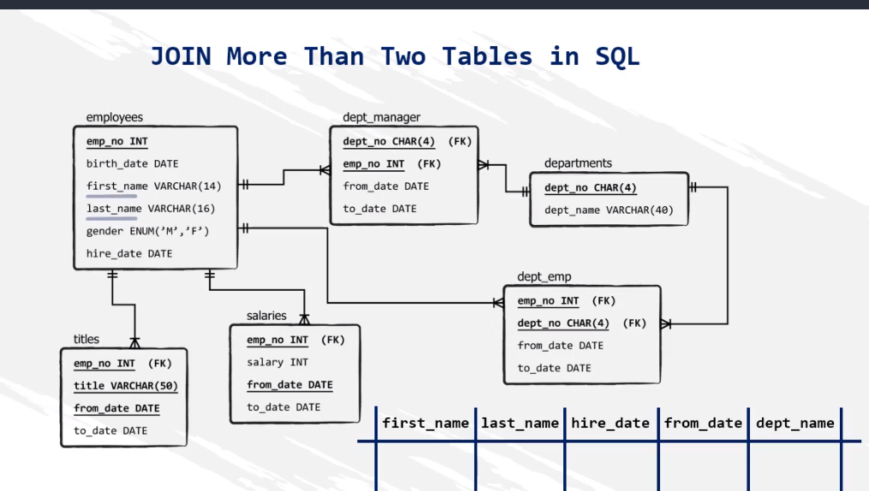

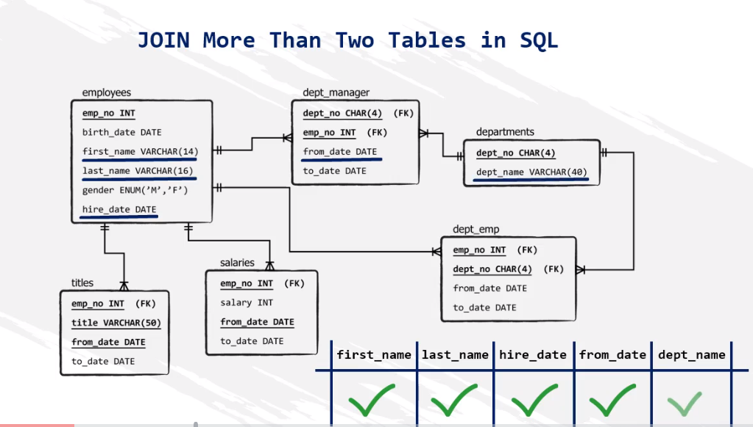

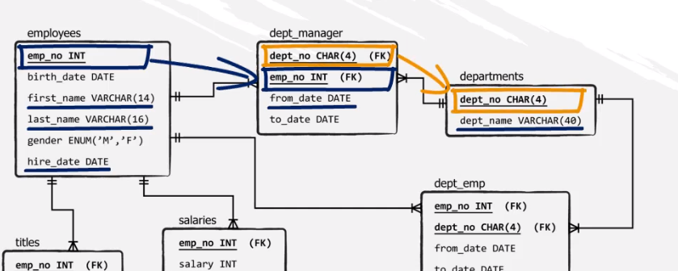

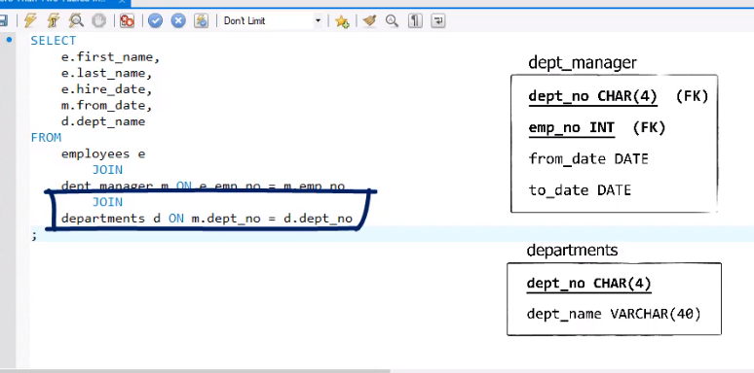

Now we changed the order so when combining multiple tables just use join.

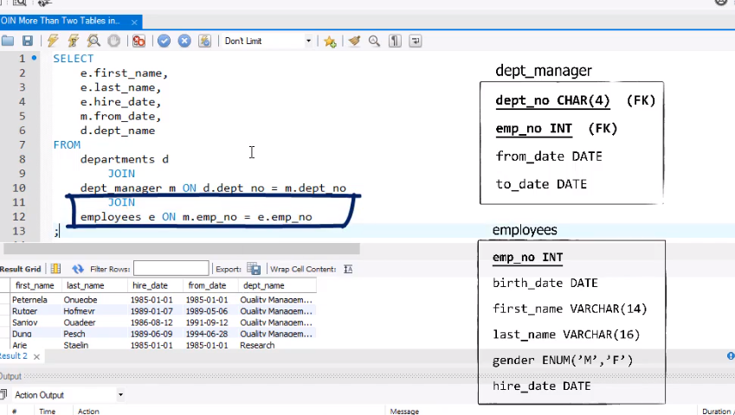

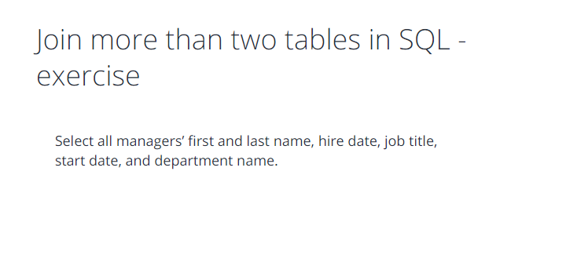

Join more than two tables in SQL - solution

**SELECT**

**e.first_name,**

**e.last_name,**

**e.hire_date,**

**t.title,**

**m.from_date,**

**d.dept_name**

**FROM**

**employees e**

**JOIN**

**dept_manager m ON e.emp_no = m.emp_no**

**JOIN**

**departments d ON m.dept_no = d.dept_no**

**JOIN**

**titles t ON e.emp_no = t.emp_no**

**WHERE t.title = 'Manager'**

**ORDER BY e.emp_no;**

-

- 2nd Solution:

-

**SELECT**

**e.first_name,**

**e.last_name,**

**e.hire_date,**

**t.title,**

**m.from_date,**

**d.dept_name**

**FROM**

**employees e**

**JOIN**

**dept_manager m ON e.emp_no = m.emp_no**

**JOIN**

**departments d ON m.dept_no = d.dept_no**

**JOIN**

**titles t ON e.emp_no = t.emp_no**

**AND m.from_date = t.from_date**

**ORDER BY e.emp_no;**

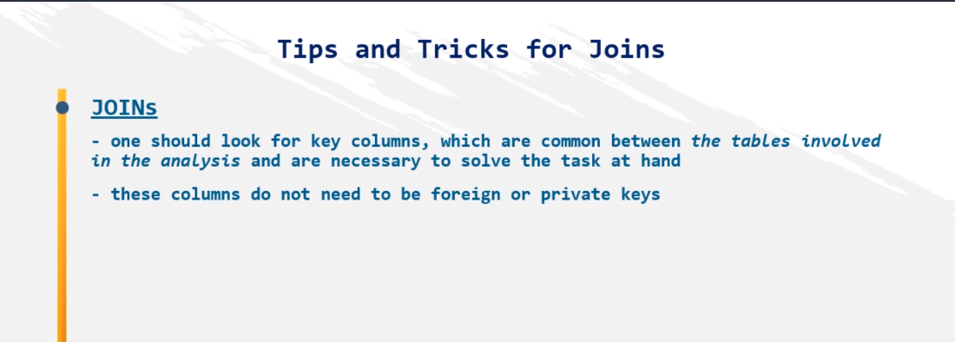

Tips and tricks for joins - exercise

How many male and how many female managers do we have in the ‘employees’ database?

Tips and tricks for joins - solution

**SELECT**

**e.gender, COUNT(dm.emp_no)**

**FROM**

**employees e**

**JOIN**

**dept_manager dm ON e.emp_no = dm.emp_no**

**GROUP BY gender;**

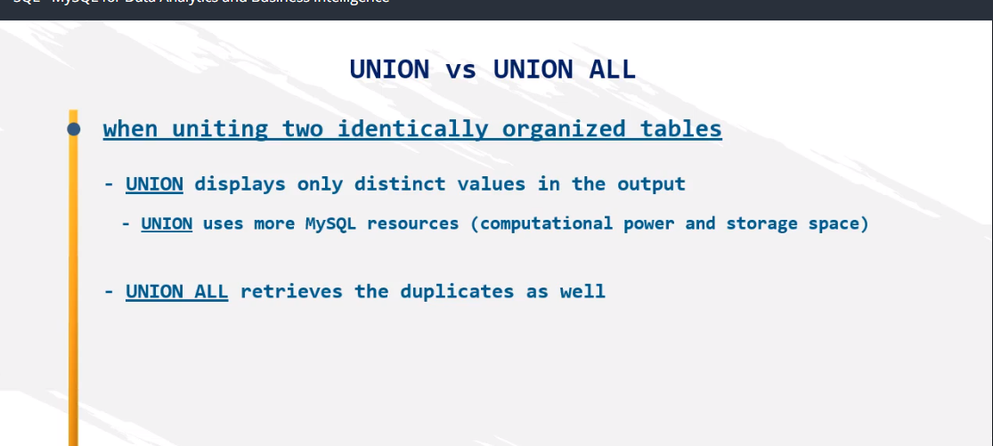

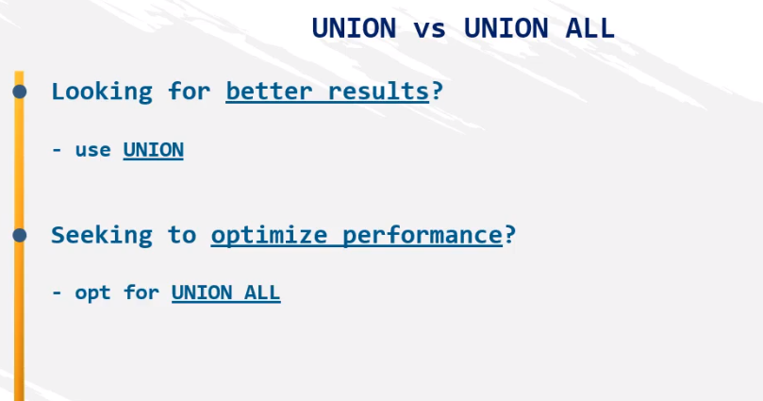

UNION vs UNION ALL - exercise

Go forward to the solution and execute the query. What do you think is the meaning of the minus sign before subset A in the last row (ORDER BY -a.emp_no DESC)?

UNION vs UNION ALL - solution

**SELECT**

**\***

**FROM**

**(SELECT**

**e.emp_no,**

**e.first_name,**

**e.last_name,**

**NULL AS dept_no,**

**NULL AS from_date**

**FROM**

**employees e**

**WHERE**

**last_name = 'Denis' UNION SELECT**

**NULL AS emp_no,**

**NULL AS first_name,**

**NULL AS last_name,**

**dm.dept_no,**

**dm.from_date**

**FROM**

**dept_manager dm) as a**

**ORDER BY -a.emp_no DESC;**

* [Overview](https://www.udemy.com/course/sql-mysql-for-data-analytics-and-business-intelligence/learn/lecture/8762130#overview)
* [Q&A](https://www.udemy.com/course/sql-mysql-for-data-analytics-and-business-intelligence/learn/lecture/8762130#questions)
* [Bookmarks](https://www.udemy.com/course/sql-mysql-for-data-analytics-and-business-intelligence/learn/lecture/8762130#bookmarks)
* [Announcements](https://www.udemy.com/course/sql-mysql-for-data-analytics-and-business-intelligence/learn/lecture/8762130#announcements)

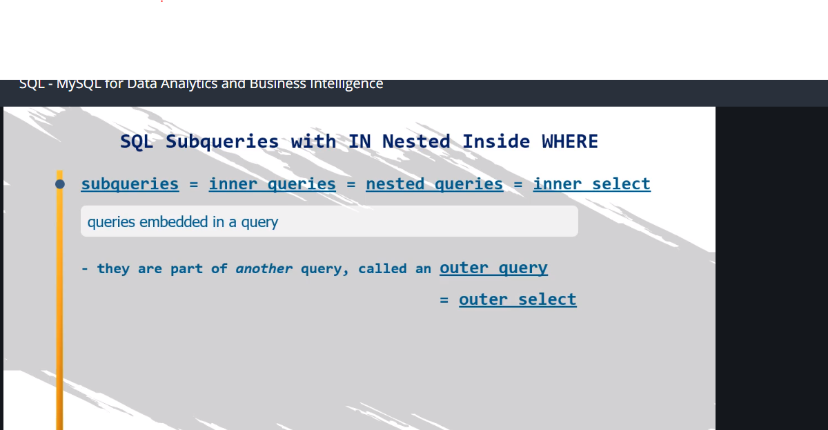

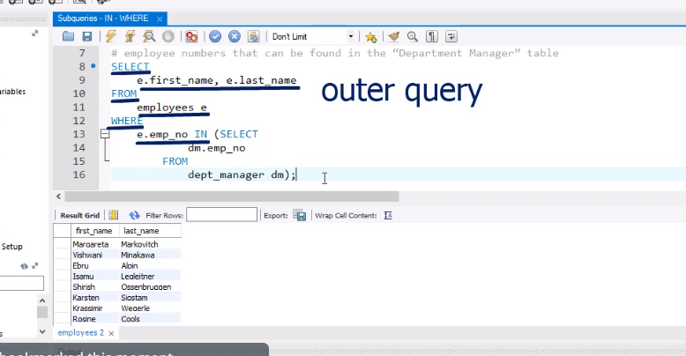

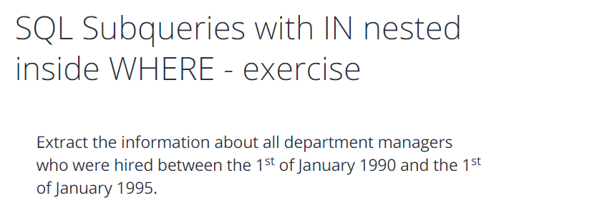

SQL Subqueries with IN nested inside WHERE - solution

**SELECT**

**\***

**FROM**

**dept_manager**

**WHERE**

**emp_no IN (SELECT**

**emp_no**

**FROM**

**employees**

**WHERE**

**hire_date BETWEEN '1990-01-01' AND '1995-01-01');**

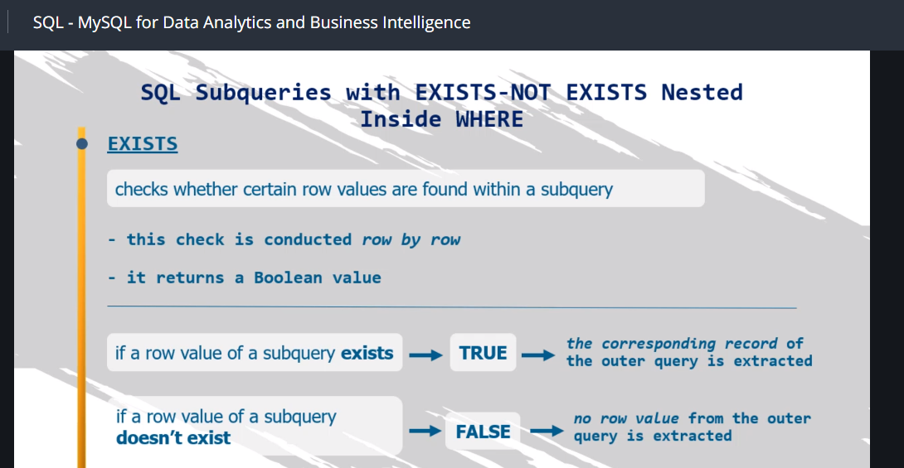

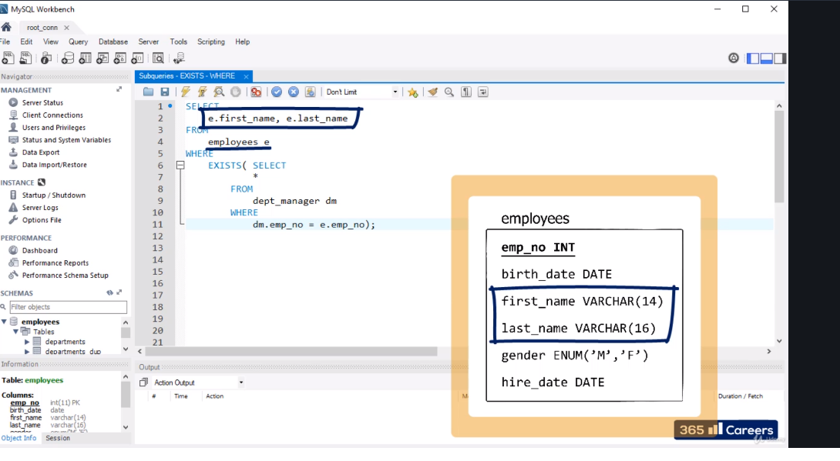

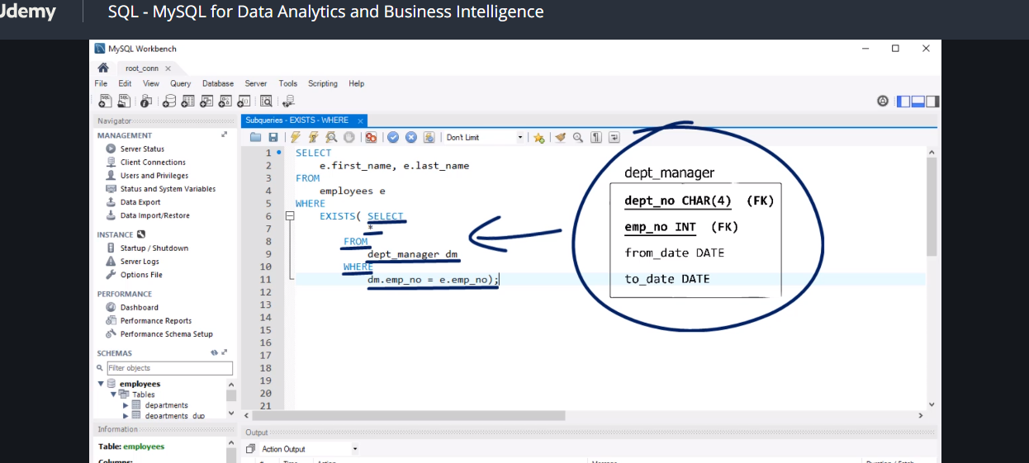

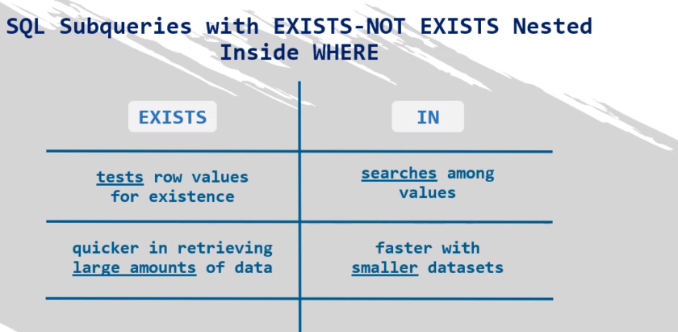

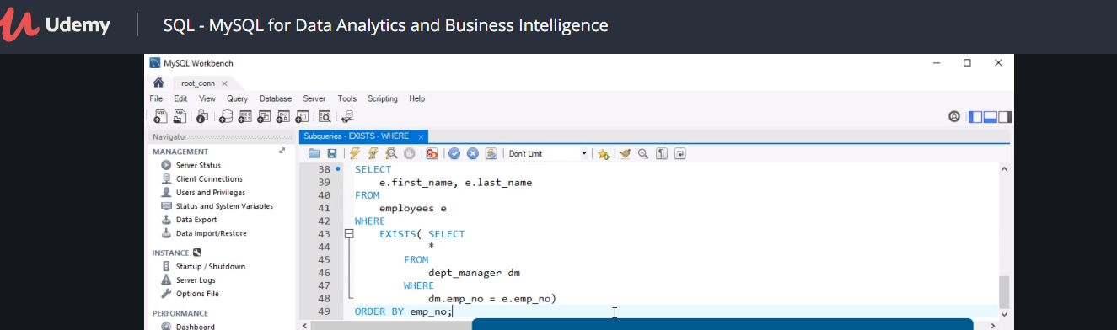

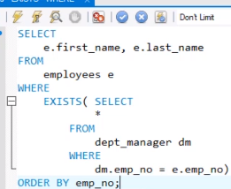

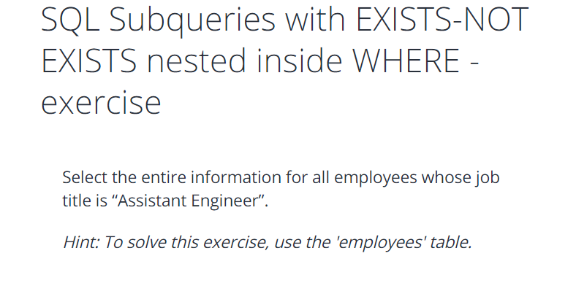

**SELECT**

**\***

**FROM**

**employees e**

**WHERE**

**EXISTS( SELECT**

**\***

**FROM**

**titles t**

**WHERE**

**t.emp_no = e.emp_no**

**AND title = 'Assistant Engineer');**

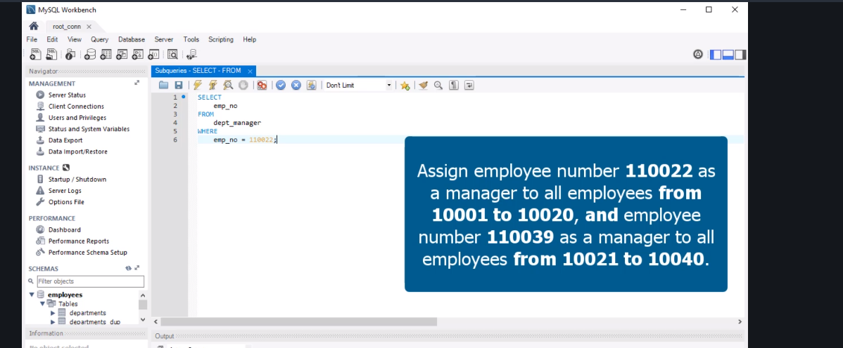

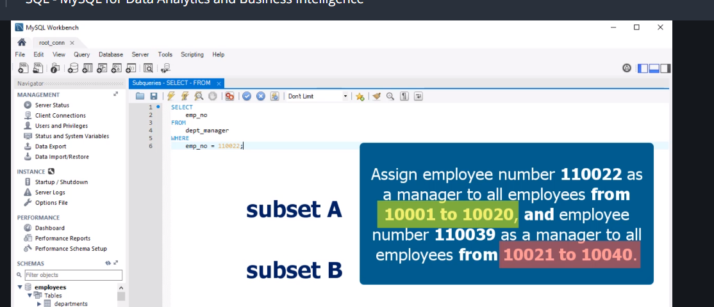

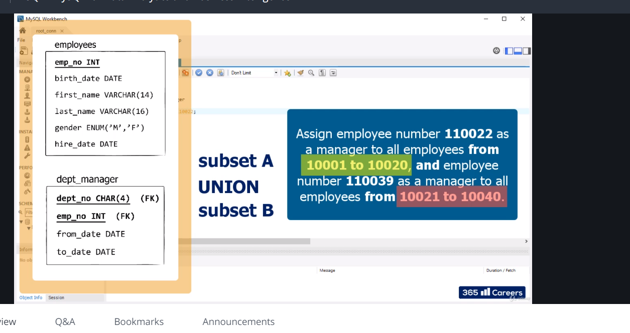

Take note inner query means there is another query inside select select

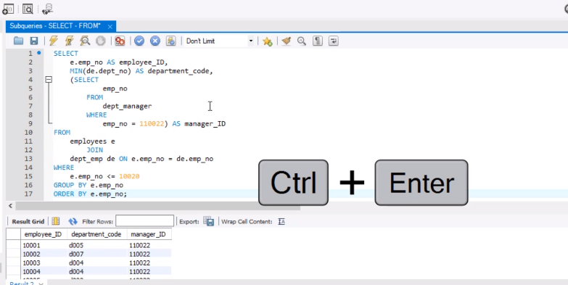

Big query continuation

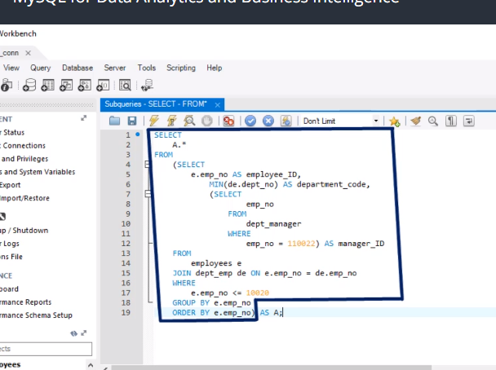

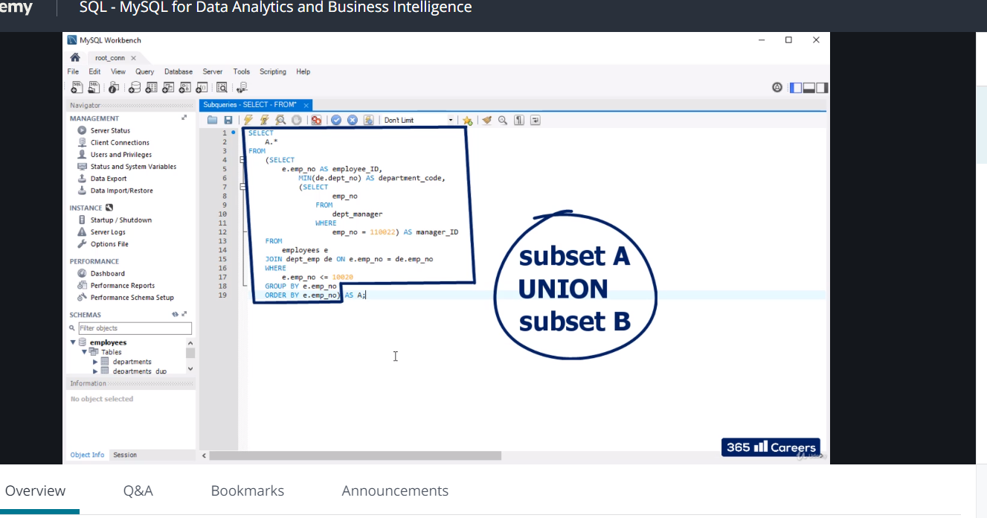

Just copy a to b with few changes

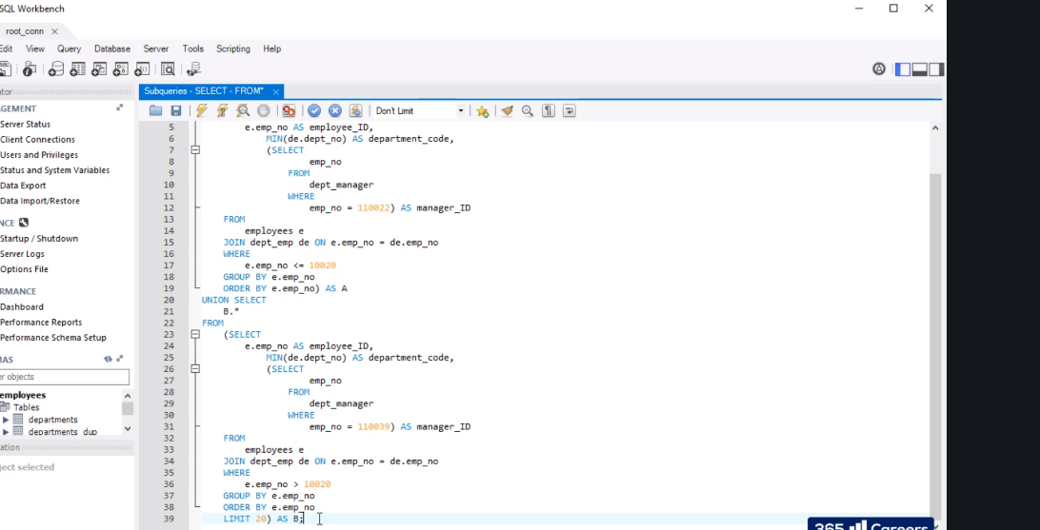

SQL Subqueries nested in SELECT and FROM - exercise 1

Starting your code with “DROP TABLE”, create a table called “emp_manager” *(emp_no – integer of 11, not null; dept_no – CHAR of 4, null; manager_no – integer of 11, not null).*

SQL Subqueries nested in SELECT and FROM - solution 1

**DROP TABLE IF EXISTS emp_manager;**

**CREATE TABLE emp_manager (**

**emp_no INT(11) NOT NULL,**

**dept_no CHAR(4) NULL,**

**manager_no INT(11) NOT NULL**

**);**

SQL Subqueries nested in SELECT and FROM - exercise 2

Fill *emp_manager* with data about employees, the number of the department they are working in, and their managers.

Your query skeleton must be:

*Insert INTO emp_manager SELECT*

*U.\**

*FROM*

*(A)*

*UNION (B) UNION (C) UNION (D) AS U;*

A and B should be the same subsets used in the last lecture *(SQL Subqueries Nested in SELECT and FROM)*. In other words, assign employee number 110022 as a manager to all employees from 10001 to 10020 (this must be subset A), and employee number 110039 as a manager to all employees from 10021 to 10040 (this must be subset B).

Use the structure of subset A to create subset C, where you must assign employee number 110039 as a manager to employee 110022.

Following the same logic, create subset D. Here you must do the opposite - assign employee 110022 as a manager to employee 110039.

Your output must contain 42 rows.

Good luck!

INSERT INTO emp_manager

SELECT

u.*

FROM

(SELECT

a.*

FROM

(SELECT

e.emp_no AS employee_ID,

MIN(de.dept_no) AS department_code,

(SELECT

emp_no

FROM

dept_manager

WHERE

emp_no = 110022) AS manager_ID

FROM

employees e

JOIN dept_emp de ON e.emp_no = de.emp_no

WHERE

e.emp_no <= 10020

GROUP BY e.emp_no

ORDER BY e.emp_no) AS a UNION SELECT

b.*

FROM

(SELECT

e.emp_no AS employee_ID,

MIN(de.dept_no) AS department_code,

(SELECT

emp_no

FROM

dept_manager

WHERE

emp_no = 110039) AS manager_ID

FROM

employees e

JOIN dept_emp de ON e.emp_no = de.emp_no

WHERE

e.emp_no > 10020

GROUP BY e.emp_no

ORDER BY e.emp_no

LIMIT 20) AS b UNION SELECT

c.*

FROM

(SELECT

e.emp_no AS employee_ID,

MIN(de.dept_no) AS department_code,

(SELECT

emp_no

FROM

dept_manager

WHERE

emp_no = 110039) AS manager_ID

FROM

employees e

JOIN dept_emp de ON e.emp_no = de.emp_no

WHERE

e.emp_no = 110022

GROUP BY e.emp_no) AS c UNION SELECT

d.*

FROM

(SELECT

e.emp_no AS employee_ID,

MIN(de.dept_no) AS department_code,

(SELECT

emp_no

FROM

dept_manager

WHERE

emp_no = 110022) AS manager_ID

FROM

employees e

JOIN dept_emp de ON e.emp_no = de.emp_no

WHERE

e.emp_no = 110039

GROUP BY e.emp_no) AS d) as u;

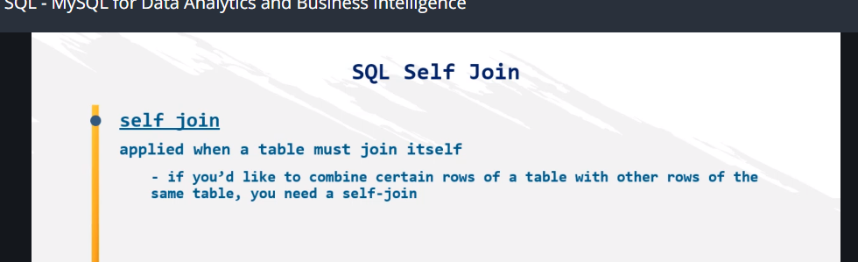

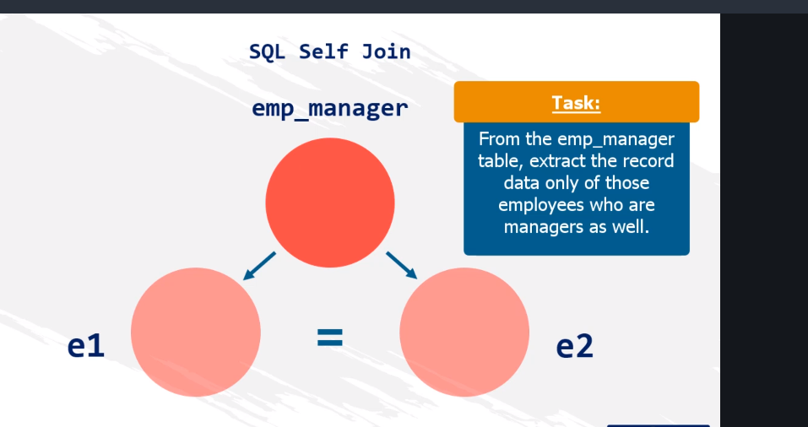

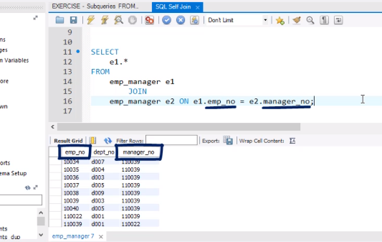

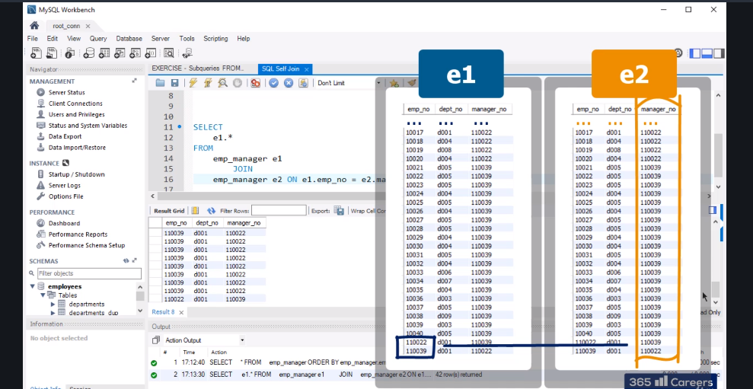

The final solution

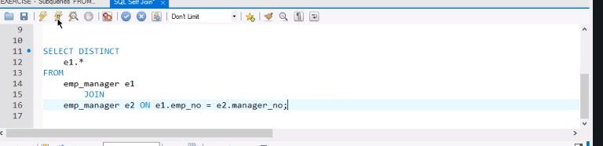

Real final solution or any of them gives same answer

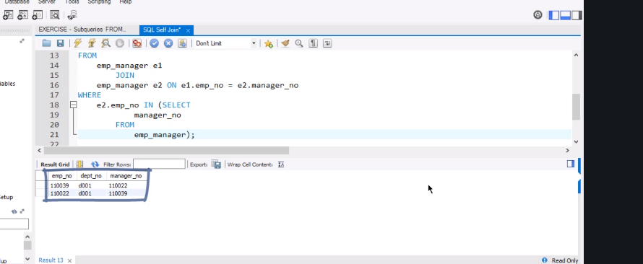

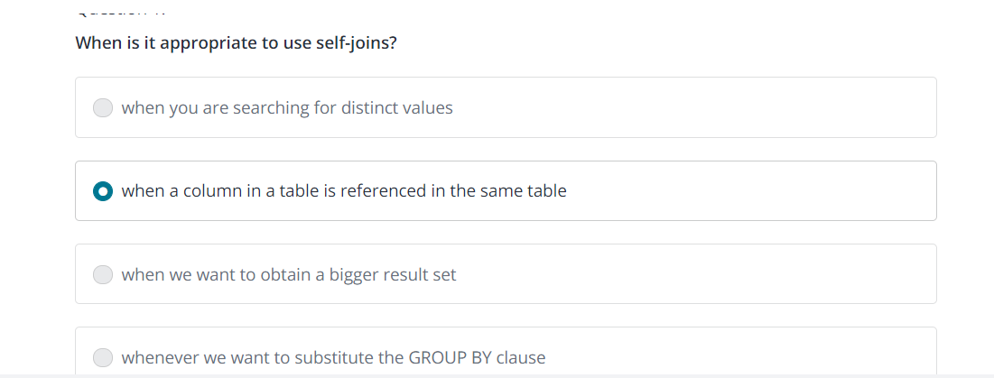

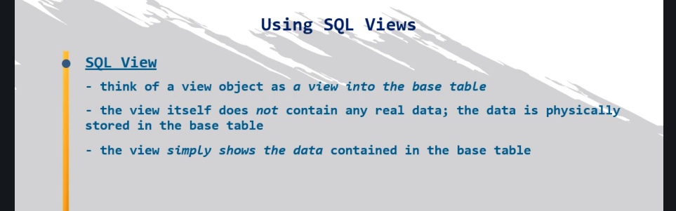

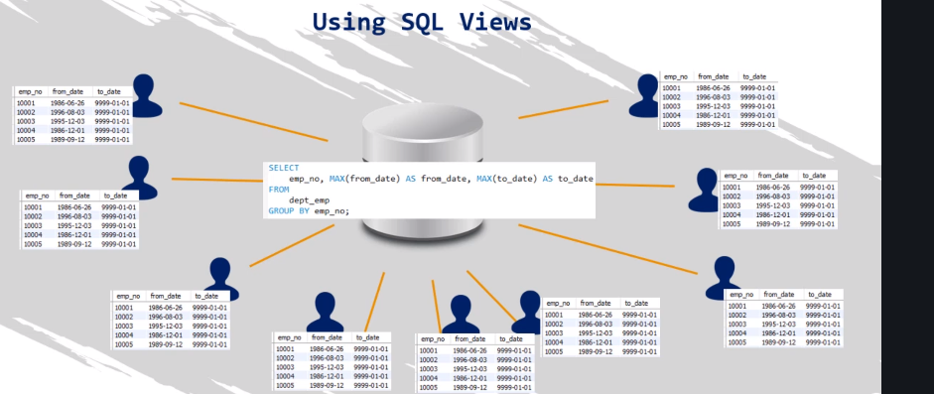this just good when u want to see a table but dnt want to run query all the time because too much people are using it

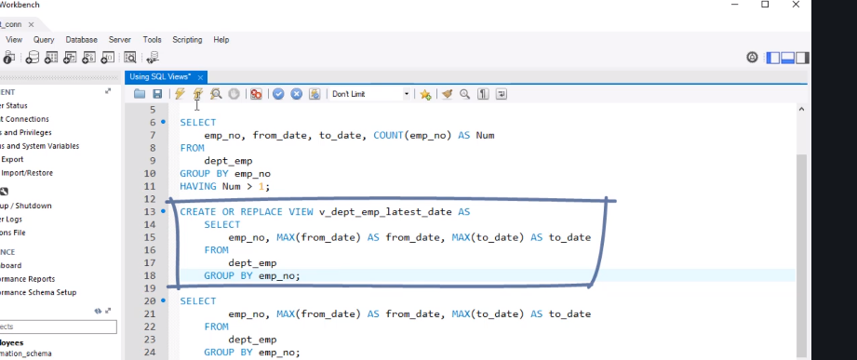

Always use a v underscore

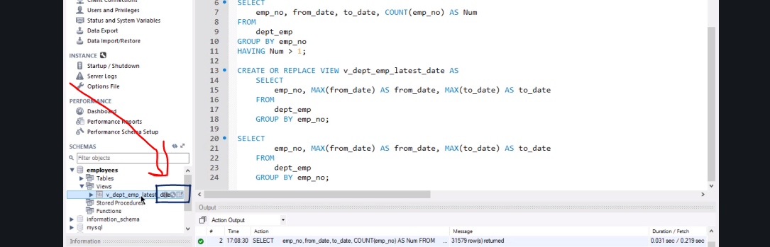

Always use v_

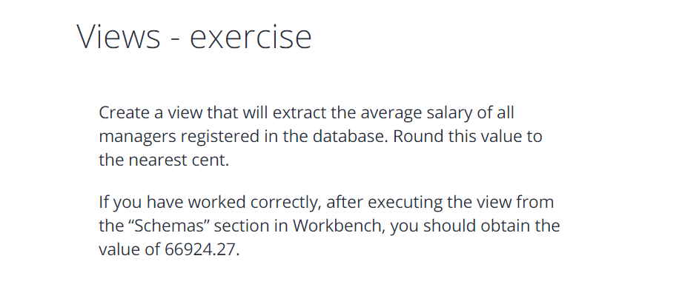

**CREATE OR REPLACE VIEW v_manager_avg_salary AS**

**SELECT**

**ROUND(AVG(salary), 2)**

**FROM**

**salaries s**

**JOIN**

**dept_manager m ON s.emp_no = m.emp_no;**

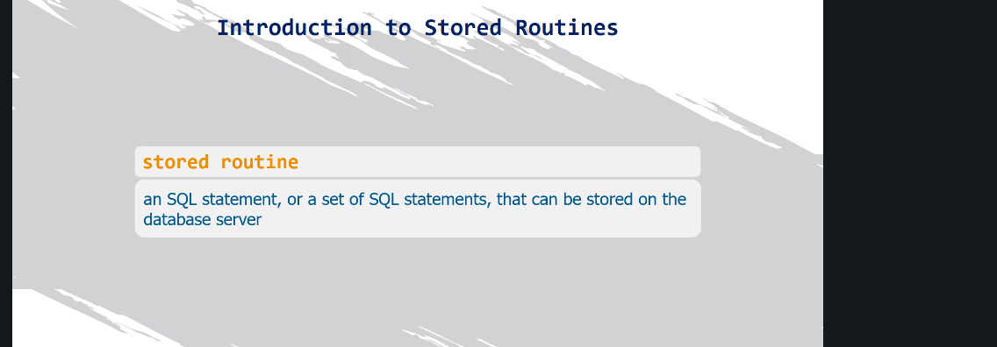

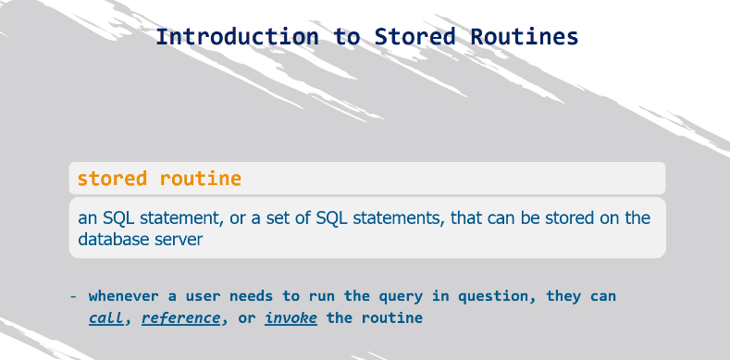

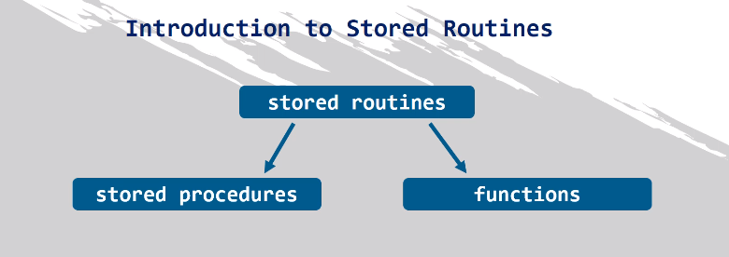

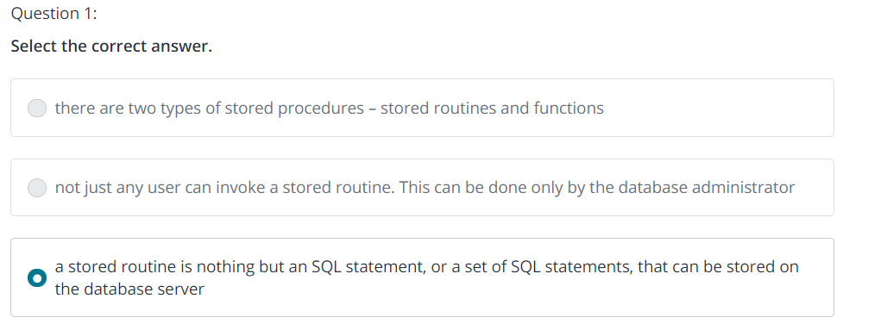

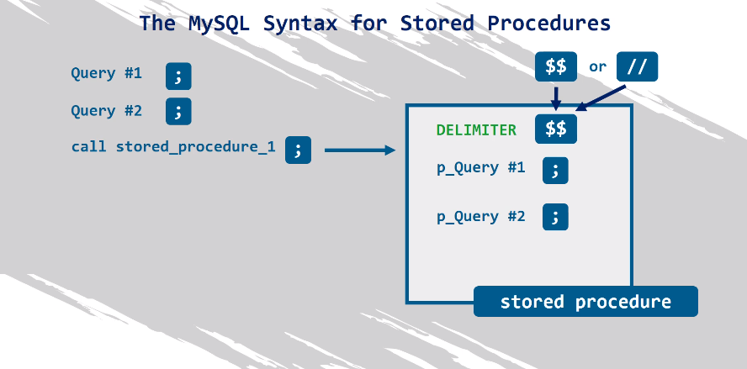

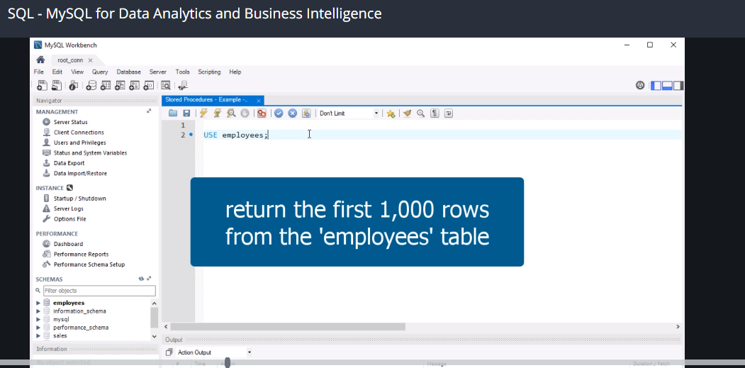

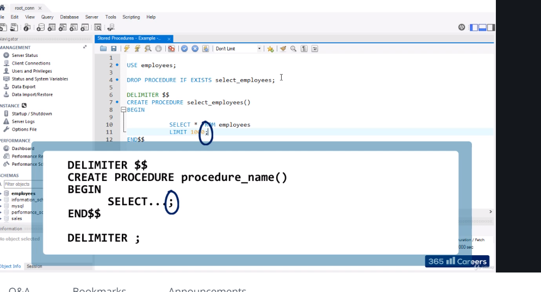

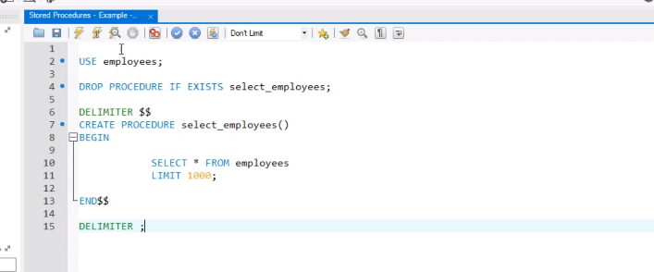

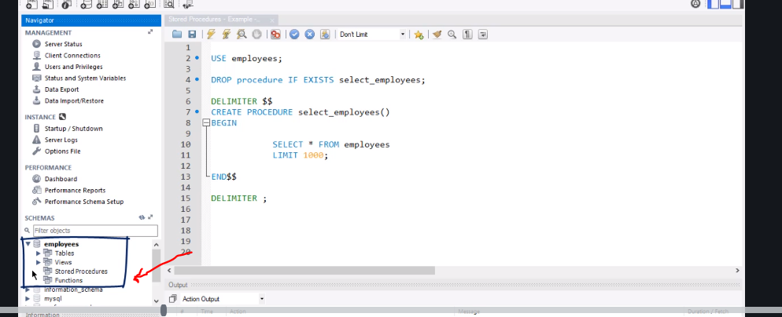

**It saves in stored procedures so refresh and see it**

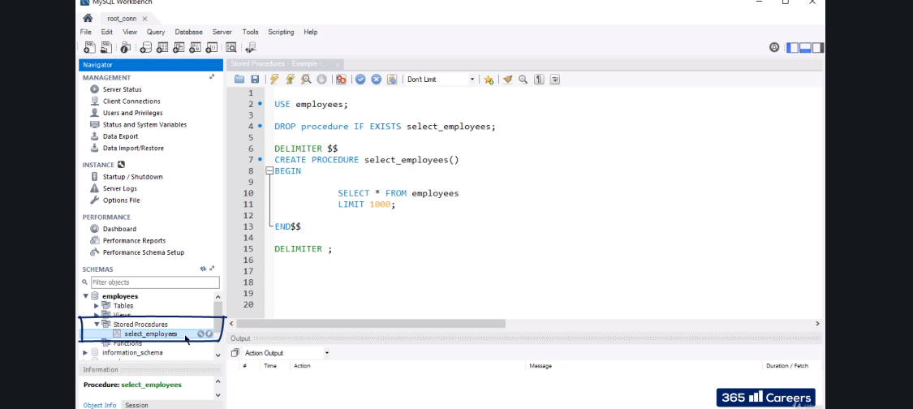

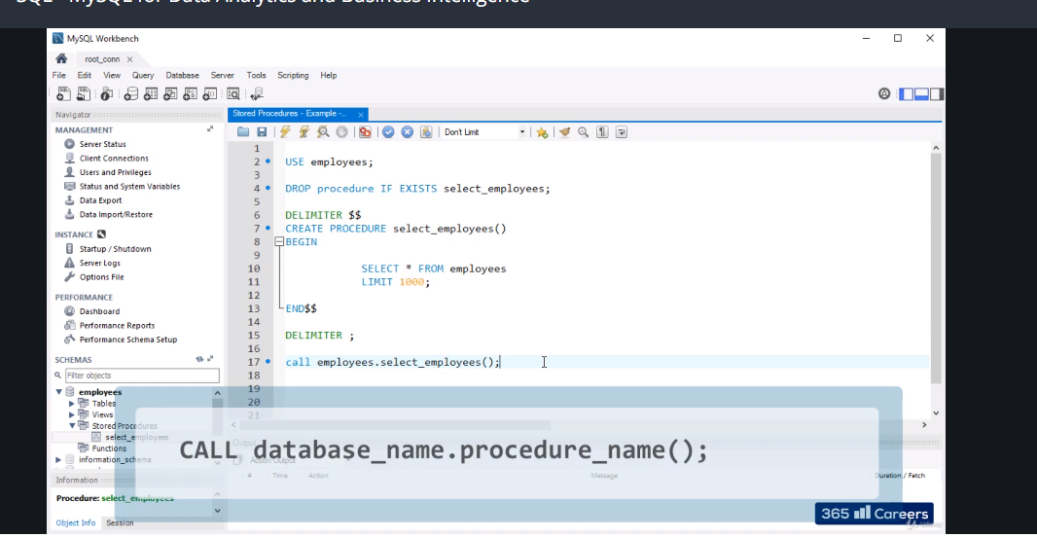

**Or**

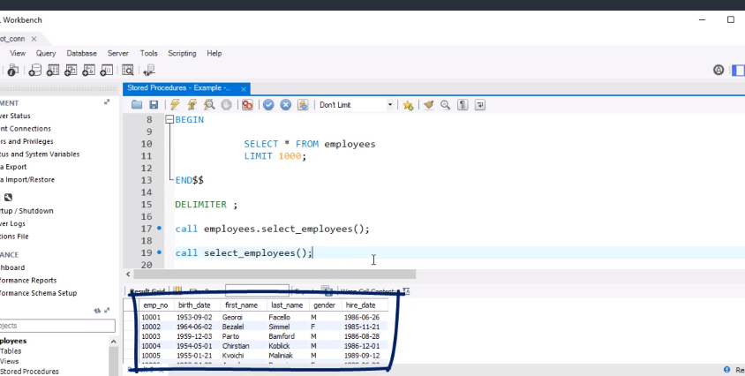

**Or just click the thunder sign which is the third way to access it**

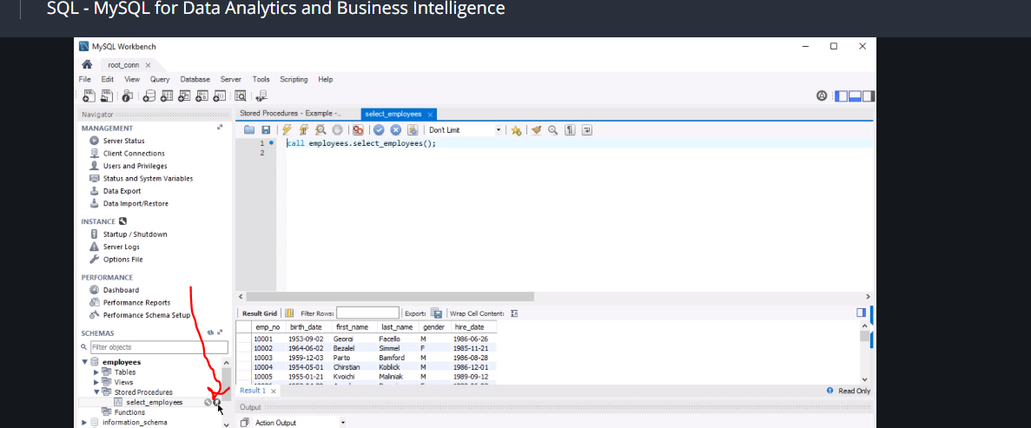

Stored procedures - Example - Part II - exercise

Create a procedure that will provide the average salary of all employees.

Then, call the procedure.

Stored procedures - Example - Part II - solution

**DELIMITER $$**

**CREATE PROCEDURE avg_salary()**

**BEGIN**

**SELECT**

**AVG(salary)**

**FROM**

**salaries;**

**END$$**

**DELIMITER ;**

**CALL avg_salary;**

**CALL avg_salary();**

**CALL employees.avg_salary;**

**CALL employees.avg_salary();**

**To delete or drop procedure**

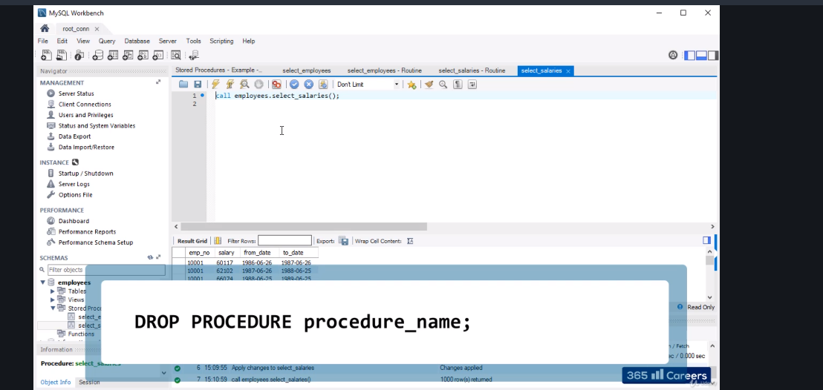

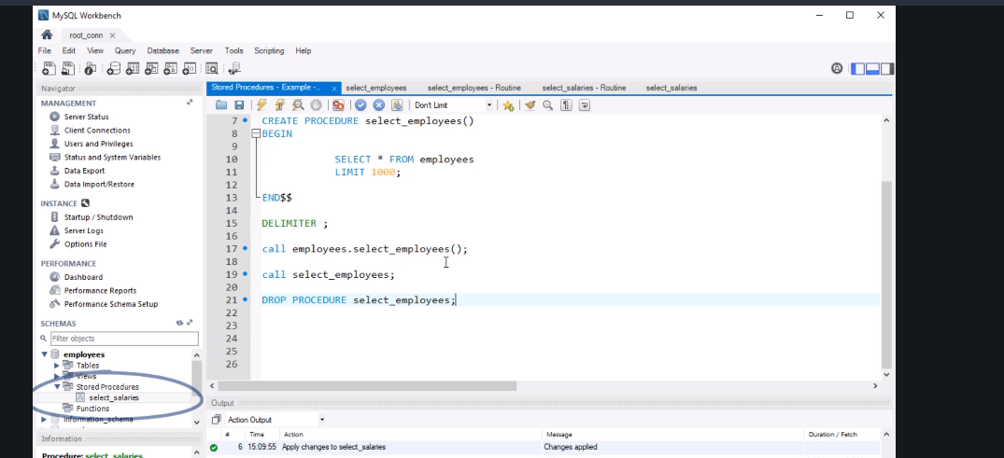

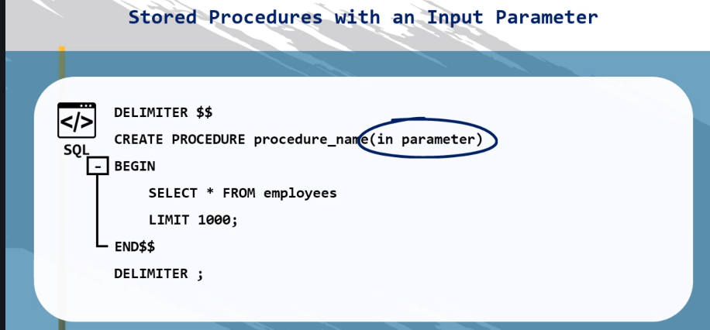

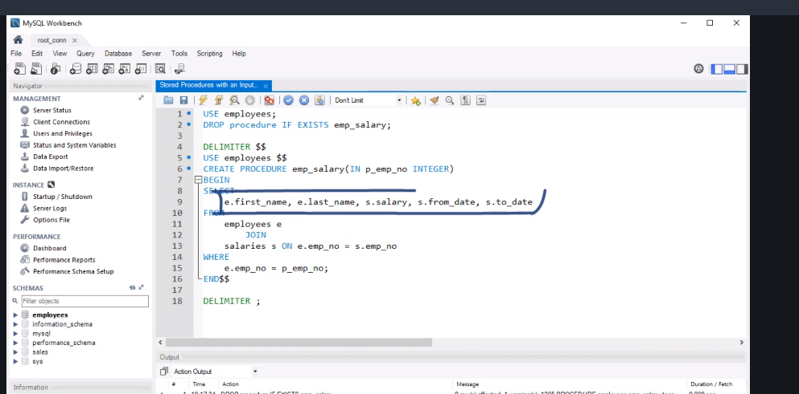

**Use p_**

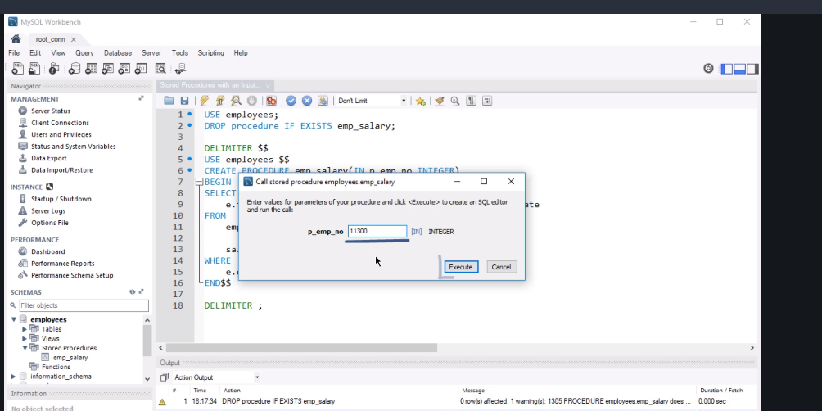

**Now we calculate average salary**

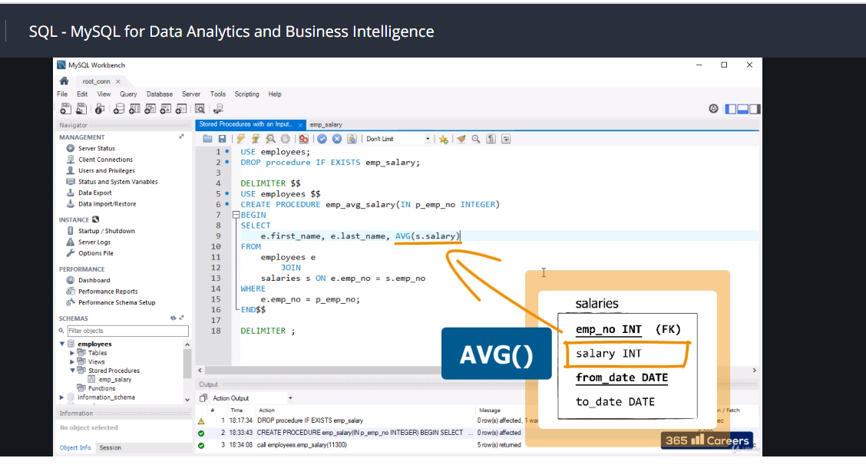

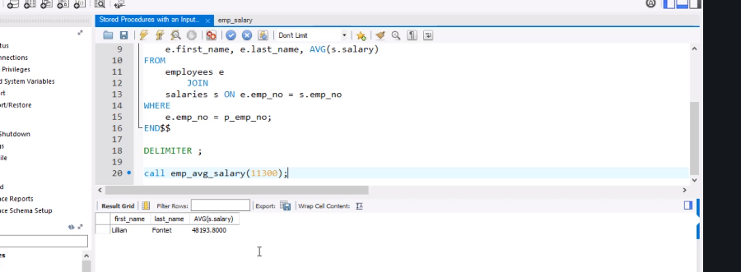

**We can call it as above by the input.**

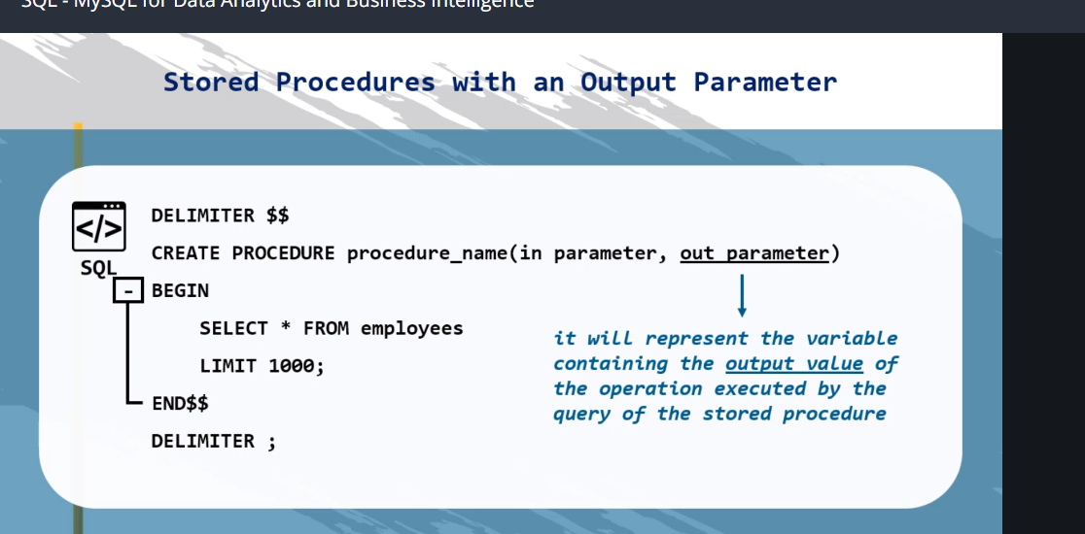

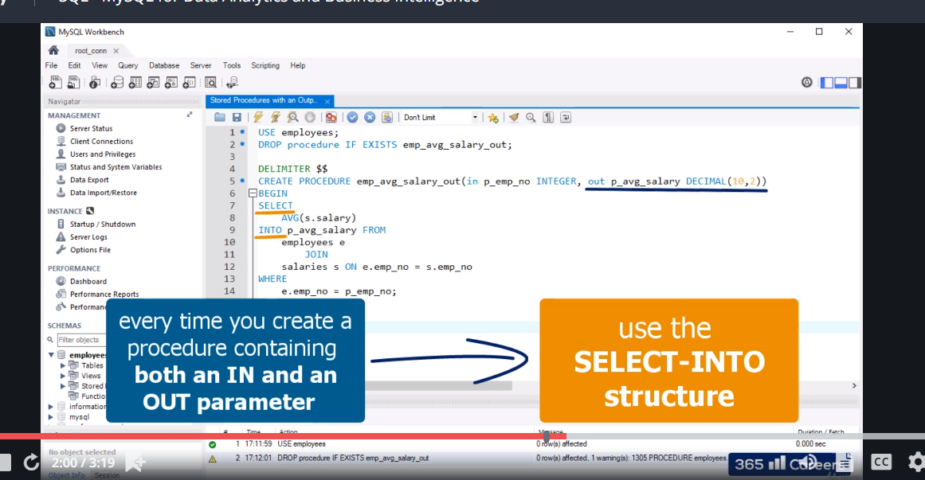

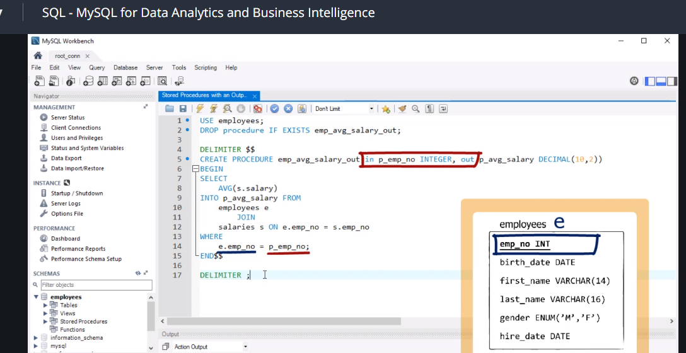

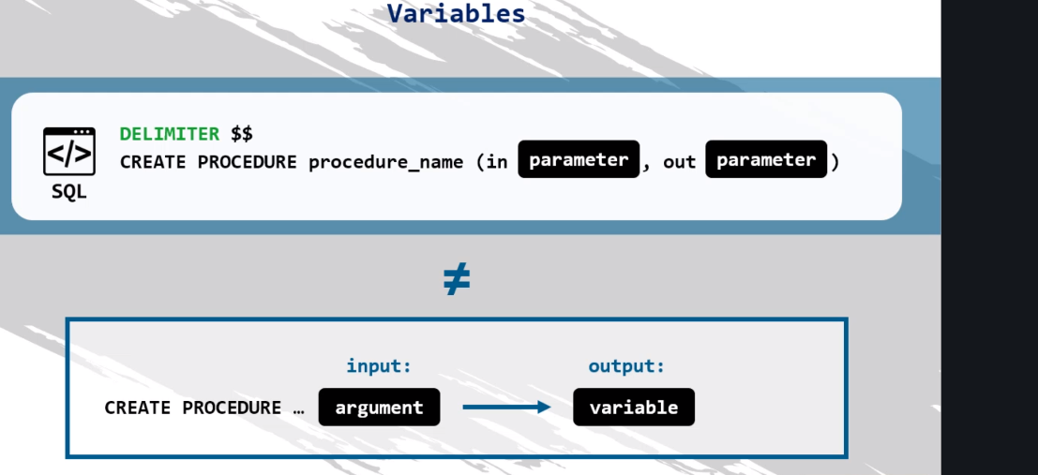

Variables - exercise

Create a variable, called ‘v_emp_no’, where you will store the output of the procedure you created in the last exercise.

Call the same procedure, inserting the values ‘Aruna’ and ‘Journel’ as a first and last name respectively.

Finally, select the obtained output.

Variables - solution

**SET @v_emp_no = 0;**

**CALL emp_info('Aruna', 'Journel', @v_emp_no);**

**SELECT @v_emp_no;**

Error Code: 1418.

**Error Code: 1418. This function has none of DETERMINISTIC, NO SQL, or READS SQL DATA in its declaration and binary logging is enabled…**

Let’s begin by saying that a *log* is a software component where you can save information about some events or errors that happened during the execution of a certain application. A log is preserved for traceability or debugging reasons and this is how it is used in MySQL as well.

Consequently, a *Binary* Log is a log that contains database changes. This type of logging affects the way in which we need to structure our code when creating MySQL functions.

**When the Binary Log has been enabled**, it will always check whether a function is changing the data in the database and what is the result to be produced. The situation can be described like this.

Unless we specify what the exact behavior of our function should be, our code will lead to an error. This error is with code 1418 and states that the function has none of the following characteristics in its declaration: DETERMINISTIC, NO SQL, or READS SQL DATA.

To solve this error, we must include one (or more) of these characteristics in our code in the way shown in the previous video. They must be placed right after we ‘ve specified the return type of the function. Here’s the syntax to use:

**create function <function name> <function parameters> returns <type> <characteristics> …**

Let’s check the meaning of these characteristics:

· DETERMINISTIC – it states that the function will always return identical result given the same input

· NO SQL – means that the code in our function does not contain SQL (rarely the case)

· READS SQL DATA – this is usually when a simple SELECT statement is present

When none of those is present in our code, MySQL assumes that our function is non deterministic and that it changes data. This might not be the case, but still, in the end, an error is raised just because MySQL cannot know a priori what our function will do. Adding one of those to our code will prevent this error of showing up.

That said, there is another way to stop the error - by *disabling* the binary log when creating functions. And we can achieve this by executing the following command:

SET @@global.log_bin_trust_function_creators := 1;

Technically speaking, this operation isn’t the safest one out there. Nevertheless, for the purposes of this course, it is the one that will solve the potential problems regardless of the version of MySQL.

In conclusion, remember that sometimes the Binary Log may be disabled anyway and you don’t have to take any of the above actions. In that case, we simply hope you’ve enjoyed reading this article! Thank you!

User-defined functions in MySQL - exercise

Create a function called ‘emp_info’ that takes for parameters the first and last name of an employee, and returns the salary from the newest contract of that employee.

*Hint: In the BEGIN-END block of this program, you need to declare and use two variables – v_max_from_date that will be of the DATE type, and v_salary, that will be of the DECIMAL (10,2) type.*

Finally, select this function.

User-defined functions in MySQL - solution

**DELIMITER $$**

**CREATE FUNCTION emp_info(p_first_name varchar(255), p_last_name varchar(255)) RETURNS decimal(10,2)**

**DETERMINISTIC NO SQL READS SQL DATA**

**BEGIN**

**DECLARE v_max_from_date date;**

**DECLARE v_salary decimal(10,2);**

**SELECT**

**MAX(from_date)**

**INTO v_max_from_date FROM**

**employees e**

**JOIN**

**salaries s ON e.emp_no = s.emp_no**

**WHERE**

**e.first_name = p_first_name**

**AND e.last_name = p_last_name;**

**SELECT**

**s.salary**

**INTO v_salary FROM**

**employees e**

**JOIN**

**salaries s ON e.emp_no = s.emp_no**

**WHERE**

**e.first_name = p_first_name**

**AND e.last_name = p_last_name**

**AND s.from_date = v_max_from_date;**

**RETURN v_salary;**

**END$$**

**DELIMITER ;**

**SELECT EMP_INFO('Aruna', 'Journel');**

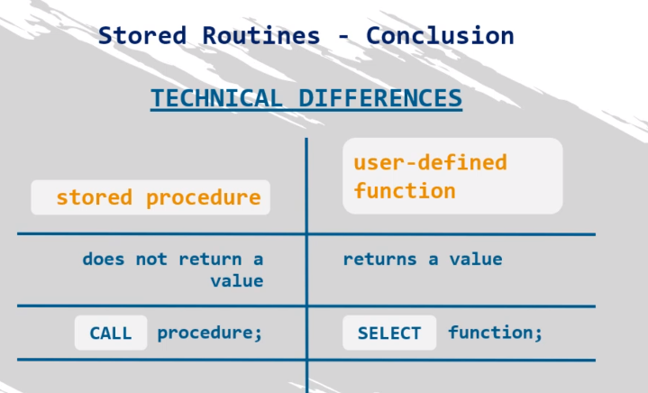

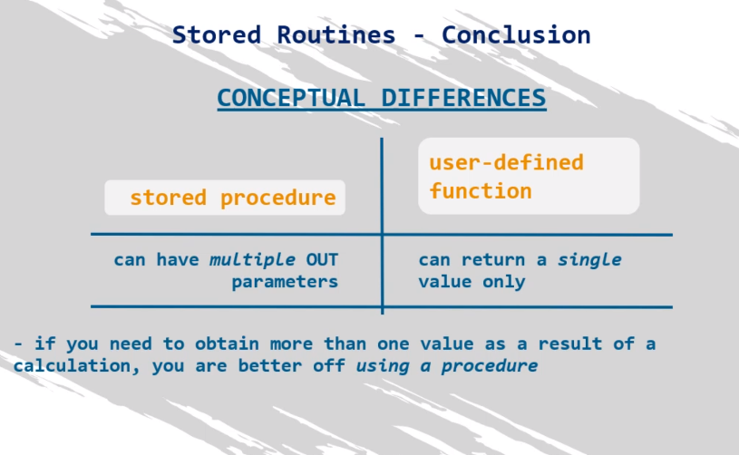

**Fuck functions**

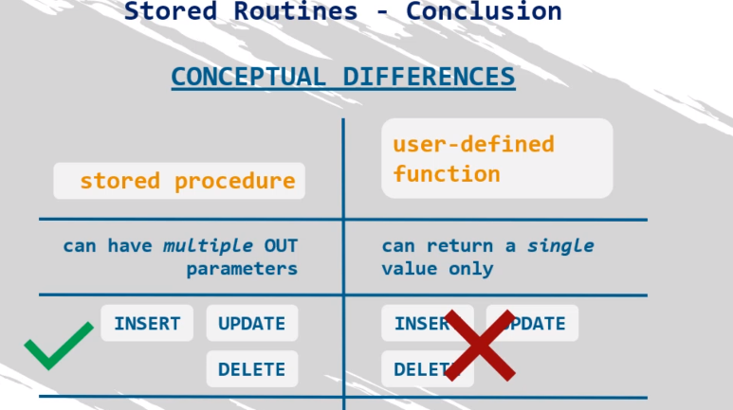

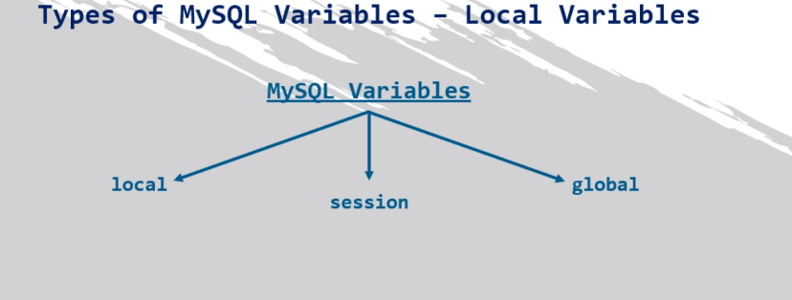

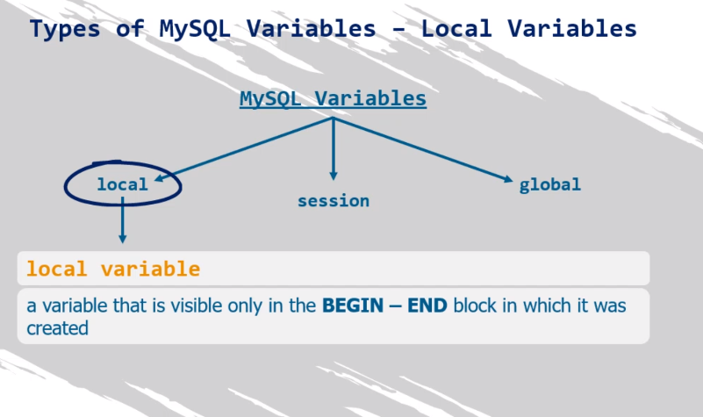

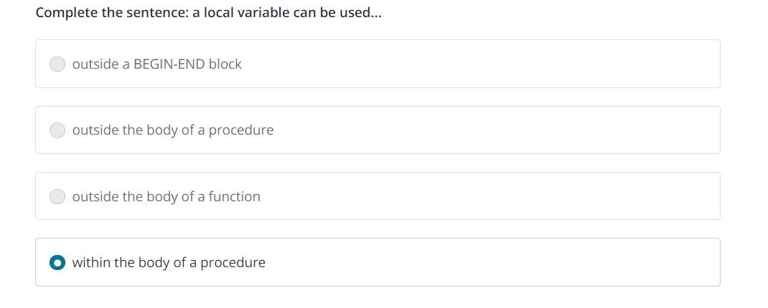

MySQL Triggers - exercise

Create a trigger that checks if the hire date of an employee is higher than the current date. If true, set this date to be the current date. Format the output appropriately (YY-MM-DD).

MySQL Triggers - solution

**DELIMITER $$**

**CREATE TRIGGER trig_hire_date**

**BEFORE INSERT ON employees**

**FOR EACH ROW**

**BEGIN**

**IF NEW.hire_date > date_format(sysdate(), '%Y-%m-%d') THEN**

**SET NEW.hire_date = date_format(sysdate(), '%Y-%m-%d');**

**END IF;**

**END $$**

**DELIMITER ;**

**INSERT employees VALUES ('999904', '1970-01-31', 'John', 'Johnson', 'M', '2025-01-01');**

**SELECT**

**\***

**FROM**

**employees**

**ORDER BY emp_no DESC;**

MySQL Indexes - exercise 2

Select all records from the ‘salaries’ table of people whose salary is higher than $89,000 per annum.

Then, create an index on the ‘salary’ column of that table, and check if it has sped up the search of the same SELECT statement.

MySQL Indexes - solution 2

**SELECT**

**\***

**FROM**

**salaries**

**WHERE**

**salary > 89000;**

**CREATE INDEX i_salary ON salaries(salary);**

**SELECT**

**\***

**FROM**

**salaries**

**WHERE**

**salary > 89000;**

The CASE Statement - exercise 1

Similar to the exercises done in the lecture, obtain a result set containing the employee number, first name, and last name of all employees with a number higher than 109990. Create a fourth column in the query, indicating whether this employee is also a manager, according to the data provided in the *dept_manager* table, or a regular employee.

The CASE Statement - solution 1

**SELECT**

**e.emp_no,**

**e.first_name,**

**e.last_name,**

**CASE**

**WHEN dm.emp_no IS NOT NULL THEN 'Manager'**

**ELSE 'Employee'**

**END AS is_manager**

**FROM**

**employees e**

**LEFT JOIN**

**dept_manager dm ON dm.emp_no = e.emp_no**

**WHERE**

**e.emp_no > 109990;**

The CASE Statement - exercise 2

Extract a dataset containing the following information about the managers: employee number, first name, and last name. Add two columns at the end – one showing the difference between the maximum and minimum salary of that employee, and another one saying whether this salary raise was higher than $30,000 or NOT.

If possible, provide more than one solution.

The CASE Statement - solution 2

**SELECT**

**dm.emp_no,**

**e.first_name,**

**e.last_name,**

**MAX(s.salary) - MIN(s.salary) AS salary_difference,**

**CASE**

**WHEN MAX(s.salary) - MIN(s.salary) > 30000 THEN 'Salary was raised by more then $30,000'**

**ELSE 'Salary was NOT raised by more then $30,000'**

**END AS salary_raise**

**FROM**

**dept_manager dm**

**JOIN**

**employees e ON e.emp_no = dm.emp_no**

**JOIN**

**salaries s ON s.emp_no = dm.emp_no**

**GROUP BY s.emp_no;**

**SELECT**

**dm.emp_no,**

**e.first_name,**

**e.last_name,**

**MAX(s.salary) - MIN(s.salary) AS salary_difference,**

**IF(MAX(s.salary) - MIN(s.salary) > 30000, 'Salary was raised by more then $30,000', 'Salary was NOT raised by more then $30,000') AS salary_increase**

**FROM**

**dept_manager dm**

**JOIN**

**employees e ON e.emp_no = dm.emp_no**

**JOIN**

**salaries s ON s.emp_no = dm.emp_no**

**GROUP BY s.emp_no;**

**#**

The CASE Statement - exercise 3

Extract the employee number, first name, and last name of the first 100 employees, and add a fourth column, called “current_employee” saying “Is still employed” if the employee is still working in the company, or “Not an employee anymore” if they aren’t.

*Hint: You’ll need to use data from both the ‘employees’ and the ‘dept_emp’ table to solve this exercise.*

The CASE Statement - solution 3

**SELECT**

**e.emp_no,**

**e.first_name,**

**e.last_name,**

**CASE**

**WHEN MAX(de.to_date) > SYSDATE() THEN 'Is still employed'**

**ELSE 'Not an employee anymore'**

**END AS current_employee**

**FROM**

**employees e**

**JOIN**

**dept_emp de ON de.emp_no = e.emp_no**

**GROUP BY de.emp_no**

**LIMIT 100;**

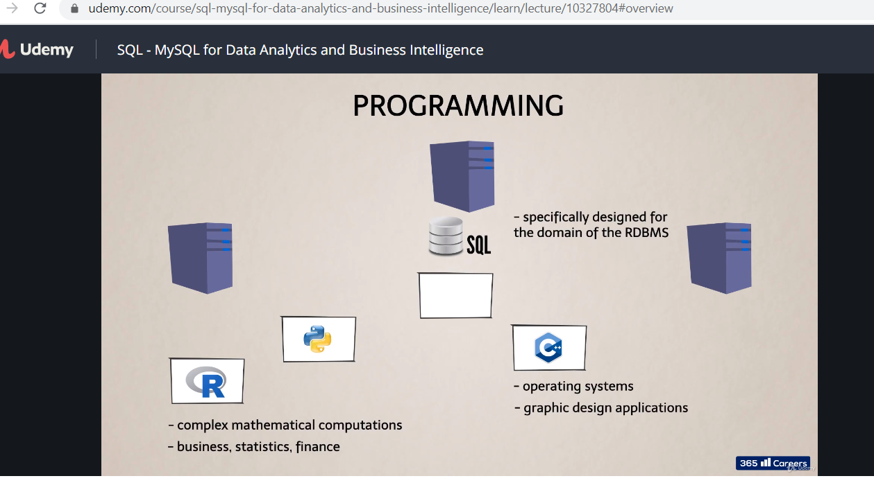

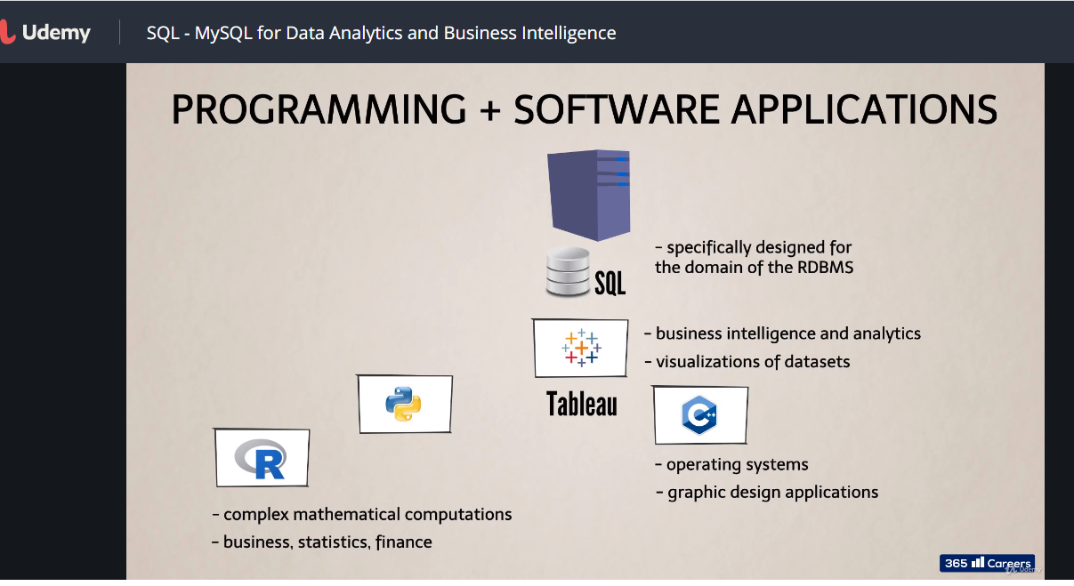

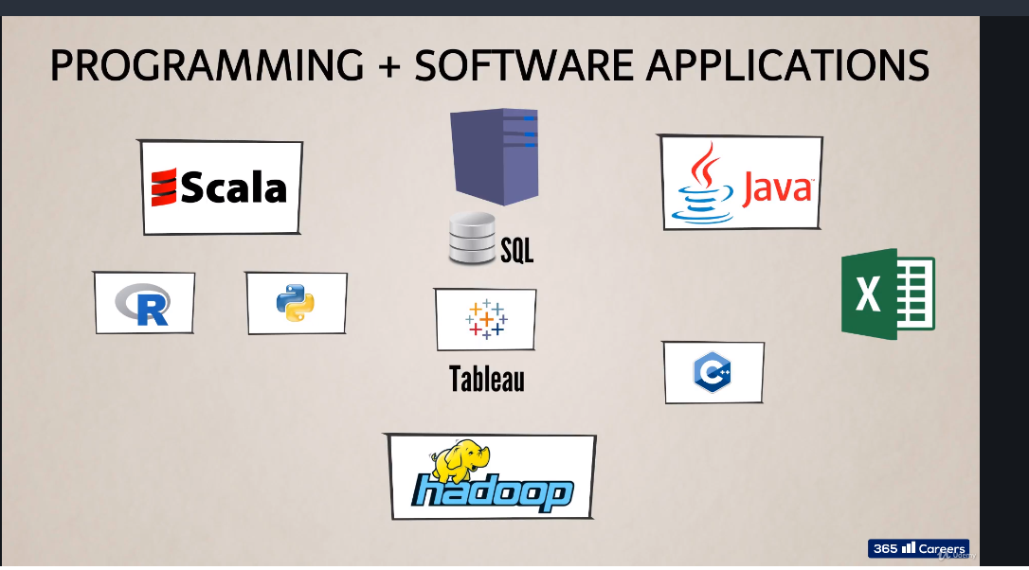

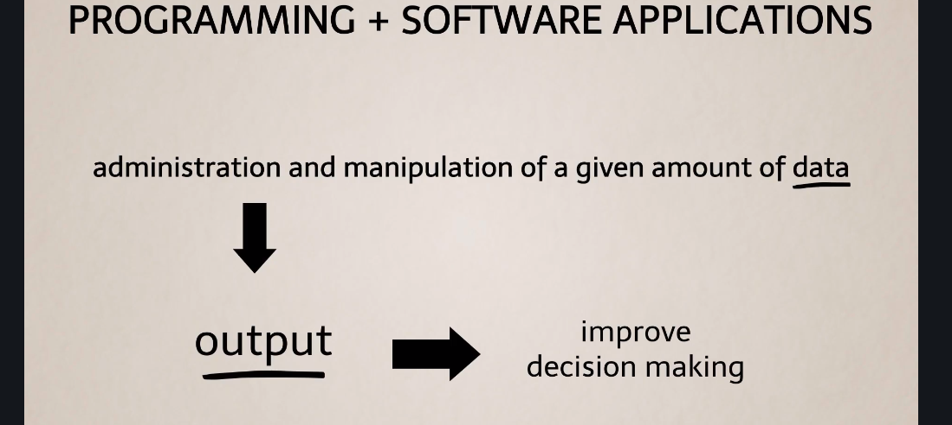



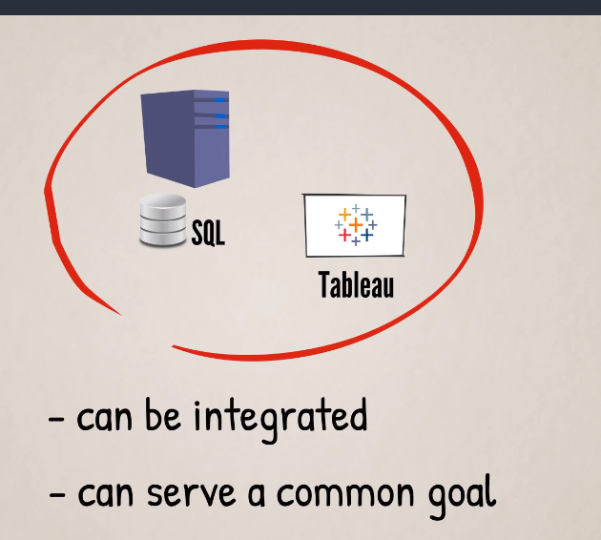

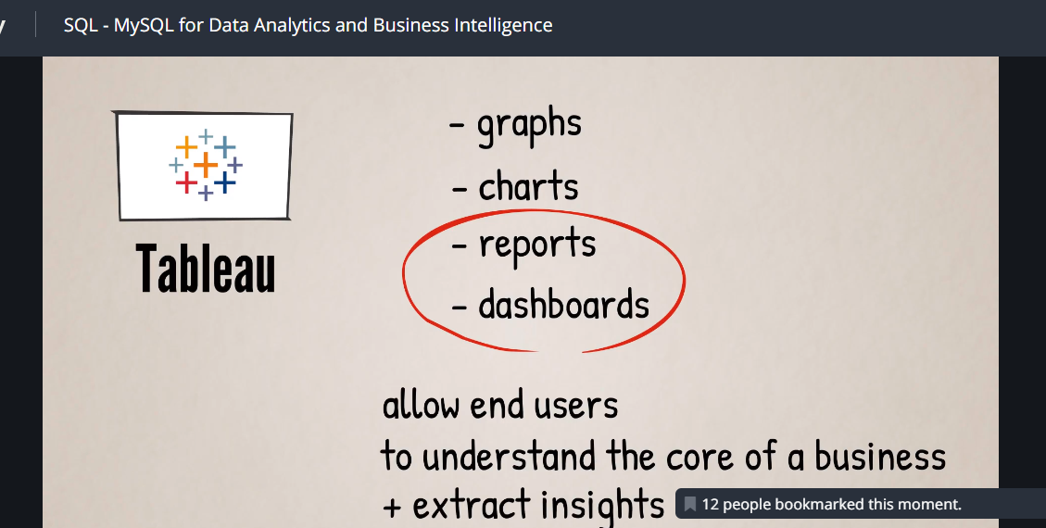

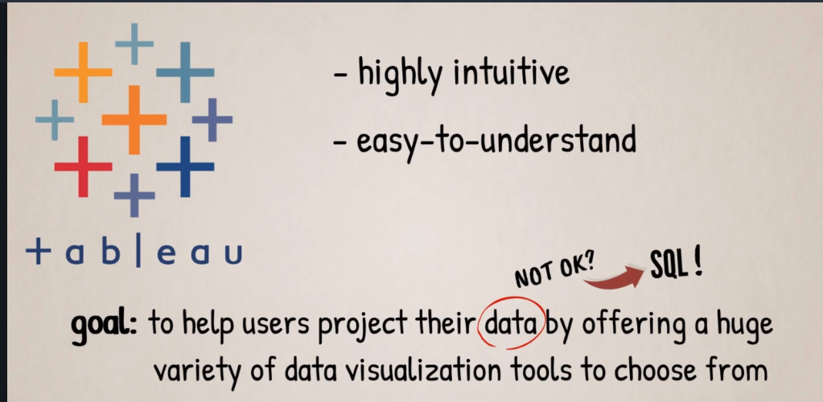

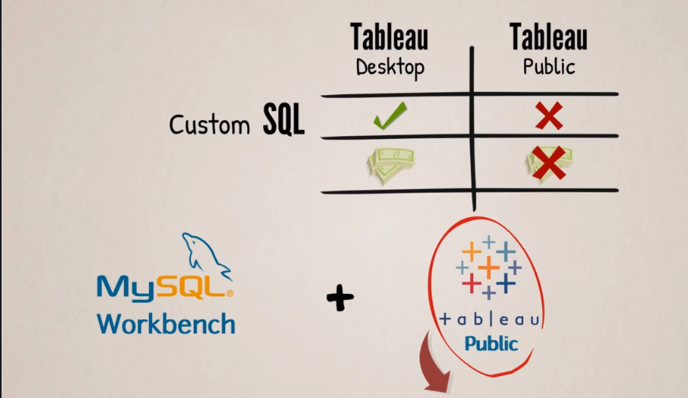

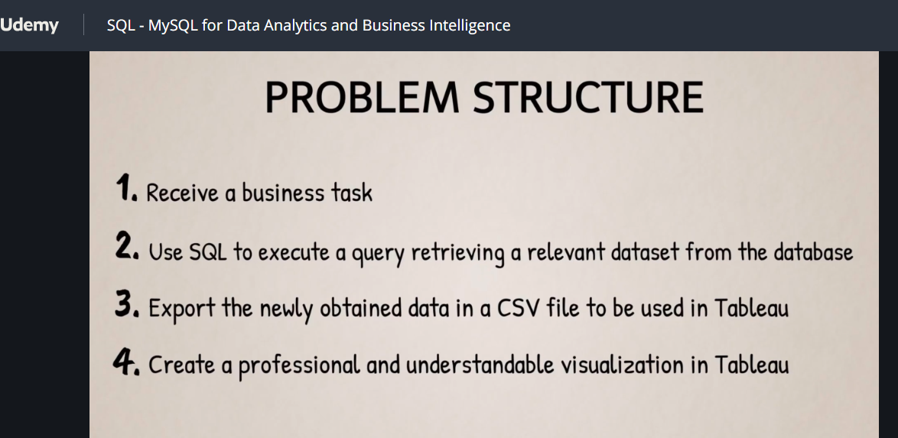

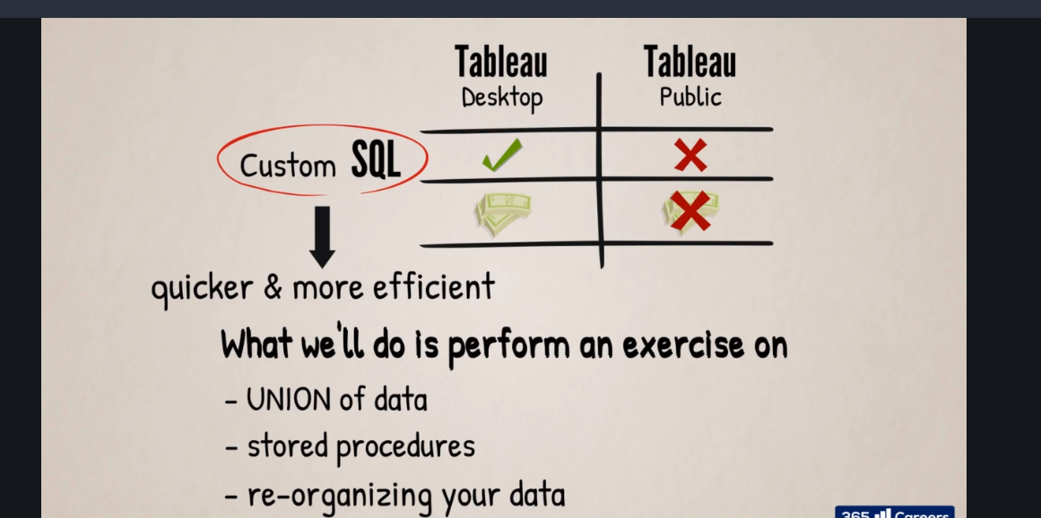

**Now go to google and type tableau public**

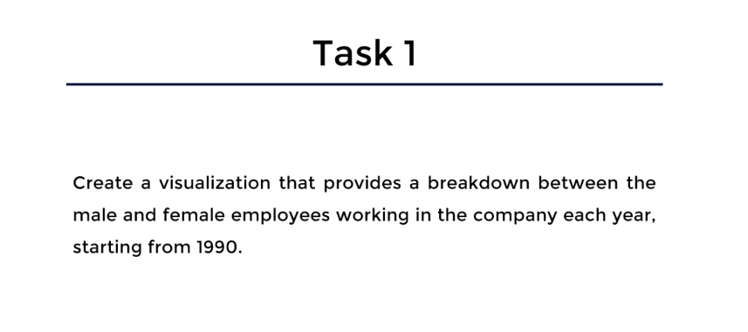

**This is the chart to visualise the output**

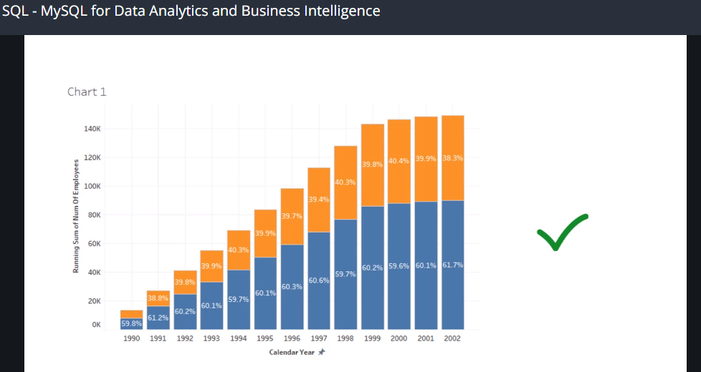

**To generate it you must have the outputs**

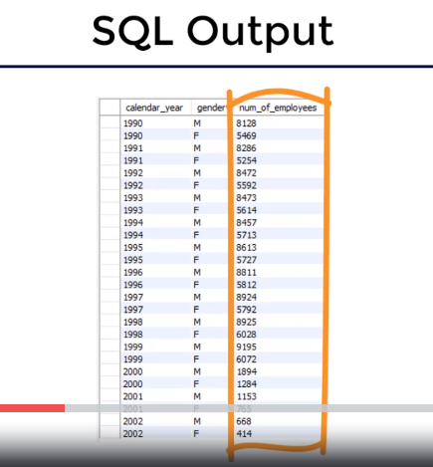

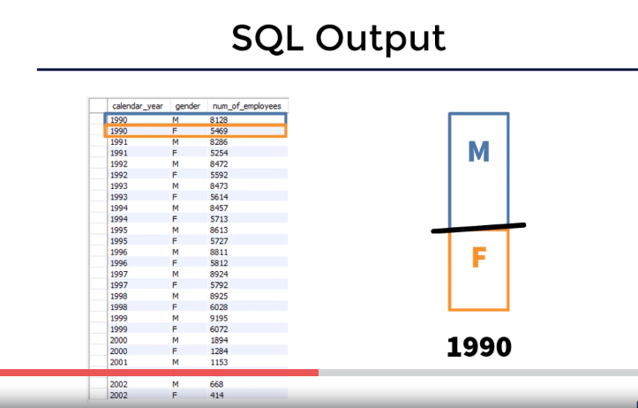

Task 1: SQL Solution - Code

**SELECT**

**YEAR(d.from_date) AS calendar_year,  
    e.gender,      
    COUNT(e.emp_no) AS num_of_employees**

**FROM       
     t_employees e           
          JOIN      
     t_dept_emp d ON d.emp_no = e.emp_no**

**GROUP BY calendar_year , e.gender**

**HAVING calendar_year >= 1990;**

Next step is to bring the data into tableau

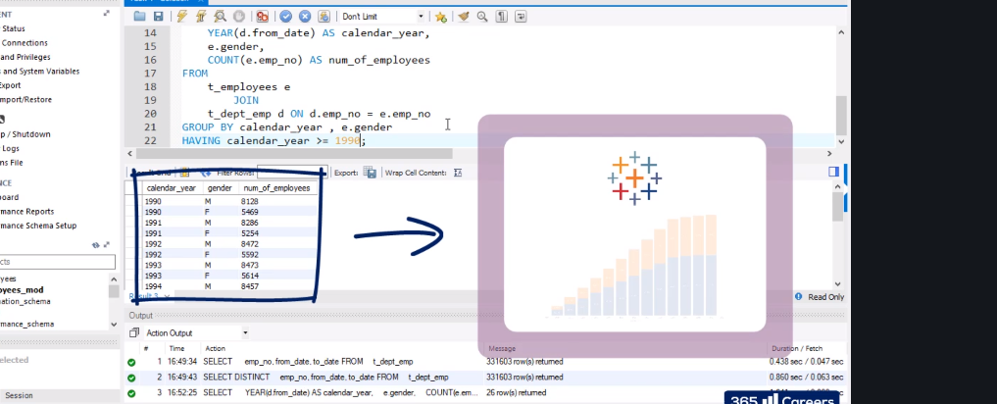

**So this will be exportd in csv format and loaded I tableau for analysis purpose**

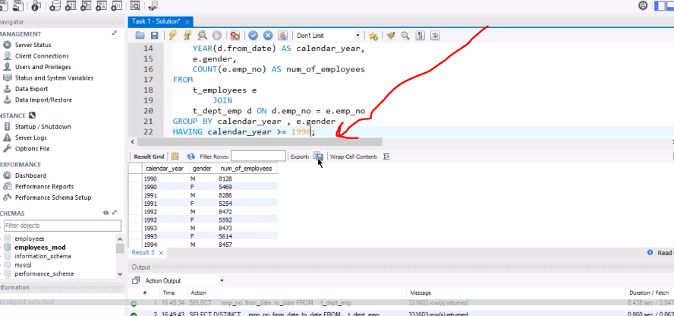

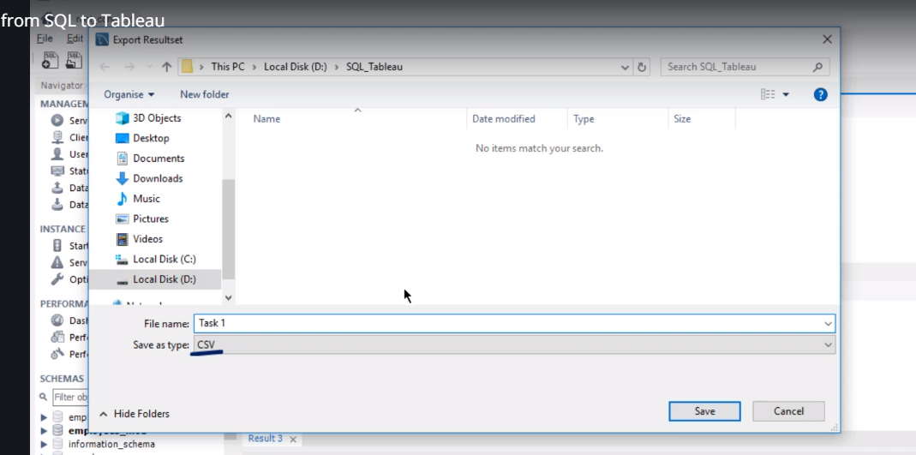

**Go to tableau**

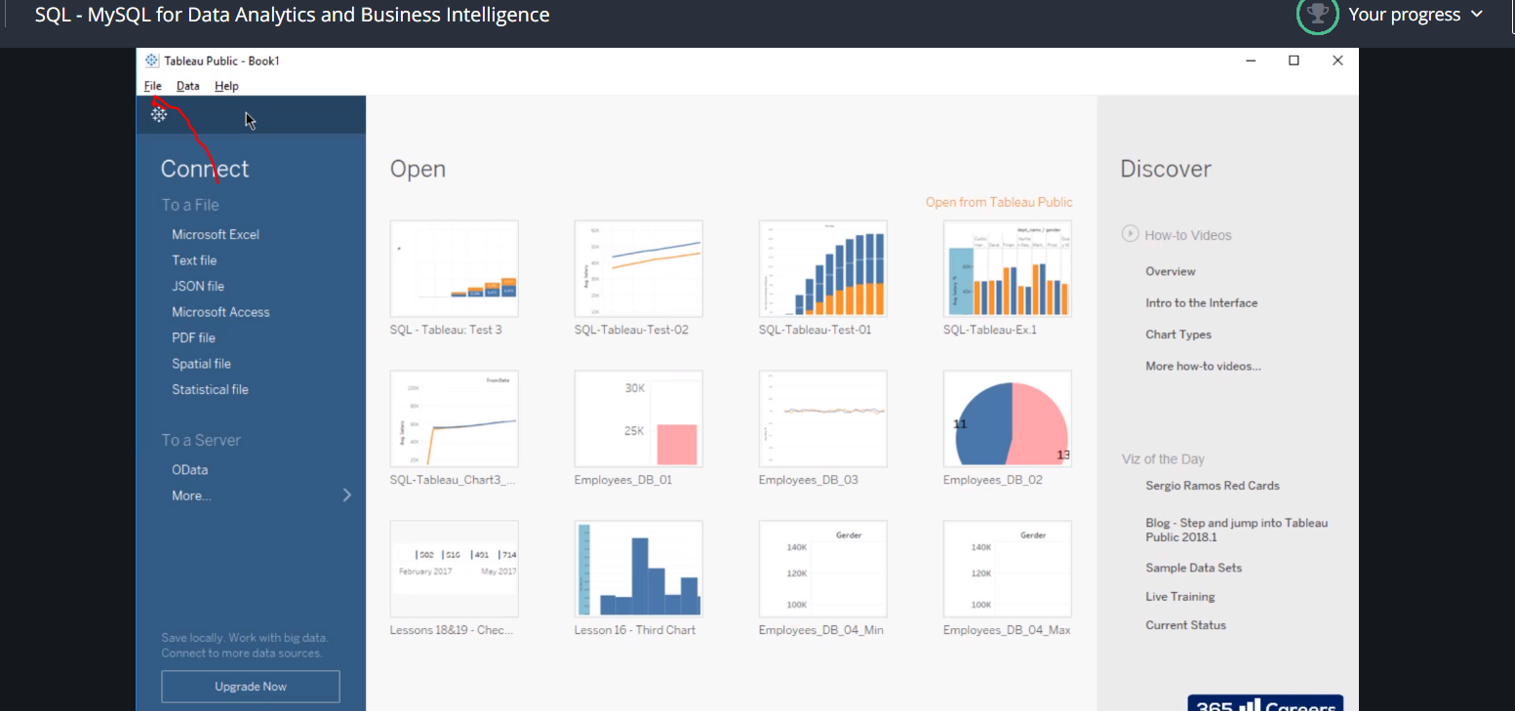

**Click file- new**

**Or just click text file and click the csv you saved from sql into the tableu**

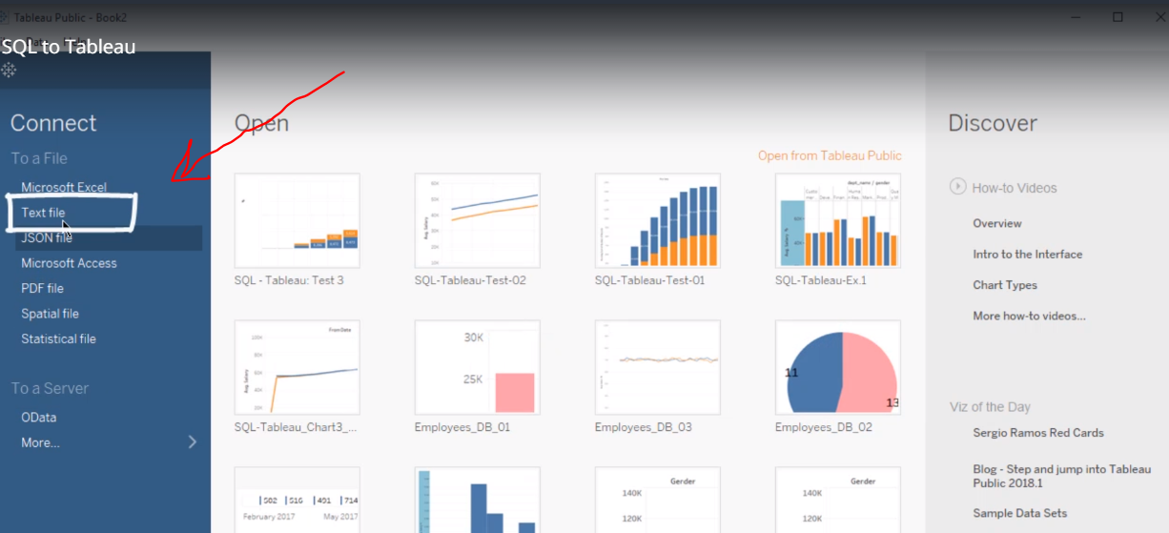

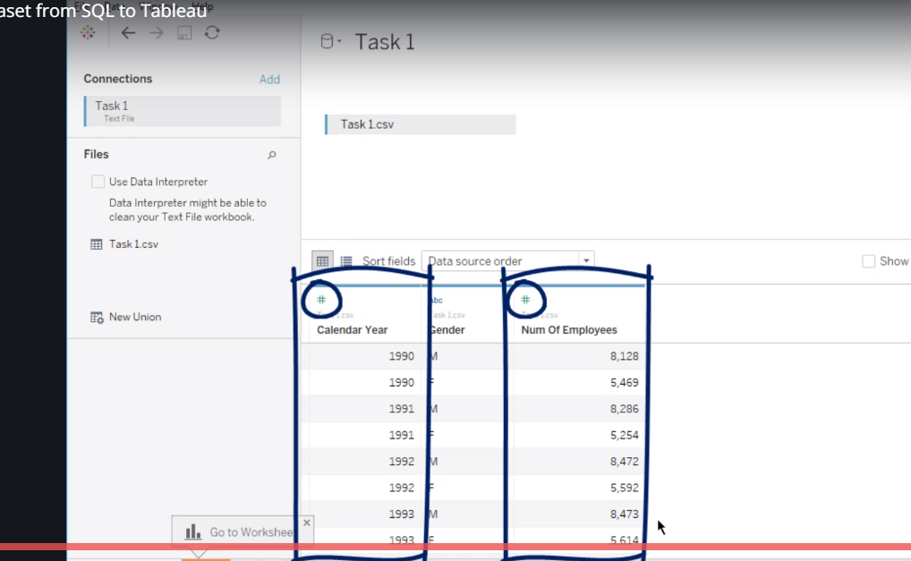

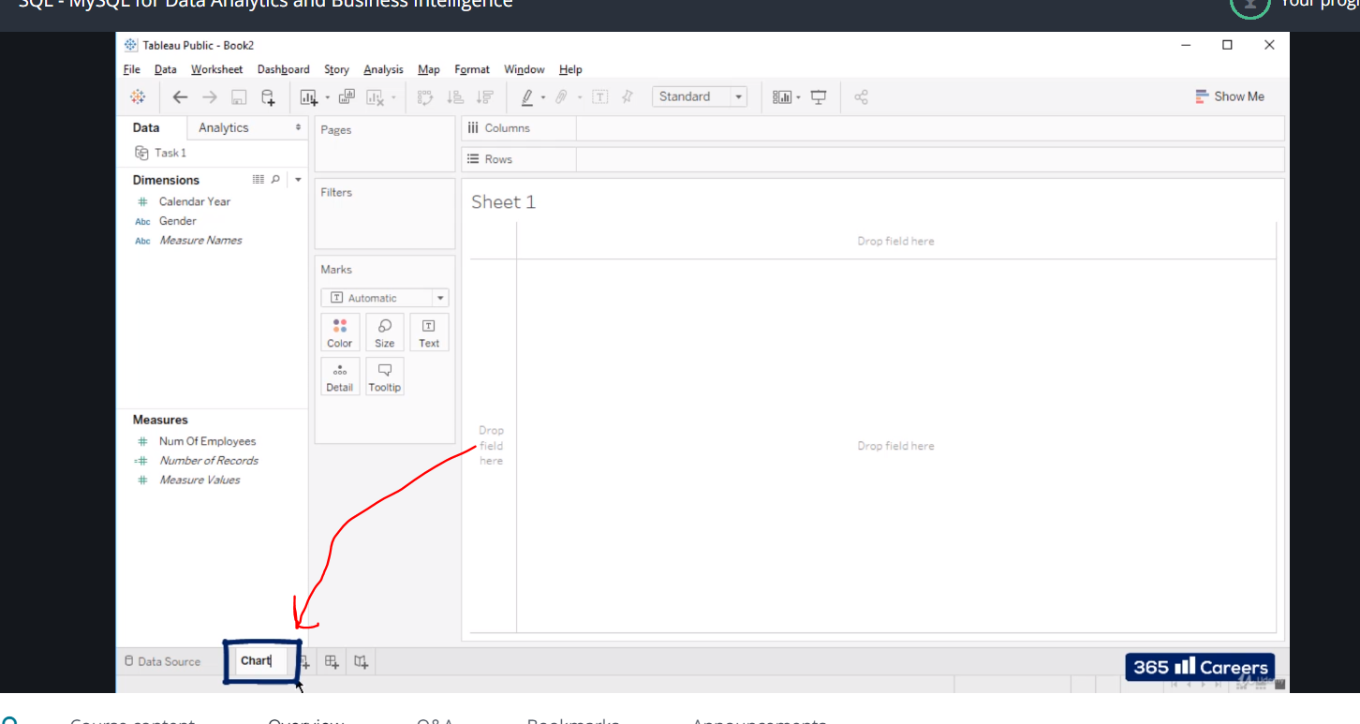

**Click and rename the sheet if you like.**

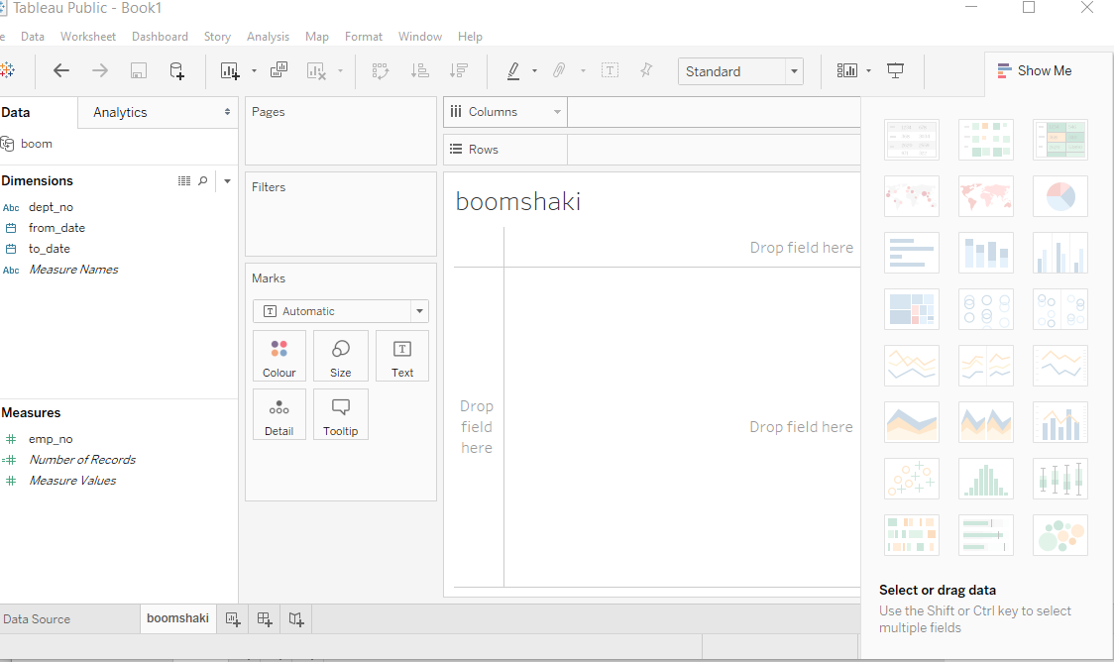

**Note you can drag and drop the dimension so you can drop it in either rows or columns**

**Click dropdown to change it to a bar chart**

**Then put gender as the detail drag it**

**Repeat it again**

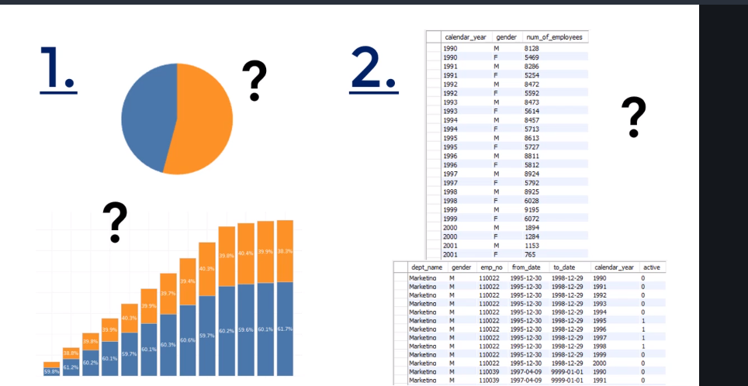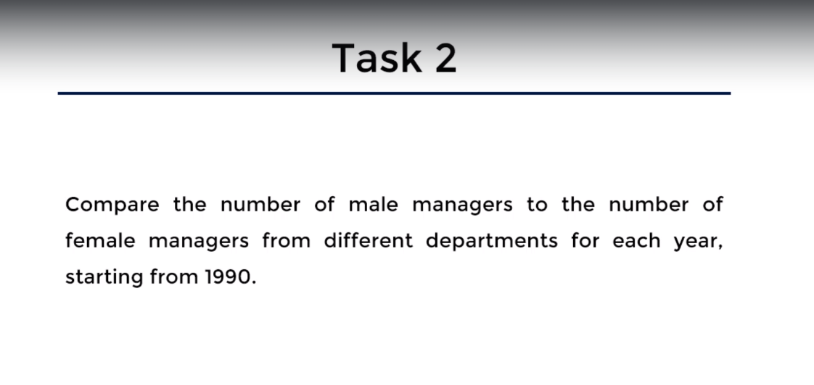

**Now we choose to use an area chat**

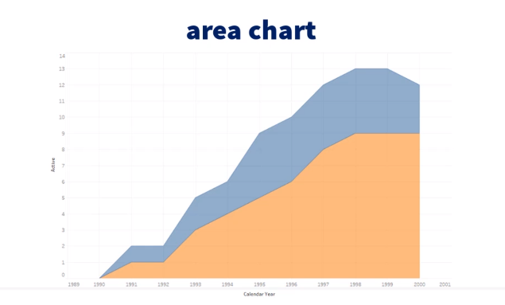

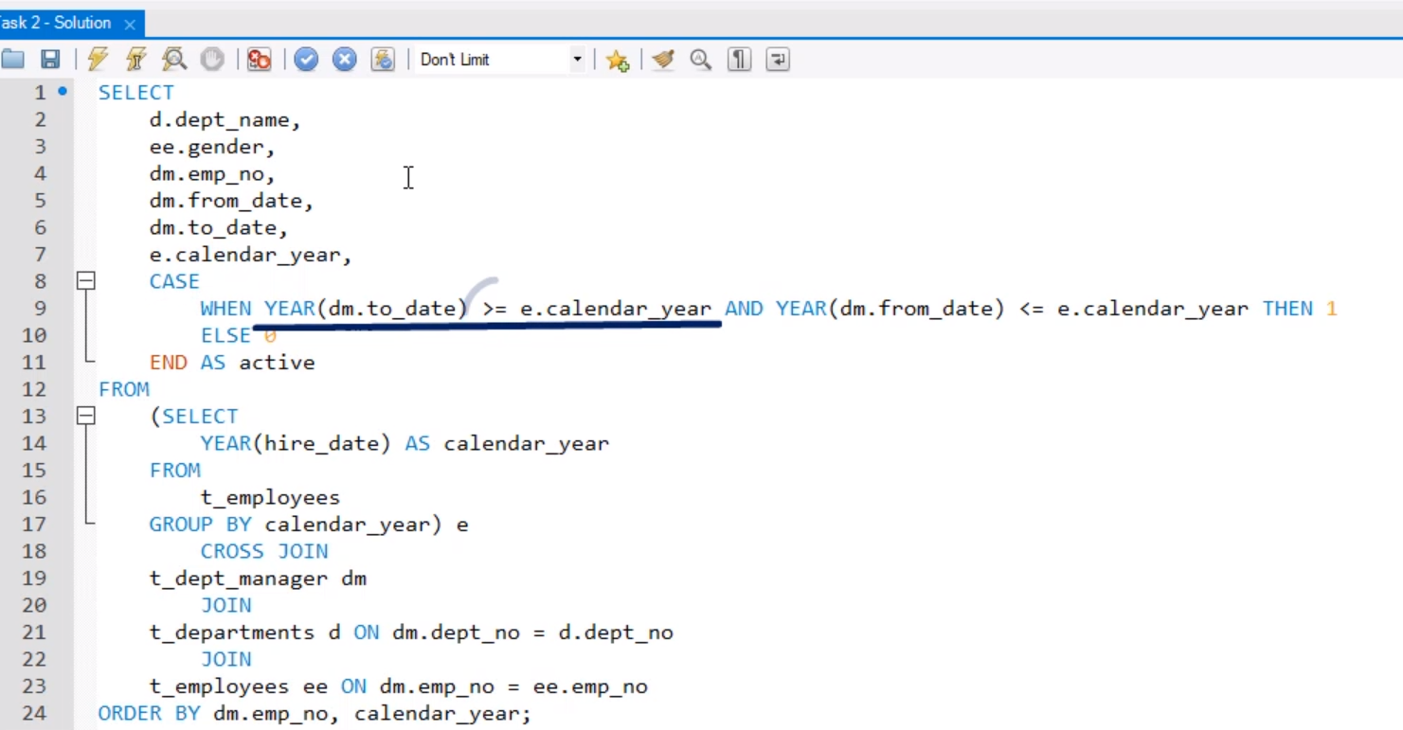

**SELECT   
    d.dept_name,  
    ee.gender,  
    dm.emp_no,  
    dm.from_date,  
    dm.to_date,  
    e.calendar_year,  
    CASE  
        WHEN YEAR(dm.to_date) >= e.calendar_year AND YEAR(dm.from_date) <= e.calendar_year THEN 1  
        ELSE 0  
    END AS active  
FROM  
    (SELECT   
        YEAR(hire_date) AS calendar_year  
    FROM  
        t_employees  
    GROUP BY calendar_year) e  
        CROSS JOIN  
    t_dept_manager dm  
        JOIN  
    t_departments d ON dm.dept_no = d.dept_no  
        JOIN   
    t_employees ee ON dm.emp_no = ee.emp_no  
ORDER BY dm.emp_no, calendar_year;**

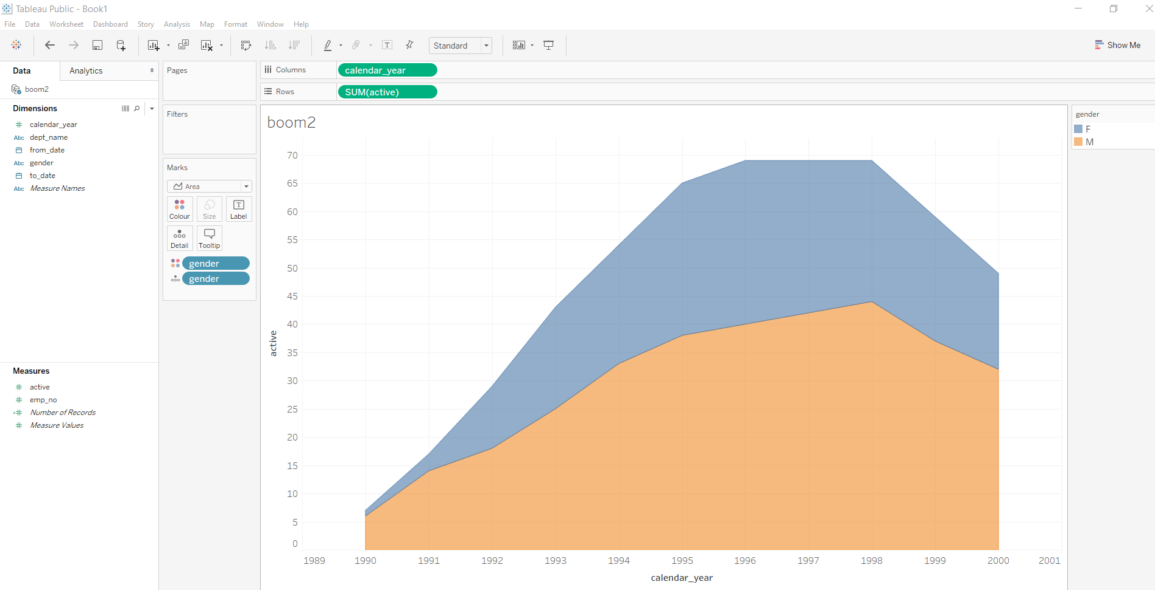

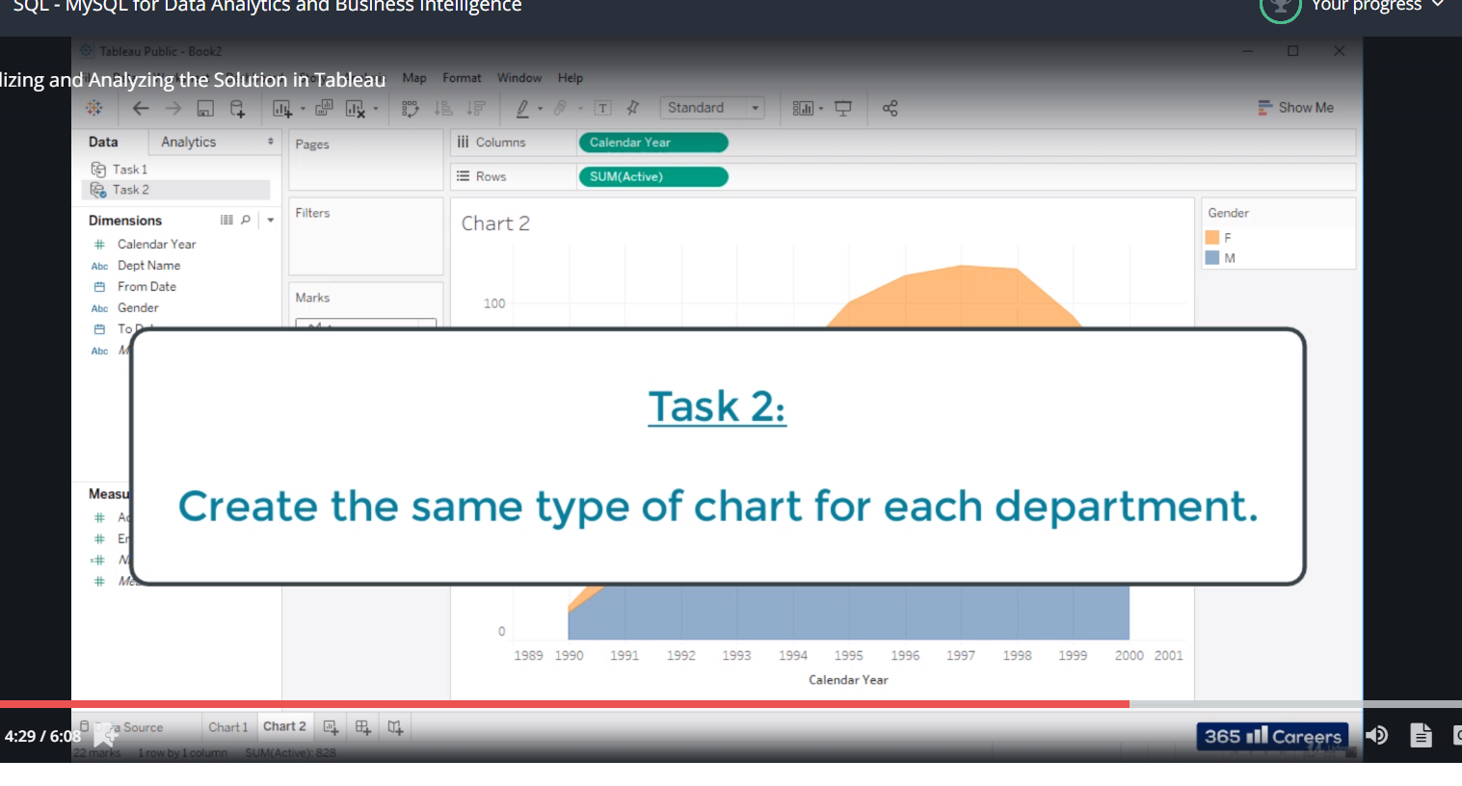

**Right click and select the one you want**

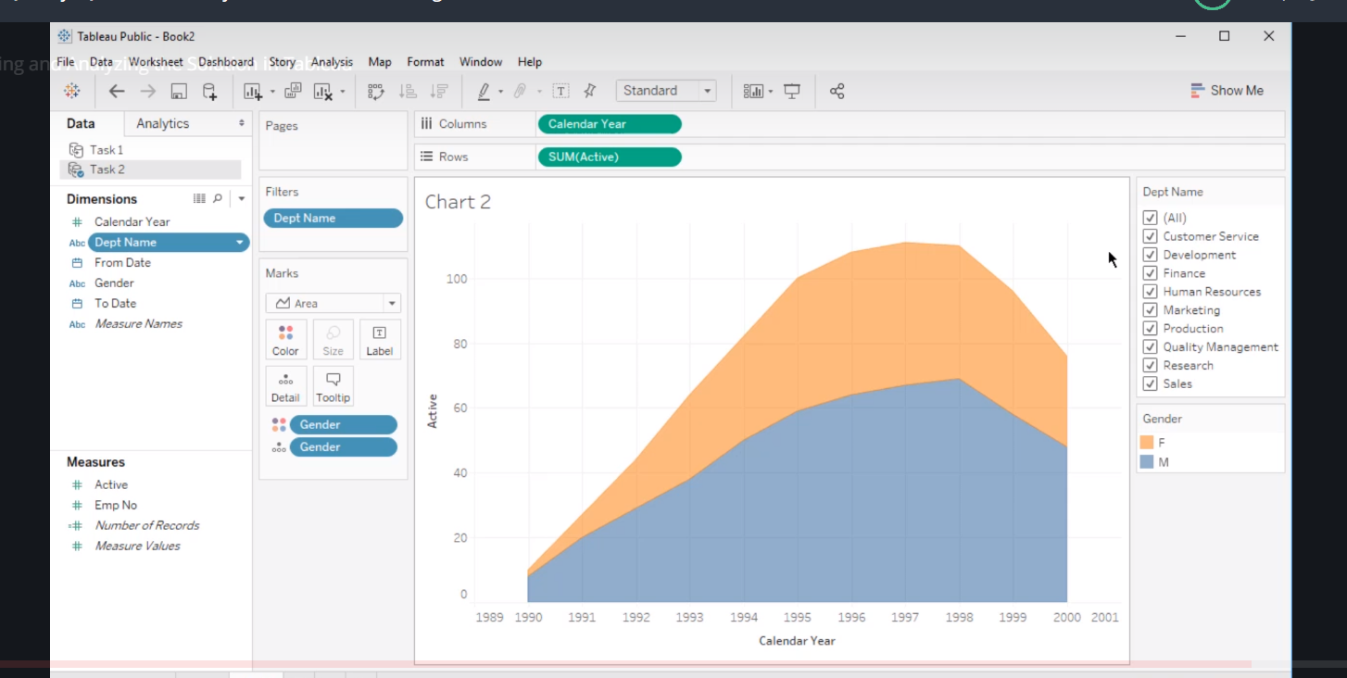

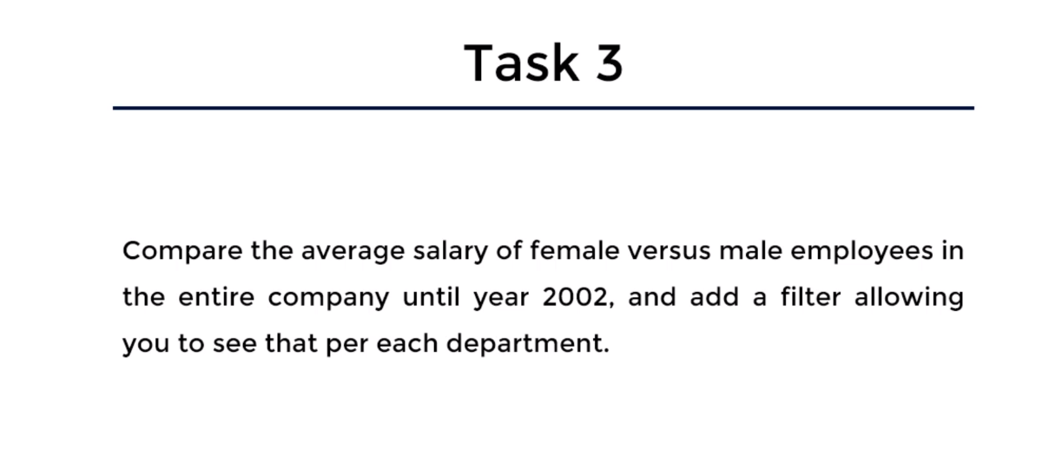

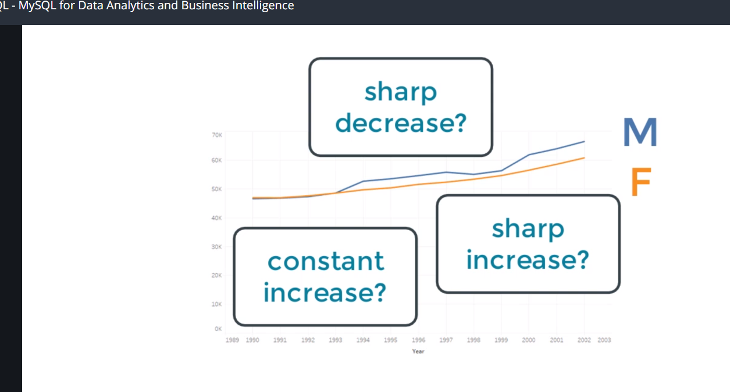

Task 3: SQL Solution - Code

**SELECT   
    e.gender,  
    d.dept_name,  
    ROUND(AVG(s.salary), 2) AS salary,  
    YEAR(s.from_date) AS calendar_year  
FROM  
    t_salaries s  
        JOIN  
    t_employees e ON s.emp_no = e.emp_no  
        JOIN  
    t_dept_emp de ON de.emp_no = e.emp_no  
        JOIN  
    t_departments d ON d.dept_no = de.dept_no  
GROUP BY d.dept_no , e.gender , calendar_year  
HAVING calendar_year <= 2002  
ORDER BY d.dept_no;**

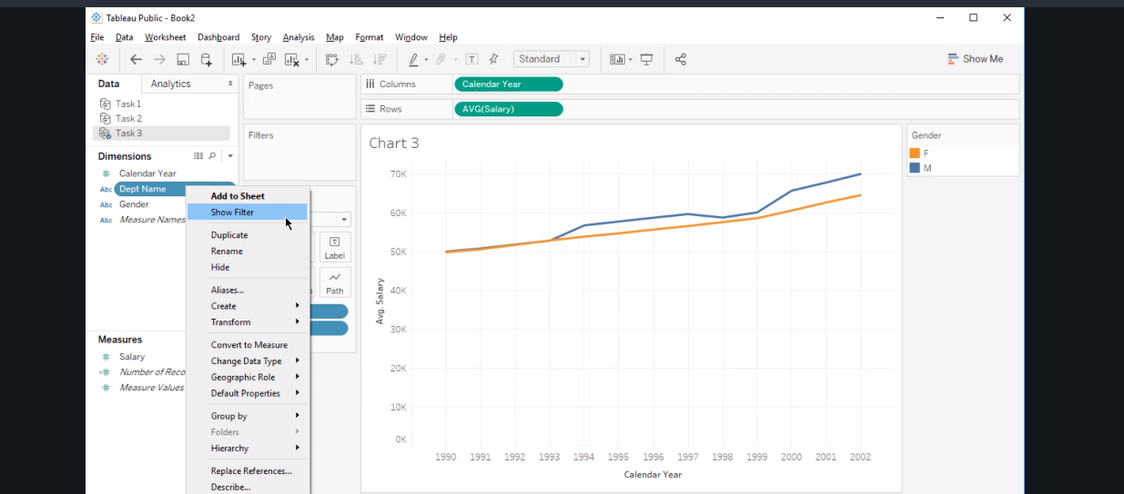

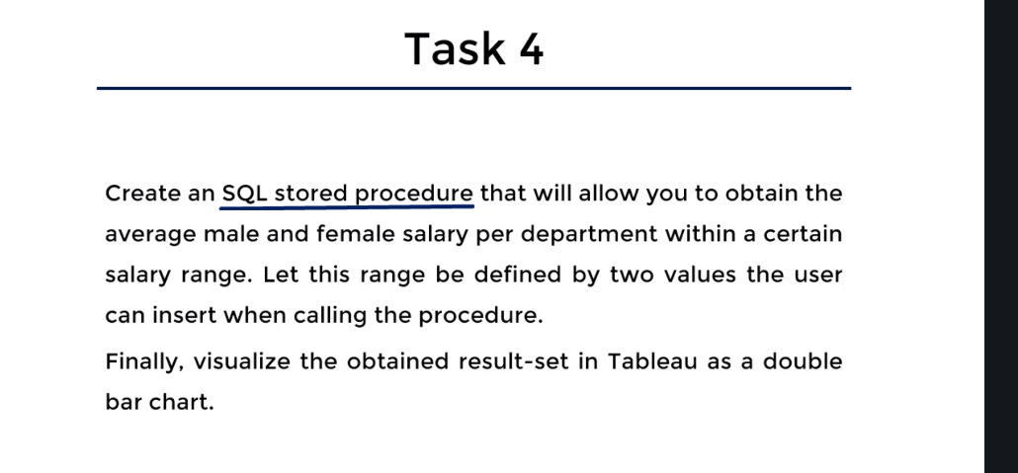

Task 4: Solution in SQL - Code

**DROP PROCEDURE IF EXISTS filter_salary;**

**DELIMITER $$  
CREATE PROCEDURE filter_salary (IN p_min_salary FLOAT, IN p_max_salary FLOAT)  
BEGIN  
SELECT   
    e.gender, d.dept_name, AVG(s.salary) as avg_salary  
FROM  
    t_salaries s  
        JOIN  
    t_employees e ON s.emp_no = e.emp_no  
        JOIN  
    t_dept_emp de ON de.emp_no = e.emp_no  
        JOIN  
    t_departments d ON d.dept_no = de.dept_no  
    WHERE s.salary BETWEEN p_min_salary AND p_max_salary  
GROUP BY d.dept_no, e.gender;  
END$$**

**DELIMITER ;**

**CALL filter_salary(50000, 90000);**

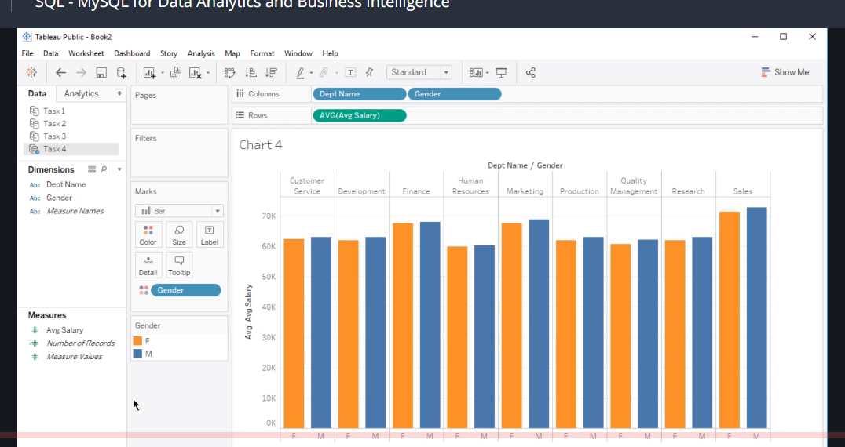

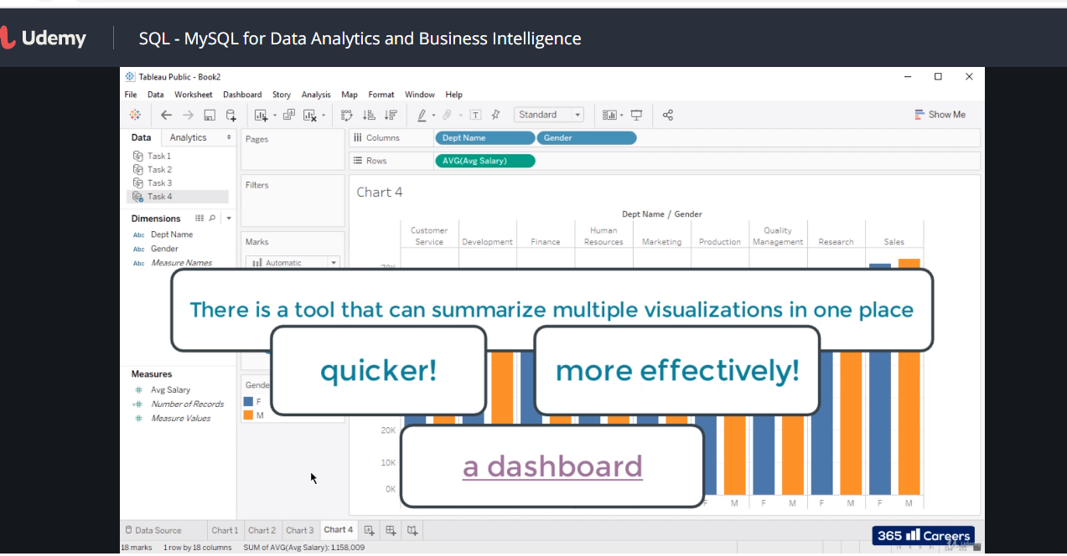

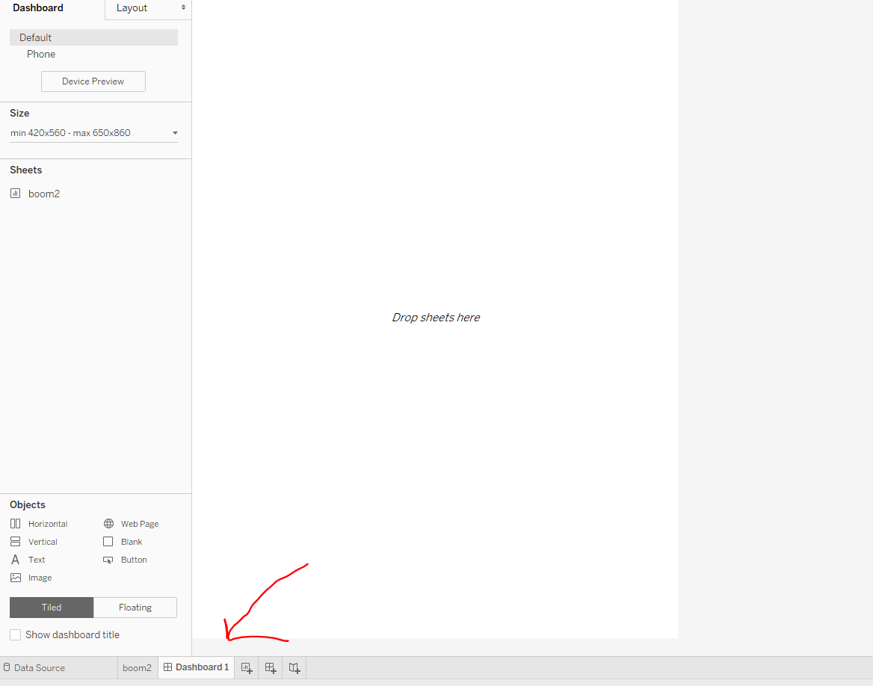

**Finally answer to all the queries**

**USE employees;**

**# Exercise 1**

**# Find the average salary of male and female employees in each department.**

**SELECT**

**d.dept_name, e.gender, AVG(salary)**

**FROM**

**salaries s**

**JOIN**

**employees e ON s.emp_no = e.emp_no**

**JOIN**

**dept_emp de ON e.emp_no = de.emp_no**

**JOIN**

**departments d ON d.dept_no = de.dept_no**

**GROUP BY de.dept_no , e.gender**

**ORDER BY de.dept_no;**

**# Exercise 2**

**# Find the lowest department number encountered the 'dept_emp' table. Then, find the highest department number.**

**SELECT**

**MIN(dept_no)**

**FROM**

**dept_emp;**

**SELECT**

**MAX(dept_no)**

**FROM**

**dept_emp;**

**# Exercise 3**

**# Obtain a table containing the following three fields for all individuals whose employee number is no greater than 10040:**

**# - employee number**

**# - the smallest department number among the departments where an employee has worked in (use a subquery to retrieve this value from the 'dept_emp' table)**

**# - assign '110022' as 'manager' to all individuals whose employee number is less than or equal to 10020, and '110039' to those whose number is between 10021 and 10040 inclusive (use a CASE statement to create the third field).**

**# If you've worked correctly, you should obtain an output containing 40 rows.**

**# Here’s the top part of the output.**

**SELECT**

**emp_no,**

**(SELECT**

**MIN(dept_no)**

**FROM**

**dept_emp de**

**WHERE**

**e.emp_no = de.emp_no) dept_no,**

**CASE**

**WHEN emp_no <= 10020 THEN '110022'**

**ELSE '110039'**

**END AS manager**

**FROM**

**employees e**

**WHERE**

**emp_no <= 10040;**

**# Exercise 4**

**# Retrieve a list with all employees that have been hired in the year 2000.**

**SELECT**

**\***

**FROM**

**employees**

**WHERE**

**YEAR(hire_date) = 2000;**

**# Exercise 5**

**# Retrieve a list with all employees from the ‘titles’ table who are engineers.**

**# Repeat the exercise, this time retrieving a list with all employees from the ‘titles’ table who are senior engineers.**

**SELECT**

**\***

**FROM**

**titles**

**WHERE**

**title LIKE ('%engineer%');**

**SELECT**

**\***

**FROM**

**titles**

**WHERE**

**title LIKE ('%senior engineer%');**

**# After LIKE, you could proceed to indicate what you are looking for with or without using parentheses. Both options work correctly. We think using parentheses is better for legibility reasons and that’s why it is the first option we’ve suggested.**

**SELECT**

**\***

**FROM**

**titles**

**WHERE**

**title LIKE '%engineer%';**

**SELECT**

**\***

**FROM**

**titles**

**WHERE**

**title LIKE '%senior engineer%';**

**# Exercise 6**

**# Create a procedure that asks you to insert an employee number to obtain an output containing the same number, as well as the number and name of the last department the employee has worked for.**

**# Finally, call the procedure for employee number 10010.**

**# If you've worked correctly, you should see that employee number 10010 has worked for department number 6 - "Quality Management".**

**DROP procedure IF EXISTS last_dept;**

**DELIMITER $$**

**CREATE PROCEDURE last_dept (in p_emp_no integer)**

**BEGIN**

**SELECT**

**e.emp_no, d.dept_no, d.dept_name**

**FROM**

**employees e**

**JOIN**

**dept_emp de ON e.emp_no = de.emp_no**

**JOIN**

**departments d ON de.dept_no = d.dept_no**

**WHERE**

**e.emp_no = p_emp_no**

**AND de.from_date = (SELECT**

**MAX(from_date)**

**FROM**

**dept_emp**

**WHERE**

**emp_no = p_emp_no);**

**END$$**

**DELIMITER ;**

**call employees.last_dept(10010);**

**# Exercise 7**

**# How many contracts have been registered in the ‘salaries’ table with duration of more than one year and of value higher than or equal to $100,000?**

**# Note: Apply this exercise for non-leap years only.**

**# Hint: You may wish to compare the difference between the start and end date of the salaries contracts to the number of seconds there are in a non-leap year.**

**SELECT**

**COUNT(*)**

**FROM**

**salaries**

**WHERE**

**salary >= 100000**

**AND ((to_date - from_date) >= (60 * 60 * 24 * 7 * 52));**

**# Exercise 8**

**# Create a trigger that checks if the hire date of an employee is higher than the current date. If true, set this date to be the current date. Format the output appropriately (YY-MM-DD).**

**# Extra challenge: You may try to declare a new variable called 'today' which stores today's data, and then use it in your trigger!**

**# After creating the trigger, execute the following code to see if it's working properly.**

**/\***

**INSERT employees VALUES ('999904', '1970-01-31', 'John', 'Johnson', 'M', '2025-01-01');**

**SELECT**

**\***

**FROM**

**employees**

**ORDER BY emp_no DESC;**

**\*/**

**DROP TRIGGER IF EXISTS trig_hire_date;**

**DELIMITER $$**

**CREATE TRIGGER trig_hire_date**

**BEFORE INSERT ON employees**

**FOR EACH ROW**

**BEGIN**

**DECLARE today date;**

**SELECT date_format(sysdate(), '%Y-%m-%d') INTO today;**

**IF NEW.hire_date > today THEN**

**SET NEW.hire_date = today;**

**END IF;**

**END $$**

**DELIMITER ;**

**# Exercise 9**

**# Define a function that retrieves the largest contract salary value of an employee. Apply it to employee number 11356.**

**# Also, what is the lowest salary value per contract of the same employee? You may want to create a new function that will deliver this number to you. Apply it to employee number 11356 again.**

**# Feel free to apply the function to other employee numbers as well.**

**DROP FUNCTION IF EXISTS f_highest_salary;**

**DELIMITER $$**

**CREATE FUNCTION f_highest_salary (p_emp_no INTEGER) RETURNS DECIMAL(10,2)**

**DETERMINISTIC**

**BEGIN**

**DECLARE v_highest_salary DECIMAL(10,2);**

**SELECT**

**MAX(s.salary)**

**INTO v_highest_salary FROM**

**employees e**

**JOIN**

**salaries s ON e.emp_no = s.emp_no**

**WHERE**

**e.emp_no = p_emp_no;**

**RETURN v_highest_salary;**

**END$$**

**DELIMITER ;**

**SELECT f_highest_salary(11356);**

**DROP FUNCTION IF EXISTS f_lowest_salary;**

**DELIMITER $$**

**CREATE FUNCTION f_lowest_salary (p_emp_no INTEGER) RETURNS DECIMAL(10,2)**

**DETERMINISTIC**

**BEGIN**

**DECLARE v_lowest_salary DECIMAL(10,2);**

**SELECT**

**MIN(s.salary)**

**INTO v_lowest_salary FROM**

**employees e**

**JOIN**

**salaries s ON e.emp_no = s.emp_no**

**WHERE**

**e.emp_no = p_emp_no;**

**RETURN v_lowest_salary;**

**END$$**

**DELIMITER ;**

**SELECT f_lowest_salary(10356);**

**# Exercise 10**

**# Based on the previous example, you can now try to create a function that accepts also a second parameter which would be a character sequence.**

**# Evaluate if its value is 'min' or 'max' and based on that retrieve either the lowest or the highest salary (using the same logic and code**

**# from Exercise 9). If this value is a string value different from ‘min’ or ‘max’, then the output of the function should return**

**# the difference between the highest and the lowest salary.**

**DROP FUNCTION IF EXISTS f_salary;**

**DELIMITER $$**

**CREATE FUNCTION f_salary (p_emp_no INTEGER, p_min_or_max varchar(10)) RETURNS DECIMAL(10,2)**

**DETERMINISTIC**

**BEGIN**

**DECLARE v_salary_info DECIMAL(10,2);**

**SELECT**

**CASE**

**WHEN p_min_or_max = 'max' THEN MAX(s.salary)**

**WHEN p_min_or_max = 'min' THEN MIN(s.salary)**

**ELSE MAX(s.salary) - MIN(s.salary)**

**END AS salary_info**

**INTO v_salary_info FROM**

**employees e**

**JOIN**

**salaries s ON e.emp_no = s.emp_no**

**WHERE**

**e.emp_no = p_emp_no;**

**RETURN v_salary_info;**

**END$$**

**DELIMITER ;**

**select employees.f_salary(11356, 'min');**

**select employees.f_salary(11356, 'max');**

**select employees.f_salary(11356, 'maxxx');**